8. Inclusive Education
This is a plain English summary of Australia’s 2019 CRPD Factsheet 8

Education in Australia
The education system in Australia fails to meet the needs of students with disability.
It is rare for students with disability to get an education where they are fully included.
Only one third of people with disability aged between 15 and 65 years finished high school.
Nearly twice as many people without disability in this age group finished high school.
Many school aged people with disability do not go to school and most of them say it is because of their disability.
Main mainstream schools are not accessible.
Principals and staff at schools tell parents their children will be better off at a special school.
Special schools only take children with disability so exclude them from their peers and community.
Students have bad experiences including
- Discrimination and bullying by other students and teachers
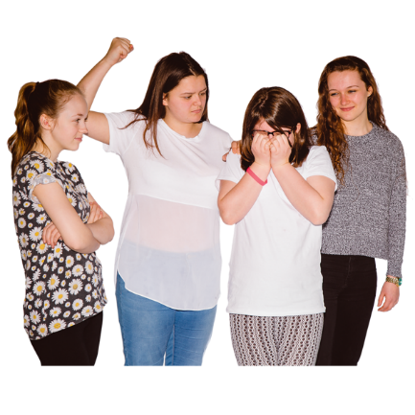
- Lack of support
- Teachers not being trained well
Australian government request to CRPD Committee
The Australian government want the CRPD Committee to agree they…

“may offer education through specialist classes or
schools consistently with article 24.”

This is a breach of CRPD Article 24 and CRPD General Comment 4.

What we recommend
Make a national Action Plan for Inclusive Education.
The plan should include laws and guides that follow CRPD Article 24 and CRPD General Comment 4.

Stop the increasing number students with disability that are put in special schools.

Use funding from special schools to make sure students are included into mainstream schools.

In consultation with Indigenous people and their organisations, create programs and to increase the number of Indigenous students attending school and finishing high school.

