10. Participation of people with disability and DPOs
This is a plain English summary of Australia’s 2019 CRPD Factsheet 10

DPOs
DPO is short for Disabled Peoples Organisations.
DPOs are run by and for people with disability.
Examples of DPOs in Australia are PWDA, CID and Speak Out Tasmania.
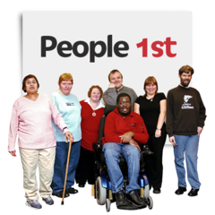

The Committee has made it clear that people with disability and our organisations need to be involved in making laws that affect us.
We need to be involved in making the Convention a reality and making sure we get our rights.
We need to be involved in decision making processes like making new laws.

Issues
Australia has not done very well at involving people with disability and our organisations when making laws and protecting our rights.
There is not enough funding for DPOs and other organisations that represent people with disability.
Women with disability are not well included in work the government does to protect all women.
There are no programs that focus on promoting the rights of children with disability.
Funding and timing for CRPD events like COSP and Shadow Reporting are limited.

What we recommend
- The government must work with people with disability and DPOs when making laws to implement the CRPD.
- Our organisations need to have good funding so we can participate in making sure we get our human rights.
- We need to be involved in checking the government is following the CRPD.
- Make sure organisations that represent women and children are well funded, supported and included in this work.
- Provide more funding and time for us to prepare and participate in CRPD monitoring events like COSP and Shadow Reporting.

