1. Implementation of CRPD
This is a plain English summary of Australia’s 2019 CRPD Factsheet 1

Issue
There is no comprehensive human rights law in Australia.
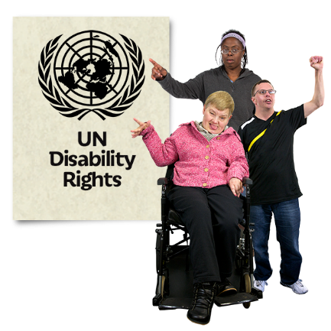
There are lots of rights in the CRPD that are not covered in our laws.
Australia has interpretive declarations on CRPD articles 12, 17 and 18 that means the CRPD cannot be fully applied.

Laws and policy
The Disability Discrimination Act is the main law that protects people with disability from discrimination.
It does not cover all areas of discrimination.
The National Disability Strategy 2010 – 2020 is a policy that guides governments to meet the CRPD.
The plan and reports from this strategy are not being delivered on time.
It lack actions and outcomes that can be measured.

The National Disability Strategy sits with the Department of Social Services. It does not have much authority with other departments or State governments.
What we recommend
Establish a Human Rights Act that covers Australia’s commitments under the CRPD and other human rights conventions.

Remove the interpretative declarations on CRPD Articles 12, 17 and 18.

Make anti-discrimination laws stronger and change the Disability Discrimination Act to make sure people with disability can effectively make complaints about denial of reasonable accommodation.

Make sure the next National Disability Strategy
- has good funding
- is developed in an intersectional framework
- has outcomes that can be measured
- makes government departments accountable

Establish an independent high-level Office of Disability Inclusion to drive the National Disability Strategy and to makes sure the government complies with the CRPD.

Undertake a comprehensive assessment of the situation of women with disability, children and young people with disability, and Indigenous people with disability.

Develop a way to collect and report of data for all commitments in the CRPD.

