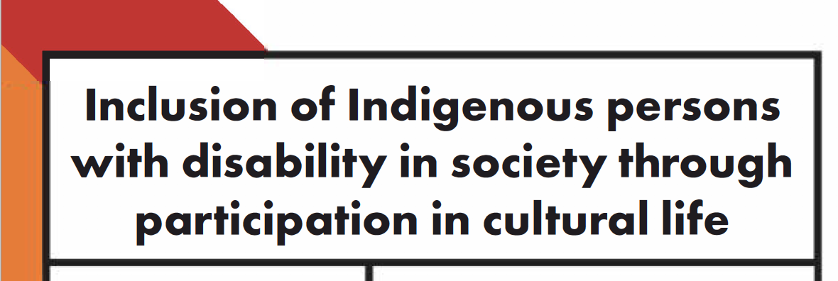

Wed Jun 12 Conference Room C 3:00pm - 4: 15pm (GMT-4)

About the Event:
This side-event will explore how CRPD obligations apply to the specific situation of Indigenous peoples with disability & how these obligations are reinforced by the UN Declaration on the Rights of Indigenous Persons.

The event will feature the views of Indigenous people with disability & human rights experts on the challenges, positive examples, & obligations in relation to implementation of the CRPD.

The event will use Captioning at Real Time (CART).

Facilitator:
June Riemer, Deputy CEO, First Peoples Disability Network

Speakers:
Rosemary Kayess, Vice-Chair, Committee on the Rights of Persons with Disabilities / Therese Sands, Co-CEO, People with Disability Australia
Setareki Macanawai, CEO, Pacific Disability Forum/ Co-Chairperson, Indigenous Persons with Disabilities Global Network {IPWDGN)
Paula Tesoriero MNZM, Disability Rights Commissioner, New Zealand Human Rights Commission / Chair, Global Alliance for National Human Rights Institutions (GANHRI) Working Group on Rights of Persons with Disabilities
Sereako Treloggen, Board Member, First Peoples Disability Network Australia

Hosted and sponsored by:
People with Disability Australia

Co-sponsors:
First Peoples Disability Network Australia
Disabled People's Organisations Australia
Pacific Disability Forum
Indigenous Persons with Disabilities Global Network
Australian Government

