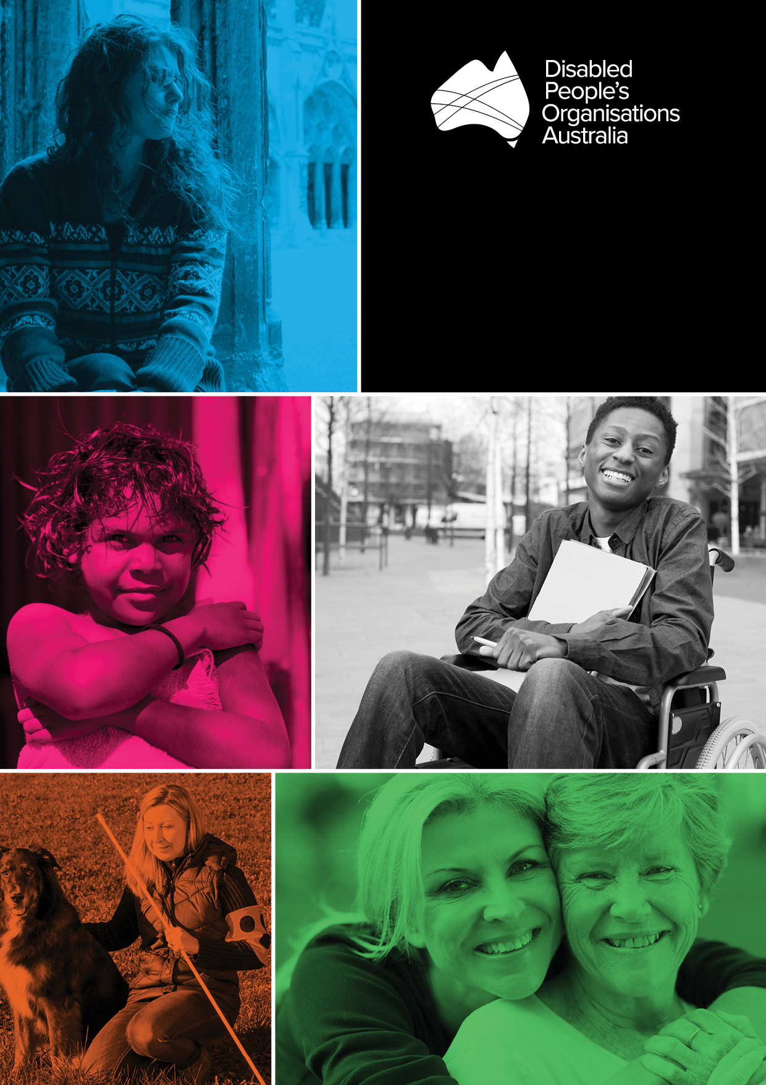

DPO AUSTRALIA
ACTIVITY WORK PLAN

July 2016 – June 2017

PUBLISHING INFORMATION

Disabled People’s Organisations Australia (DPO Australia) Activity Work Plan July 2016 - June 2017. Prepared by Carolyn Frohmader for and on behalf of DPO Australia. © DPO Australia, June 2016.

CONTACT

Therese Sands
DPO Australia
PO Box 666
Strawberry Hills NSW 2012
AUSTRALIA

+61 2 9370 3100 | director@dpoa.org.au
+61 412 935 128 | @DPOAustralia
1800 422 015 | @ThereseSands
NRS: 1800 555 677 | facebook.com/DPOA
TIS: 13 14 50 | http://www.dpoa.org.au/

This work is copyright. Apart from any use as permitted under the Copyright Act 1968, no part may be reproduced without written permission from Disabled People’s Organisations Australia (DPO Australia). All possible care has been taken in the preparation of the information contained in this document. DPO Australia disclaims any liability for the accuracy and sufficiency of the information and under no circumstances shall be liable in negligence or otherwise in or arising out of the preparation or supply of any of the information aforesaid.

1 ABOUT DPO AUSTRALIA

Disabled People’s Organisations Australia, known as ‘DPO Australia’ or ‘DPOA’, is an alliance of national Disabled People’s Organisations (DPOs) in Australia. The key purpose of DPO Australia is to promote, protect and advance the human rights and freedoms of people with disability in Australia by working collaboratively on areas of shared interests, purposes and strategic priorities and opportunities. DPO Australia (formerly known as the ‘Australian Cross Disability Alliance’) was founded by, and is comprised of four national cross-disability DPOs: First Peoples Disability Network Australia (FPDN); Women With Disabilities Australia (WWDA); National Ethnic Disability Alliance (NEDA); and People with Disability Australia (PWDA). DPO Australia has been funded by the Australian Government to be the recognised coordinating point between Government/s and other stakeholders, for consultation and engagement with people with disability in Australia. The four founding member organisations of DPO Australia recognise and value the strength of working together in a spirit of mutual respect and trust, to proactively pursue human rights outcomes for all people with disability in Australia.

Women With Disabilities Australia (WWDA) is the national cross-disability DPO for women and girls with all types of disability in Australia. It operates as a transnational human rights organisation and is run by women with disability, for women with disability. WWDA represents more than 2 million disabled women in Australia, has affiliate organisations and networks of women with disability in most States and Territories, and is internationally recognised for its global leadership in advancing the human rights of women and girls with disability.

National Ethnic Disability Alliance (NEDA) is the national peak organisation representing the rights and interests of people from Culturally and Linguistically Diverse (CALD/NESB) people with disability, their families and carers throughout Australia. NEDA advocates at the federal level so that CALD/NESB people with disability can participate fully in all aspects of social, economic, political and cultural life.

First Peoples Disability Network (Australia) (FPDN) is the national cross-disability DPO representing Aboriginal and Torres Strait Islander people with disability and their families. FPDNA utilises a range of strategies in its representative role, including through the provision of high-level advice to governments, and educating the government and non-government sectors about how to meet the unmet needs of Aboriginal and Torres Strait Islander people with disability.

People with Disability Australia (PWDA) is a national cross-disability DPO, representing all people with disability. Its primary membership is made up of people with disability and organisations primarily constituted by people with disability. It also has a large associate membership of other individuals and organisations committed to the disability rights movement. Founded in 1981, the International Year of Disabled Persons, PWDA seeks to provide people with disability with a voice of their own.

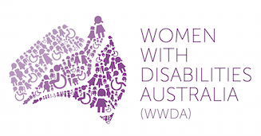 |  |  | 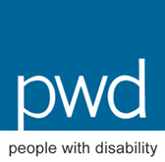

1.1 PURPOSE OF DPO AUSTRALIA

The key purpose of DPO Australia is to promote, protect and advance the human rights and freedoms of people with disability in Australia by working collaboratively on areas of shared interests, purposes and strategic priorities and opportunities.

1.2 KEY OBJECTIVES OF DPO AUSTRALIA

DPO Australia will:

- work to advance the rights of all people with disability from all walks of Australian life, in relevant policy frameworks, strategies, partnership agreements and any other relevant initiatives;
- promote and engender a collaborative, co-operative and respectful relationship with all levels of Government in the efforts of DPO Australia to advance the human rights of people with disability;
- build on and further develop networks, strategic alliances and partnerships at state/territory, national and international levels to advance human rights of people with disability;
- promote DPO Australia at national and international levels as the coordinating point for engagement with the Australian DPO sector; and
- build respect for, appreciation of, and faith in the DPO sector in Australia.

1.3 GUIDING PRINCIPLES OF DPO AUSTRALIA

DPO Australia will:

- recognise and agree that the international human rights normative framework, including international human rights treaties and instruments to which Australia is party provide the human rights framework to advance the rights of people with disability;
- work from and within a human rights framework and approach in its work to promote, protect and advance the human rights and freedoms of people with a disability;
- build a culture of engagement with, and inclusive of all persons with disability;
- recognise and support the right of all people with disability to join one or more of the DPO Australia organisations, and other DPO and representative organisations; and
- represent a cross-disability perspective that ensures there are no gaps in representation of people with disability.

2 BACKGROUND & CONTEXT

The DPO Australia Activity Work Plan builds on the work plan agreed by the member organisations of the Australian Cross Disability Alliance (ACDA) in June 2015, and reflects the transition of the ACDA to DPO Australia. The Activity Work Plan is premised on the key work that is required by Department of Social Services (DSS) as well as the key work that DPO Australia has identified as critical to progressing the rights of people with disability in Australia.

Critically, this Activity Work Plan is underpinned by the internationally shared values and purpose of Disabled Peoples Organisations (DPOs). DPOs are governed by, led by and constituted of people with disability, and collectively form a disability rights movement that places people with disability at the centre of decision-making in all aspects of our lives. This is known internationally through the motto, “Nothing About Us, Without Us”.

While DPOs are diverse, they share common aspects, such as the requirement for a majority of people with disability, as a minimum for a DPO governing body; and the requirement that people with disability democratically elect and vote for their representative on the governing body.

DPOs are representative organisations of people with disability, and distinct from representative organisations for people with disability. The Convention on the Rights of Persons with Disabilities (CRPD) outlines the obligation of States Parties to guarantee the participation and involvement of representative organisations of people with disability in decision-making in all aspects of our lives (Article 4(3)), to promote the establishment of organisations of people with disability (Article 29) and ensure our participation in CRPD implementation and monitoring (Articles 4 and 33). The CRPD provides the framework to ensure that people with disability, through our representative organisations are the main participants in CRPD implementation, and our opinions should always be given priority in matters affecting our lives.

3 GOALS & KEY OBJECTIVES

Goal 1
Establish DPO Australia as the national human rights based model of DPO representation to effect its purpose to promote, protect and advance the human rights of people with disability in Australia

Key Objectives:

- Fully implement the revised DPO Australia operating structure as formally agreed to by DPO Australia member organisations.
- Secure the funding, structure and sustainability of DPO Australia post June 30, 2017.
- Develop the 5 year DPO Australia Strategic Plan (2017-2022).

Goal 2
Undertake focused systemic advocacy and research on priority human rights issues for people with disability in Australia

Key Objectives:

- Undertake work in the policy priority area of the right of people with disability to freedom from all forms of violence and abuse.
- Undertake work in the policy priority area of the right of people with disability to liberty and security of person, with a specific focus on indefinite detention.
- Undertake work in the policy priority area of the right of people with disability to live independently and be included in the community, with a specific focus on housing.
- Establish a DPO Research Agenda that reflects the needs of people with disability and which supports human rights reforms to disability policy and practice.

Goal 3
Actively participate in the development and implementation of Australian Government policies and legislation affecting people with disability

Key Objectives:

- Advocate for the establishment of formal engagement mechanisms for people with disability to provide feedback to Government on key reform agendas.
- Engage in policy and law reform and program design and implementation in relation to the National Disability Strategy (NDS).
- Actively contribute to the reforms under the Disability Employment Framework.
- Actively contribute to the implementation and design of the National Disability Insurance Scheme (NDIS).
- Actively contribute to the Review of the National Disability Advocacy Program (NDAP) in 2016-17.
- Develop and implement a Government Relations Strategy, including protocols and engagement strategies for working with and informing government on critical issues.

Goal 4
Undertake priority infrastructure and systems development for engagement with people with disability and other stakeholders

Key Objectives:

- Develop a Stakeholder Engagement Strategy and procedures to ensure regular and consistent contact and information sharing with people with disability and other stakeholders.
- Develop a Communications and Media Strategy and procedures to effect the purpose and objectives of DPO Australia.
- Promote the interests and concerns of people with disability through DPO Australia representation on relevant committees, advisory bodies and other relevant fora.

Goal 5
Contribute to relevant United Nations processes to advance the human rights of people with disability, including a focus on monitoring domestic implementation of the international human rights treaties and instruments to which Australia is party

Key Objectives:

- Promote DPO Australia at the international level, including through the UN, as the key co-ordinating point for international engagement with people with disability in Australia.
- Facilitate the representation of people with disability at relevant UN events and fora, including through civil society delegations to treaty monitoring processes, and special procedures.
- Participate in civil society human rights monitoring and implementation, including through shadow reporting processes and domestic policy and law reform processes.
- Facilitate the promotion of activities for the United Nations International Day of People with Disability

