Australian Cross Disability Alliance (ACDA)

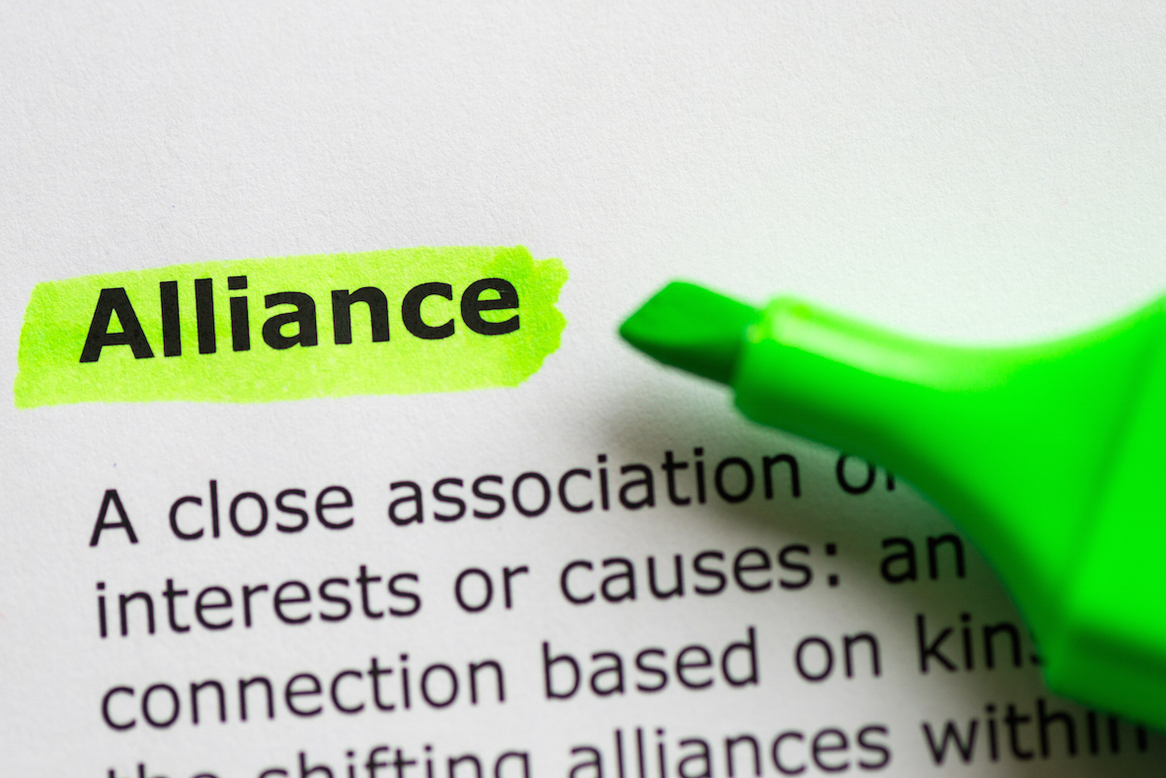

Activity Progress Report
February 2015 – July 2015

 | 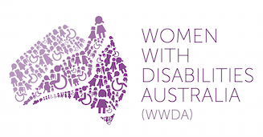 | 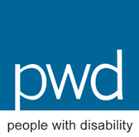

ACDA Contact

Chris Brophy
Director, Strategic Communications
Women With Disabilities Australia (WWDA)
PO Box 407, Lenah Valley TASMANIA 7008
E: chris@wwda.org.au

About the Australian Cross Disability Alliance (ACDA)

The Australian Cross Disability Alliance (ACDA) is an alliance of national disabled person’s organisations (DPOs) in Australia. The key purpose of the ACDA is to promote, protect and advance the human rights and freedoms of people with disability in Australia by working collaboratively on areas of shared interests, purposes and strategic priorities and opportunities. The ACDA is made up of four national cross-disability Disabled Person’s Organisations: First Peoples Disability Network Australia (FPDNA); Women With Disabilities Australia (WWDA); National Ethnic Disability Alliance (NEDA); and, People with Disability Australia (PWDA). The ACDA model has been funded by the Australian Government to be the recognised coordinating point between Government/s and other stakeholders, for consultation and engagement with people with disability in Australia. In forming the ACDA, its four founding member organisations recognise and value the strength of working together in a spirit of mutual respect and trust, to proactively pursue human rights outcomes for all people with disability in Australia.

First Peoples Disability Network Australia (FPDNA) is the national cross-disability DPO representing Aboriginal and Torres Strait Islander people with disability and their families. FPDNA utilises a range of strategies in its representative role, including through the provision of high-level advice to governments, and educating the government and non-government sectors about how to meet the unmet needs of Aboriginal and Torres Strait Islander people with disability.

Women With Disabilities Australia (WWDA) is the national cross-disability DPO for women and girls with all types of disabilities in Australia. It operates as a transnational human rights organisation and is run by women with disabilities, for women with disabilities. WWDA’s work is grounded in a human rights based framework which links gender and disability issues to a full range of civil, political, economic, social and cultural rights.

National Ethnic Disability Alliance (NEDA) is the national peak organisation representing the rights and interests of people from Culturally and Linguistically Diverse (CALD/NESB) people with disability, their families and carers throughout Australia. NEDA advocates at the federal level so that CALD/NESB people with disability can participate fully in all aspects of social, economic, political and cultural life.

People with Disability Australia (PWDA) is a national disability rights and advocacy organisation. Its primary membership is made up of people with disability and organisations primarily constituted by people with disability. It also has a large associate membership of other individuals and organisations committed to the disability rights movement.

The key objectives of the Australian Cross Disability Alliance (ACDA) are to:
- work to advance the rights of all people with disability from all walks of Australian life, in relevant policy frameworks, strategies, partnership agreements and any other relevant initiatives;
- promote and engender a collaborative, co-operative and respectful relationship with all levels of Government in the efforts of the ACDA to advance the human rights of people with disability;
- build on and further develop networks, strategic alliances and partnerships at state/territory, national and international levels to advance human rights of people with disability;
- promote the ACDA at national and international levels as the coordinating point for engagement with the Australian DPO sector; and.
- build respect for, appreciation of, and faith in the DPO sector in Australia.

About this Report

The Australian Cross Disability Alliance (ACDA) was formally announced by the Assistant Minister for Social Services, Mitch Fifield, in February 2015. The first six months has seen the ACDA focus on beginning work to formally establish the new Alliance model, through the development of an Operating model, Priority Activity Work Plan, policies, procedures and protocols to ensure its effective operation, along with developing processes to inform evidence based priority action and issue areas to focus the Alliance’s work into the future. Although in its early establishment phase, the past six months has seen the ACDA work proactively to engage with Government and other stakeholders to advance the human rights of people with disability, through for example: ACDA representation on advisory structures and fora; development of ACDA policy Submissions; and provision of advice and expertise on Government reforms and programs affecting people with disability; and engagement with a wide range of stakeholders. This Report provides a brief overview of the activities of the ACDA for the period February-July 2015. This Report provides information on ACDA activities under four key program areas: 1) Submissions & Policy Advice; 2) Representation; 3) Stakeholder Engagement & Development; and, 4) Operational Planning & Development.

Submissions & Policy Advice

Date | Activity | Detail | Comments/Outcomes/Action
17/02/15 | Department of Social Services: Development of NDIS Quality and Safeguards Framework; and NDIS ILC Policy | Consultation meeting with Department of Social Services (DSS) personnel. Provision of advice and recommendations regarding National Consultation for the NDIS Quality and Safeguards Framework. | Ongoing process. ACDA involved in consultations, representation activities, policy input and development of written submissions.
27/02/15 | Department of Social Services: NDIS Policy and Legislation Branch | Meeting to initiate, advise on, and assist in the development of Q&A Pages to provide a simple explanation of the NDIS Quality and Safeguarding Framework and consultation process. WWDA represented ACDA. | Q&A Pages developed and uploaded to DSS NDIS Engagement site.
09/03/2015 | Department of Social Services: Mid-Year Economic and Fiscal Outlook (MYEFO) Cessation of social security benefits while in psychiatric confinement | Written submission. Meetings and teleconferences. Provision of advice and recommendations. FPDN and NEDA represented ACDA at meetings with DSS personnel.
18/03/15 | Senate Community Affairs References Committee: Inquiry into the impact on service quality, efficiency and sustainability of recent Commonwealth community service tendering processes by the Department of Social Services | Written submission. Supplementary written Submission developed in response to questions on notice from Senate Hearing. WWDA and PWDA represented ACDA. | Formally submitted, publicly available at:  http://www.aph.gov.au/Parliamentary_Business/Committees/Senate/Community_Affairs/Grants/Submissions
27/03/15 | Department of Social Services: International Day of People with Disability | Provision of advice and recommendations regarding International Day of People with Disability patron, and format/structure of National Disability Awards.
11/05/15 | Department of Social Services: Internal Employment Taskforce | Provision of advice regarding the new National Disability Employment Framework. Advice and recommendations regarding programmatic reform of employment (led by Commonwealth under the National Disability Strategy). PWDA represented ACDA.
25/05/15 | Department of Social Services: Consultation Paper – Proposal for a National Disability Insurance Scheme Quality and Safeguarding Framework | Joint submission by WWDA and PWDA. | Formally submitted, publicly available at:  http://wwda.org.au/papers/subs/subs2011/

09/06/15 | Department of Social Services: Development of the Third Action Plan for the National Framework for Protecting Australia’s Children | Provision of advice and details of recommended stakeholders to participate in the specialist ‘Disability’ Roundtable to inform the National Framework for Protecting Australia’s Children.
09/06/15 | Department of Social Services: DES Youth Mental Health Initiative | Provision of advice on initiative, including on meaningful consultation processes for young people with disability. WWDA and PWDA represented ACDA.
22/06/15 | Department of Social Services: Disability Employment Services (DES) Data and Performance | Provision of advice and feedback regarding readability of DSS letters and fact sheets relating to transition of DES participants from lower performing DES providers to higher performing providers. WWDA represented ACDA.
06-07/15 | Department of Social Services: National Disability Employment Framework Consultations | ACDA member organisations submitted substantial information, supporting documents, evidenced based research reports, etc to inform national consultation. | Ongoing process.
02/07/15 | Joint Standing Committee on Treaties: Consideration of the Marrakesh Treaty to Facilitate Access to Published Works for People who are Blind, Visually Impaired or otherwise Print Disabled (Marrakesh, 27 June 2013) | Written submission supporting the ratification by Australia of the Marrakesh Treaty. | Formally submitted, publicly available at:  http://www.aph.gov.au/Parliamentary_Business/Committees/Joint/Treaties/16_June_2015/Submissions Monitor progress
02/07/15 | Victorian Royal Commission into Family Violence | Written submission and supporting materials provided. | Formally submitted and written response received. Monitor progress.
27/07/15 | Department of Social Services: National Disability Awards | Provision of advice and recommendations on Award categories, and judging panel membership. | Ongoing process. ACDA involvement, including as members of judging panel.
30/07/15 | Australian Human Rights Commission: Willing to Work Inquiry | WWDA and PWDA, on behalf of ACDA, met with Donna Purcell (Manager of the Inquiry) to provide advice and expertise on the Inquiry consultation process, and key issues for the Inquiry. | Ongoing process. ACDA will provide Willing to Work Inquiry range of reports and materials stemming from previous consultations with people with disability regarding employment.
31/07/15 | Department of Social Services: Review of the National Disability Advocacy Framework | Written submission. | Formally submitted. ACDA to provide input to next phase of consultation on NDAP. Submission publicly available at:  http://pwd.org.au/pwda-publications/submissions.html
06-07/15 | Senate Community Affairs References Committee: Inquiry into violence, abuse and neglect against people with disability in institutional and residential settings | Development of draft written Submission.  Provision of advice, expertise, support and recommendations to Senate Secretariat, including organising witnesses for public hearings; assisting with development of hearings program and content; undertaking research, providing supporting materials to inform the Inquiry, assisting with the development of Easy English guides, development of the Terms of Reference for the Inquiry, supporting witnesses to give evidence. WWDA and PWDA have represented ACDA to date on this work. | Ongoing process. ACDA to provide evidence at Sydney hearing 27/08/15.

Representation

Date | Activity | Detail | Comments/Outcomes/Action
06/02/15 | ACDA Media Release | Welcoming funding of ACDA and announcing broad role of ACDA. ACDA member organisations interviewed by media. | Media coverage including print media.
11/02/15 | National Press Conference: Senate Inquiry into Violence and Abuse Against People with Disability in Institutional and Residential Settings. | Current ACDA member organisations assisted organisation of Press Conference, were represented at the event and provided media responses. | Senate Inquiry into Violence and Abuse Against People with Disability in Institutional and Residential Settings is an ongoing ACDA activity. WWDA and PWDA developed the Terms of Reference for the Inquiry.
20/02/15 | Accessible Public Transport National Advisory Committee (APTNAC) | PWDA and NEDA represent ACDA on this National Committee, and its sub-Committees. | Ongoing ACDA representation.
08/03/15 | UN Commission on the Status of Women (CSW) 59th Session | WWDA and PWDA represented both member organisations, and the ACDA, at the 59th session of CSW in New York. | High level of interest in the ACDA model at CSW. WWDA and PWDA had a number of significant and high level meetings at CSW (eg: Human Rights Watch, Centre for Reproductive Rights, Disability Rights International, AWID, UN Women) introducing the ACDA and the work of its member organisations.
07/04/15 | ACDA Media Release: Immigration | Department of Immigration to review decision relating to child with Down syndrome.
21/04/15 | Senate Community Affairs References Committee: Inquiry into the impact on service quality, efficiency and sustainability of recent Commonwealth community service tendering processes by the Department of Social Services | WWDA and PWDA gave evidence to the Inquiry at the Canberra hearing on 21 April. Questions taken on notice. Supplementary submission written and provide to Senate Committee.
05/15 | Australian Human Rights Commission: National Reference Group, Willing to Work Inquiry | PWDA represents ACDA on the National Reference Group. | Ongoing ACDA representation.
4/06/15 | Australian Electoral Commission (AEC) Disability Advisory Committee | NEDA and WWDA attended the annual forum of the AEC Disability Advisory Committee. | Forum minutes and proceedings yet to be released by AEC.
06/15 | Telecommunications Industry Ombudsman (TIO) Advisory Group | PWDA represents ACDA on the National Reference Group. | Ongoing ACDA representation.

11/06/15 | Senate Standing Committee on Finance and Public Administration: ‘Inquiry into Domestic Violence in Australia’ | PWDA, for and on behalf of ACDA, presented evidence to the Senate Hearing into Domestic Violence in Australia as follow up to the written submission provided to the Inquiry in Sept 2014. | WWDA and PWDA wrote Submission, publicly available at:  http://www.aph.gov.au/Parliamentary_Business/Committees/Senate/Finance_and_Public_Administration/Domestic_Violence/Submissions  Reporting time extended to 20 August 2015.
17/06/15 | National Disability Insurance Agency (NDIA): CEO’s Forum Workshop | ACDA member organisations attended CEO’s Forum Workshop; and participate in ongoing meetings. | Forum focused on outcomes sought from the ILC Policy Framework and how these can be best framed and measured.
22/06/15 | Department of Health: Office of Hearing Services, National Information Forums | ACDA member organisations attended Information sessions (held Canberra, Sydney, Melbourne) regarding interface between the NDIS and the Hearing Services Program. | Transition Planning consultation process commencing from July onwards.
07/07/15 | The 13th AWID International Forum on Women’s Rights and Development: Feminist Futures: Building Collective Power for Rights and Justice, May 5-8, 2016 Salvador, Brazil | Submitted written Application for the ACDA to present a Conference session on ‘Building Alliances to Address and Prevent Gendered Disability Violence’. WWDA coordinating this initiative for and on behalf of ACDA. | Successful applicants advised in late September 2015.
22/06/15 | National Roundtable: Development of the Third Action Plan for the National Framework for Protecting Australia’s Children | ACDA member organisations represented at, and participated in, National Roundtable [Melbourne]. | DSS Community and Sector Engagement Section.
23/06/15 | Department of Social Services: Disability Employment Services Operational Working Group (DES OWG) | WWDA and PWDA represent ACDA on DES OWG. Meets bi-monthly via teleconference. | DES OWG addresses operational issues that relate to the successful delivery of Disability Employment Services (DES). Ongoing ACDA representation.
27/07/15 | Australia’s National Research Organisation for Women’s Safety (ANROWS) National Practitioner Engagement Group | WWDA and PWDA represent the ACDA on this group. First PEG meeting held Monday 27th July. | Ongoing ACDA representation.

Stakeholder Engagement & Development

Date | Activity | Detail | Comments/Outcomes/Action
16/02/15 | National Forum of Disability Stakeholders | Forum to advise COAG Disability Ministers on priorities for NDS Second Implementation Plan, and to assist in NDS Progress Reporting to COAG. | Forum pre-meeting to enable non-government representatives to discuss and prioritise issues prior to the Disability Ministers National Forum.
16/02/15 | 2015 Disability Ministers National Forum | ACDA members presented on various priorities identified in pre-forum meeting. Engagement with COAG Ministers and other key stakeholders. | Disability Ministers National Forum held every two years as part of stakeholder engagement obligations under the National Disability Strategy 2010-2020
16/02/15 | Ministerial announcement of the ACDA | Official photos with ACDA and Minister Fifield; ACDA and State/Territory Disability Ministers | Ministers Media Release available at:  http://mitchfifield.dss.gov.au/media-releases/new-voice-for-all-australians-with-disability
17/02/15 | Our Watch | WWDA and PWDA met with Our Watch CEO and senior staff to provide advice and recommendations on the development of the Our Watch National Framework to Prevent Violence Against Women.
23/02/15 | Formal Correspondence to Ministers | Formal thank you letters to Ministers Fifield and Morrison following announcement of the ACDA. WWDA coordinated on behalf of ACDA.
23/02/15 | Formal Correspondence to Federal MP’s and Senators | Formal thank you letters to all Federal MP’s and Senators for supporting the motion for the Senate Inquiry into Violence and Abuse Against People with Disability in Institutional and Residential Settings. WWDA coordinated on behalf of ACDA.
23/02/15 | Formal Correspondence to Department of Social Services, Family Safety Branch | Regarding ACDA concerns at Department of Social Services [Family Services Branch] proposal for NDS to be funded under the National Plan to Reduce Violence Against Women and Their Children to deliver training to disability services workers regarding violence against women with disabilities. WWDA coordinated on behalf of ACDA. | DSS Family Safety Branch is now not proceeding with this proposal at this time. ACDA to follow up.

17/06/15 | Formal Correspondence to Senate Community Affairs References Committee: Inquiry into violence, abuse and neglect against people with disability in institutional and residential settings | Expressing ACDA concern at limited opportunities for people with disability to have direct input to Inquiry; requesting extension of Inquiry. WWDA coordinated on behalf of ACDA. | Response received. Senate Committee agreed to continue to accept Submissions post advertised closing date.
27/06/15 | Blind Citizens Australia (BCA) | PWDA represented ACDA at National BCA Conference, providing a session on the establishment and role of the ACDA.
16/07/15 | Multiple Sclerosis Australia (MSA) | PWDA represented ACDA at meeting with MSA to identify major advocacy and policy development areas where MSA and ACDA can collaborate. | Ongoing process.
21/07/15 | UNICEF Australia and the Child Rights Taskforce | Meetings, teleconferences correspondence regarding ACDA involvement in the national campaign for the 25th Anniversary of the ratification of the Convention on the Rights of the Child (CRC). | Ongoing process. ACDA to write relevant chapters of national report. Ongoing national work with campaign.
30/07/15 | WWDA Youth Network Launch | Ministerial launch of the WWDA Youth Network in Sydney. ACDA member organisations and delegates represented at launch and contributed to organising launch and publicising outcomes and event. | Media coverage. Strong social media response.
03-07/15 | Silent Tears Project: National Photographic Project and Exhibition – Violence Against Women with Disabilities | Provision of support, advice, input to project content and development; provision of stakeholders and networks; by PWDA and WWDA .

Operational Planning & Development

Date | Activity | Detail | Comments/Outcomes/Action
17/02/15 | Australian Cross Disability Alliance Meeting [Melbourne] | Meeting with DSS - scene setting on Government/DSS expectations of the ACDA; Draft MOU for discussion; shared values.
03-04/15 | Negotiations and finalisation of ACDA member organisations Service Agreements with Department of Social Services (DSS) | A number of meetings and discussions with Department of Social Services (DSS) regarding finalisation of the Service Agreements.
20-21/05/15 | Australian Cross Disability Alliance Workshop [Melbourne] | 2 day Planning and Governance Workshop. Attended by Department of Social Services (DSS) personnel and facilitated by Liz Forsyth, from KPMG. | Development of ACDA Memorandum of Understanding (MOU), Operating Model and Framework, and Priority Activity Workplan
01/06/15 | ACDA Triage Process | WWDA developed triage process and procedure for managing requests to ACDA. | WWDA responsible for managing and responding to incoming requests until ACDA fully established.
05/06/15 | Australian Cross Disability Alliance Forum [Sydney] | Half day Forum to finalise and sign off on ACDA Memorandum of Understanding (MOU), Operating Model and Framework, and Priority Activity Workplan
03-07/2015 | Australian Cross Disability Alliance Model and national Disability Representation Framework | Correspondence, briefing papers, teleconferences, meetings, etc with and between Department of Social Services (DSS), ACDA member organisations and national representative organisations, to formalise the establishment of the national disability representation framework and structure, including the establishment of ACDA as the recognised national coordinating point between Government/s and other stakeholders, for consultation and engagement with people with disability in Australia.
27/07/15 | Australian Cross Disability Alliance Planning Meeting [Hobart] | Included meeting with Department of Social Services (DSS) to provide advice and input to the National Disability Awards process.

07/15 | Australian Cross Disability Alliance: Systems Infrastructure Development | Commencement of work to develop platforms, systems and processes to support the work of ACDA. Incudes for eg: development of templates for reporting, meetings, relevant procedures etc; electronic filing systems and sharing arrangements; beginning of development of ACDA website; social media platforms (twitter etc); logo development. | WWDA Director Strategic Communications, undertaking bulk of systems and digital platforms development for and on behalf of ACDA.
06-07/15 | Australian Cross Disability Alliance: Activity Workplan Development [ACDA Establishment Phase] | Commencement of work to give effect to ACDA Priority Workplan, including for eg: establishing alliances and partnerships; finalising Operating Model and Framework; identifying and liaising with Consultants to assist in development of key ACDA documents [Communication Strategy; Stakeholder Engagement Strategy; Media Strategy etc]; commencement of analysis of the state of play for UN conventions and treaties in Australia as they impact on people with disability. | PWDA sought quotes from appropriate consultants; provided briefings on scope of planning work; identified consultant to undertake work.
Fortnightly | Australian Cross Disability Alliance Operational Meetings [via teleconference] | Fortnightly meetings with ACDA member organisations CEO’s. NEDA providing teleconference facilities and minute taking for and on behalf of ACDA.

