POSITION PAPER

Disability Inclusive National Preventive Mechanism (NPM)

Introduction
Australia’s ratification of the Optional Protocol to the Convention against Torture and other Cruel, Inhuman or Degrading Treatment or Punishment (OPCAT) requires the establishment of a National Preventive Mechanism (NPM). An NPM is an independent oversight mechanism focused on preventing torture and other cruel, inhuman or degrading treatment (ill-treatment) primarily by monitoring and inspecting places of detention.
People with disability are significantly over-represented in places of detention and experience much higher rates of all forms of violence, torture and ill-treatment. We argue that the NPM must be disability inclusive to prevent disability based detention and to prevent torture and ill-treatment perpetrated against people with disability in places of detention.
This Position Paper outlines key issues and recommendations to ensure that Australia’s NPM is strongly disability inclusive.

Ratification of OPCAT and the CRPD
Australia ratified the Convention against Torture and other Cruel, Inhuman or Degrading Treatment or Punishment (CAT) in 1989. It signed OPCAT in 2009 and ratified it in December 2017. With OPCAT now ratified, oversight and monitoring of places of detention will be strengthened by establishing or designating an NPM in Australia.
An NPM should provide an additional mechanism for Australia to meet obligations under the Convention on the Rights of Persons with Disabilities (CRPD), as well as the other relevant human rights instruments to which Australia is party.
In particular, Article 15 of the CRPD reinforces the right of persons with disability to freedom from torture or cruel, inhuman or degrading treatment or punishment. This right is critical to realising other CRPD rights, including the rights to equal recognition before the law (Article 12), access to justice (Article 13), liberty and security of person (Article 14), freedom from exploitation and abuse (Article 16), bodily and mental integrity (Article 17) and the right to live independently and be included in the community (Article 19).

Active participation of people with disability
In the CRPD (Articles 4 and 33), there is an obligation to ensure that people with disability and our representative organisations are consulted and actively involved in the development of policy and legislation that affects us.
This means that decisions around the design, development and implementation of the NPM must be co-designed by, or at a minimum actively involve, people with disability and our representative organisations. This will ensure that the NPM, its processes and mechanisms are disability inclusive and disability responsive. The NPM must not view disability as a separate, specialist issue to be dealt with by other regulatory bodies or other stakeholders. Rather, it should ensure that disability is embedded across the entirety of its work.
People with disability are vastly over-represented in traditional sites of detention such as prisons. In addition there are a large number of disability specific places of detention where persons with disability may not be permitted to leave at will, such as forensic mental health detention or involuntary detention under civil mental health laws. It should also be noted that there is evidence that some sites of detention, or practices within sites of detention, lead to impairment for some detainees. Given these factors, it is vital that the voices, expertise and experiences of people with disability are incorporated in the NPM, including in its standards, mechanisms, inspection teams and monitoring efforts.
Embedding disability in the NPM should include:
- a formal advisory panel of people with disability and our representative organisations;
- the development of a disability inclusion action plan to ensure that the body operates in a fully inclusive, accessible and non-discriminatory manner;
- the use of peer monitors with disability to conduct inspections; and
- active engagement with people with disability and our representative organisations to develop the monitoring criteria, the role and make-up of inspection teams, and decision making regarding which places of detention should be prioritised.

Places of detention
As outlined in Article 4 of the OPCAT, places of detention are those ‘where persons are or may be deprived of their liberty’, and include commonly offered examples such as prisons, police stations, prisoner and deportation transport, court security, juvenile detention centres, military detention facilities and immigration detention centres. People with disability are frequently over-represented in many of these places of detention.
In addition, disability specific and related institutions must be included within the scope of NPM monitoring. The OPCAT definition includes a range of settings that a person may not be permitted to leave at will. Consequently, this can refer to many types of disability specific and related institutions where people with disability are over-represented, and formally detained or compelled to remain, such as:
- locked psychiatric wards and mental health facilities;
- compulsory care facilities;
- closed community-based accommodation and residences for people with disability;
- ‘time out’ and seclusion rooms and segregated areas in educational settings;
- rehabilitation facilities;
- aged care facilities, dementia units and nursing homes;
- emergency rooms and hospitals;
- child welfare institutions and out of home care arrangements; and
- boarding schools.

Many disability specific institutions and related facilities exist despite Article 14(b) of the CRPD stating ‘that the existence of a disability shall in no case justify a deprivation of liberty,’ thereby prohibiting detention on the basis of a person’s perceived or actual impairment and regardless of whether or not additional factors are also used to justify the deprivation of liberty. Therefore, it is paramount that inspection of disability specific and related institutions is prioritised by the NPM, not only to monitor conditions and practices but also as a step towards ending disability based detention.
Current high rates of violence in sites of disability specific detention suggests that existing oversight and monitoring mechanisms are failing to provide protection to people with disability. This means the design of the NPM must avoid reliance on status quo arrangements – additional legislated powers and expanded resources are likely to be necessary.

Human rights violations and the NPM
A disability inclusive NPM would assist in identifying individual and systemic human rights violations, and provide a framework to address these issues in an appropriate and disability responsive way. Thus Australia would be progressing fulfilment of its obligations under CAT, OPCAT and the CRPD.
There is considerable evidence that the right of people with disability to be free from involuntary treatment, violence, torture and ill-treatment is frequently breached in places of detention. In particular, the NPM must address the issue of non-consensual treatments and practices, behaviour modification methods and the use of restrictive practices, such as physical, chemical and mechanical restraints, applied to people with disability in detention.
In 2013 the Special Rapporteur on Torture called for an “absolute ban on all coercive and non-consensual measures, including restraint and solitary confinement,” and the NPM must seek to enforce this ban.

Recommendations:
- People with disability and our representative organisations must co-design, or be actively engaged in decisions around the design, development and implementation of the NPM, including developing the monitoring criteria, the role and make-up of inspection teams, and decision making regarding which places of detention should be prioritised.
- A formal NPM advisory panel of people with disability and our representative organisations should be established.
- The NPM must operate as a mechanism to fulfil obligations under CAT, OPCAT and CRPD.
- The NPM must not view disability as a separate, specialist issue. The NPM must be disability inclusive.
- The NPM must cover a broad scope of places of detention, including commonly understood places of detention as well as disability specific and related institutions where people with disability are over-represented, and formally detained or compelled to remain.
- Disability specific and related institutions, where people with disability are over-represented and formally detained or compelled to remain, must be prioritised by the NPM, not only to monitor conditions and practices but also to work towards ending disability based detention.
- A disability inclusion action plan must be developed to ensure the NPM operates in a fully accessible, inclusive and non-discriminatory manner.
- The NPM must not rely solely on status quo monitoring provisions. Adequate monitoring of the treatment of people with disability in all places of detention will necessitate additional legislated powers, adequate and / or expanded resources and a strong cultural shift within existing and newly established monitoring bodies.
- The NPM must employ people, including people with disability, with specific expertise in human rights and disability, and in disability support, communication methods and supported decision-making.
- People with disability must be included as peer monitors to conduct inspections and participate in making recommendations to relevant authorities and submitting relevant reform proposals to improve conditions of people deprived of their liberty.
- The NPM must address and prioritise the issue of non-consensual treatment and practices, behaviour modification methods and the use of restrictive practices applied to people with disability in all forms of detention.
- The NPM must incorporate formal feedback mechanisms to allow people with disability in all forms of detention to provide information on their experiences, with strong provisions to ensure anonymity. These mechanisms must have adequate provisions to enable decision supports where appropriate, and must allow people to provide feedback in a range of communication forms.
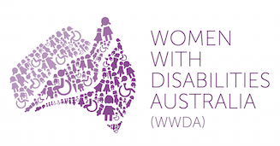 | 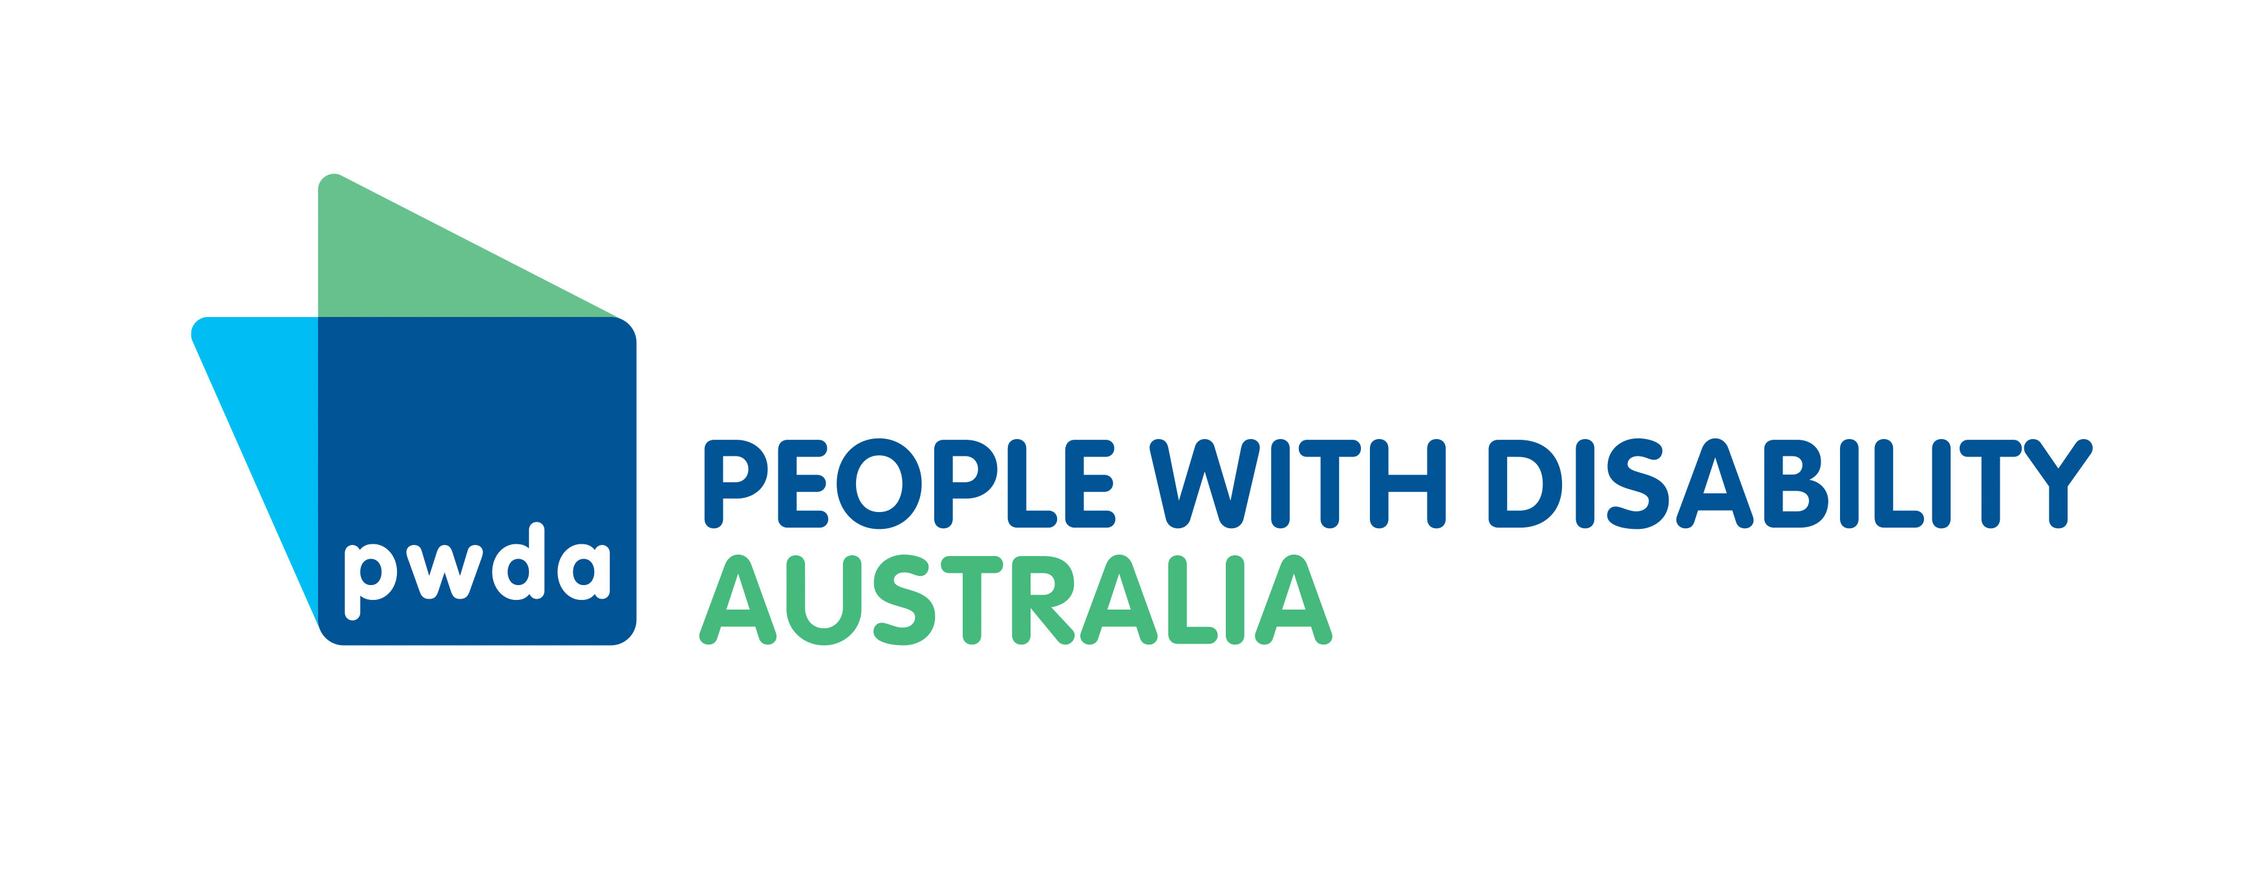

Optional Protocol to the Convention against Torture and other Cruel, Inhuman or Degrading Treatment or Punishment, opened for signature 4 February 2003, 2375 UNTS 237 (entered into force 22 June 2006). Available: http://www.ohchr.org/EN/ProfessionalInterest/Pages/OPCAT.aspx
See e.g., Disabled People’s Organisation’s Australia 2017. Submission to the Committee on the Rights of Persons with Disabilities List of issues [Australia] to be adopted during the 18th Session of the Committee on the Rights of Persons with Disabilities. Prepared by Women with Disabilities Australia (WWDA) on behalf of DPO Australia. Sydney: Disabled People’s Organisations Australia (DPO Australia). Available: http://dpoa.org.au/sub-list-issues-18th-session-crpd/; Frohmader, C. and Sands, T. 2015 Submission to the Senate Inquiry into Violence, abuse and neglect against people with disability in institutional and residential settings. Australian Cross Disability Alliance (ACDA) Sydney, Australia. Available: http://pwd.org.au/documents/Submissions/ACDASubSenInquiryViolenceInstitutions.doc; PWDA, 2014. ‘Consideration of the 4th and 5th Reports of Australia by the Committee to the Convention Against Torture’, People with Disability Australia; Baldry, E. 2014. Disability at the Margins: Limits of the Law. Griffith Law Review, Vol. 23, No. 3, 370-388; Bevan, N. and Sands, T. 2016. Submission to the Senate Inquiry into Indefinite Detention of People with Cognitive and Psychiatric Impairment in Australia, Australian Cross Disability Alliance; Sydney, Australia. Available: http://dpoa.org.au/wp-content/uploads/2016/04/ACDA_IndefiniteDetention_Submission_April2016.pdf ;
The issues in this Position Paper are more comprehensively addressed in the following research report: Lea, M., F. Beaupert, N. Bevan, D. Celermajer, P. Gooding, R. Minty, E. Phillips, C. Spivakovsky, L. Steele, D. J. Wadiwel and P. J. Weller. 2018. ‘A disability aware approach to torture prevention? Australian OPCAT ratification and improved protections for people with disability’, Australian Journal of Human Rights, https://www.tandfonline.com/doi/full/10.1080/1323238X.2018.1441611
Convention Against Torture and Other Cruel, Inhuman or Degrading Treatment or Punishment, opened for signature 10 December 1984, UNTS 1465, (entered into forced 26 June 1987) Available: http://www.ohchr.org/EN/ProfessionalInterest/Pages/CAT.aspx
Australian Human Rights Commission, 2017. Australia ratifies major anti-torture treaty OPCAT, Australian Human Rights Commission, Friday 15 December 2017. Available: https://www.humanrights.gov.au/news/media-releases/australia-ratifies-major-anti-torture-treaty-opcat
Convention on the Rights of Persons with Disabilities, open for signature 30 March 2007, 999 UNTS 3 (entered into forced 3 May 2008). Available: http://www.ohchr.org/EN/HRBodies/CRPD/Pages/ConventionRightsPersonsWithDisabilities.aspx
Baldry, E. 2014 op cit., PWDA, 2014 op cit.
See Frawley, P. and Naylor, B. ‘Human Rights and People with Disabilities in Closed Environments.’ Law in Context, Vol. 31, 2014: 48-83.
See e.g., Green J.P. and Eagar, K. ‘The health of people in Australian immigration detention centres.’ Medical Journal of Australia. 2010; 192 (2): 65-70.
PWDA, 2014 op cit., Bevan, N. and Sands, T. 2016 op cit., Baldry, E. 2014 op cit.
See Committee on the Rights of Persons with Disabilities, Guidelines on article 14 of the Convention on the Rights of Persons with Disabilities, The right to liberty and security of persons with disabilities, Adopted during the Committee’s 14th session, held in September 2015, paras 6-7, available: http://www.ohchr.org/_layouts/15/WopiFrame.aspx?sourcedoc=/Documents/HRBodies/CRPD/GC/GuidelinesArticle14.doc&action=default&DefaultItemOpen=1
Senate Community Affairs References Committee. 2015. Violence, abuse and neglect against people with disability in institutional and residential settings, including the gender and age related dimensions, and the particular situation of Aboriginal and Torres Strait Islander people with disability, and culturally and linguistically diverse people with disability. Canberra, Australian Capital Territory: Commonwealth of Australia.
Bevan, N. and Sands, T. 2016 op cit.
Mendez, J. E. 2013. A/HRC/22/53 para 63, available: http://www.ohchr.org/Documents/HRBodies/HRCouncil/RegularSession/Session22/A.HRC.22.53_English.pdf

