13 March 2018

Senate Standing Committee on Rural and Regional Affairs and Transport
PO Box 6100
Parliament House
Canberra ACT 2600
Email: rrat.sen@aph.gov.au

Dear Senate Standing Committee:
Re: The need for regulation of mobility scooters, also known as motorised wheelchairs
Disabled People’s Organisations Australia (DPO Australia) welcomes the opportunity to briefly provide key views to the Senate Standing Committee inquiry into the need for regulation of mobility scooters, also known as motorised wheelchairs. We also note our endorsement of more comprehensive submissions to this inquiry made by State based colleague DPOs, Queenslanders with Disability Network (QDN) and People with Disabilities Western Australia (PWDWA).

DPO Australia is an alliance of national disabled people’s organisations (DPOs), which are organisations constituted and governed by people with disability. Our key purpose is to promote, protect and advance the human rights and freedoms of people with disability. DPO Australia is made up of First Peoples Disability Network Australia (FPDN); Women With Disabilities Australia (WWDA); National Ethnic Disability Alliance (NEDA) and People with Disability Australia (PWDA).

DPO Australia makes this brief submission to express our concern about any proposals that would seek to regulate, and thereby significantly limit or restrict the mobility, freedom of movement, and independence of people with disability.

Mobility scooters and powered wheelchairs provide the means for many people with disability to access and participate fully in our communities on an equal basis with others. They are critical to enable social and economic participation, providing the mobility support they require to go about their lives and mobilise within their communities. Mobility scooters and powered wheelchairs are the primary way in which many people with disability independently navigate around inaccessible public transport systems, inaccessible infrastructure, and other barriers such as inaccessible footpaths and roads.

The right to liberty of movement is enshrined in the Convention on the Rights of Persons with Disabilities (CRPD) to which Australia is a party. The Council of Australia Governments (COAG) have committed to CRPD implementation through the National Disability Strategy 2010-2020. The right to liberty of movement is essential to achieving many other CRPD rights, such as the right to work, the right to education and the right to health, and underpins the full inclusion of people with disability in our society. DPO Australia opposes any regulatory measures that would breach our human rights, and in effect work against COAG commitments to implement the CRPD.

We also note that the Disability Discrimination Act 1992 prohibits disability discrimination in particular areas of life, and proposals for speed restrictions or separate access arrangements are highly likely to be discriminatory and unlawful.

Several aspects of the proposed regulations are specifically concerning, and we fail to understand how they cannot be viewed as limiting the personal mobility and independence of people with disability. For example, proposed blanket regulations that will impose weight restrictions and speed limits on mobility scooters and power wheelchairs fail to take into consideration the varying mobility or functional needs of people with disability, as well as the diversity of body shape and/or body size of people with disability.

DPO Australia recommends that the Senate Standing Committee does not recommend a regulatory framework that impacts on the rights of people with disability. We strongly recommend that there be a process where Governments work closely with people with disability and their representative organisations, and the Australian Human Rights Commission (AHRC) to analyse current State based regulatory requirements and other national guidelines (such as the AHRC Advisory Note on this issue) to ensure any regulatory framework supports mobility independence and the human rights of people with disability.

In addition to endorsing the submissions made by QDN and PWDWA, we note and acknowledge the incredible value of the many submissions provided by individuals with disability who have formally shared their experiences and concerns relating to this inquiry.

DPO Australia thanks the Committee for the opportunity to contribute to this Inquiry, and we would welcome further consultation on any of the matters we have raised.

Yours sincerely
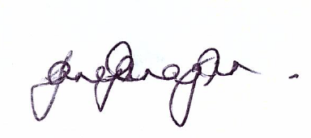
Jane Flanagan
National Ethnic Disability Alliance (NEDA)
(on behalf of DPO Australia)

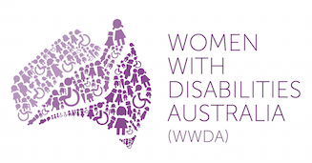 | 