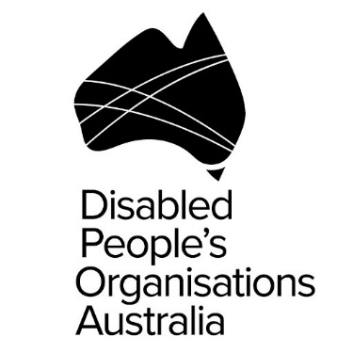
Ngila Bevan
Christopher Brophy
Disabled People’s Organisations (DPO) Australia
Formal Briefing of Committee (Australia)
16th October
People with Disability; Prison Conditions
Thank you for the opportunity to speak to the status of people with disability and prison conditions, in Australia.
The NGO Coalition report provides clear evidence that the rights of people with disability in Australia continue to be violated.
- People with disability experience extraordinary levels of violence and abuse across a range of private and public settings. Such violence often goes unnoticed, undocumented and unaddressed.
- Many people with disability are denied the presumption and exercise of legal capacity, and full equality before the law.
- Substitute decision making regimes continue to deny people with disability the right to make free, informed and independent decisions about their own lives and bodies.
- Migration laws continue to disproportionately exclude people with disability from living and working in Australia.
- Restrictive practices continue to be used in schools; health facilities; supported environments; prisons; and in the community.
- Inadequate mental health legislation fails to prevent, and in some cases, condones, forced neurological treatments, including electroconvulsive therapy.
- The forced sterilisation of people with disability remains an ongoing and legally-sanctioned practice in Australia. This particularly affects women and girls with disability, and people with intersex variations.
With regard to prison conditions,
- People with disability remain overrepresented among the prison population, often languishing in poorly managed facilities without adequate support.
- People with intellectual, cognitive or psychosocial disabilities are often detained indefinitely and without criminal conviction.
- Overcrowding is contributing to deteriorating prison conditions, including the escalation of violence and self-harm.
- Solitary confinement and unnecessary strip searches against female inmates remain unregulated, with little to no government oversight.
A 2015 Australian Senate Inquiry found that violence against people with disability in institutional and residential settings is a national epidemic, with people with disability experiencing sustained and repeated episodes of violence in such settings.
Women and girls with disability are at greater risk of violence, particularly sexual violence, and experience significantly higher levels of all forms of violence by a greater number of perpetrators compared to their peers.
Children and young people with disability experience violence and abuse at approximately three times the rate of children without disability.
The 2015 inquiry recommended a Royal Commission into violence, abuse and neglect of people with disability. This recommendation was echoed by the Committee on Economic, Social and Cultural Rights at Australia’s review, earlier this year.
To date, however, the Australian Government has ruled out a Royal Commission on the basis that the National Disability Insurance Scheme will offer protection to people with disability. This is contrary to the facts that,
- The National Disability Insurance Scheme’s Quality and Safety Framework will only apply to the 10 percent of people with disability who are eligible to access the scheme.
- The framework will not address the many forms of violence that people with disability experience, nor the range of settings in which violence occurs.
- Further, the framework will not hold people and systems to account for past violence and injustice.
We encourage the committee to prioritise the rights and concerns of people with disability in your considerations. In particular, we strongly urge the committee to recommend that the Australian Government establish a Royal Commission into all forms of violence against people with disability.
We look forward to further discussion with you on these matters.

