15 September 2017

Senate Standing Committees on Economics
PO Box 6100
Parliament House
Canberra ACT 2600
Email: economics.sen@aph.gov.au
Dear Economics Legislation Committee,
Re: Medicare Levy Amendment (National Disability Insurance Scheme Funding) Bill 2017 and 10 related bills [provisions]
Disabled People’s Organisations Australia (DPO Australia) welcomes the opportunity to provide our views to the Economics Legislation Committee’s inquiry into the Medicare Levy Amendment (National Disability Insurance Scheme Funding) Bill 2017 (the Bill) and 10 related bills [provisions].

DPO Australia is an alliance of national disabled people’s organisations (DPOs), which are organisations constituted and governed by people with disability. Our key purpose is to promote, protect and advance the human rights and freedoms of people with disability. DPO Australia is made up of First Peoples Disability Network Australia (FPDN); Women With Disabilities Australia (WWDA); National Ethnic Disability Alliance (NEDA) and People with Disability Australia (PWDA). DPO Australia is funded by the Australian Government as the coordinating point between Government/s and other stakeholders, for consultation and engagement with people with disability.

The NDIS is one of the most significant social reforms ever undertaken in Australia.
The NDIS is a long overdue investment in people with disability and their families that will enable more people to move into work, create jobs in the disability support sector, and provide further impetus for mainstream services to become accessible to people with disability. Implementation of the NDIS will bring an increase to gross domestic product (GDP) and the economic benefits of having more Australians able to participate in the community.

The NDIS is not a disability welfare program, but a universal, national insurance scheme. In ensuring that people with disability finally get the support they need, the NDIS is an essential part of Australia’s social infrastructure. The NDIS recognises that any Australian may have disability at some point in their life that will require individualised care, supports and services in order to maximise participation in employment and all aspects of community life. The risk of disability support costs is taken from the individual and pooled across all Australians. As an essential and universal scheme, the NDIS should be available to, and paid for by everyone.

The NDIS rightly has bipartisan political support and the widespread backing of the Australian community. DPO Australia, along with many other organisations agrees that it is essential that the NDIS is properly, adequately and sustainably funded.

Member organisations of DPO Australia advocated for and supported the 0.5% increase to the Medicare Levy introduced by the Labor Government in 2013. Since this time we have consistently argued that a fully funded NDIS cannot be linked to cuts to human services and welfare, and that it must be removed from the budget cycle and political debate.

Although these links have been a feature of recent budget cycles and political commentary, we welcomed the shift away from this approach by the Coalition Government through its’ 2017/2018 budget measure to increase the Medicare Levy by 0.5% from July 2019 to guarantee sustainable funding for the NDIS. We also supported the introduction of the Bill into Parliament by the Treasurer, the Hon. Scott Morrison MP.

DPO Australia supports the role of the Medicare Levy in funding the NDIS. The Medicare Levy is a permanent element of our tax system, where everyone contributes to the cost of essential universal services according to their ability to pay. The Medicare Levy increases the revenue base into the future and provides a high level of certainty that essential, universal services are available when they are needed.

While we welcome that both major parties have proposed options to increase the Medicare Levy for the purpose of funding the NDIS, they have not agreed on how this should be done. We also note that there is broad cross-party support for sustainable funding for the NDIS, although in the context of the Bill, different measures are being put forward to achieve this. In June 2017, DPO Australia joined with the Australian Federation of Disability Organisations (AFDO) and the Australian Council of Social Services (ACOSS) to urge Parliament to quickly resolve the issue of sustainable funding of the NDIS. Ongoing debate and negotiation is of great concern as it risks sustainable funding for the NDIS becoming an election issue, with the NDIS constantly part of political debate and commentary and with community support for the NDIS being eroded.

We acknowledge the merit of the principles and proposals put forward by ACOSS in its submission to this inquiry. These principles and proposals aim to strengthen the structure of the Medicare Levy to raise revenue over the long term, and in particular, we note that they aim to strengthen a progressive, more equitable tax system that lessens the impact on low income earners and restricts tax avoidance by those who have the means to contribute a higher share. We encourage the Committee to consider the ACOSS principles and proposals in the context of this inquiry.

The process for finalising secure, sustainable and sufficient funding for the NDIS can not be delayed any further. People with disability need certainty so that the focus can be on ensuring that the NDIS delivers on its objectives.

DPO Australia thanks the Committee for the opportunity to contribute to this Inquiry, and for providing us with an extension to do so. We would welcome further consultation on any of the matters we have raised.
Yours sincerely
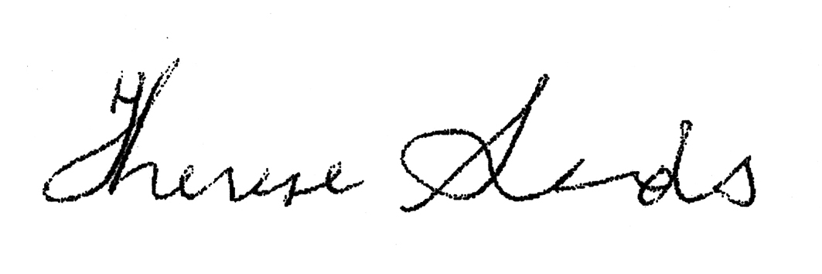
THERESE SANDS
Director

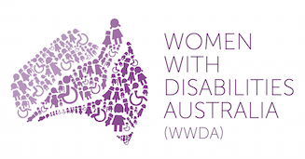 | 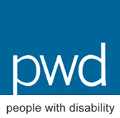

Productivity Commission, ‘National Disability Insurance Scheme (NDIS) Costs – Position Paper’, June 2017, Commonwealth of Australia 2017, p. 69.
Ibid, Box 1, p.4.
We note our ongoing concern that people with disability over the age of 65 years are not eligible for the NDIS.
Disabled People’s Organisations Australia, ‘Submission to the Department of Treasury: Priorities for the 2017/2018 Federal Budget’, January 2017, DPO Australia, p. 7; People with Disability Australia, ‘Delivering Disability Care’, 2013.
Emma Griffiths, ‘Gillard proposes Medicare levy hike to fund NDIS’, 2 May 2013, ABC News, http://www.abc.net.au/news/2013-05-01/medicare-levy-increased-to-fund-ndis/4661660
Disabled People’s Organisations Australia, op. cit., p. 7; Disabled People’s Organisations Australia, ‘Media Release: Don’t fund the NDIS with cuts to social services and childcare’, 13 February 2017, http://dpoa.org.au/dont-fund-ndis-cuts-social-services-childcare/
Disabled People’s Organisations Australia, ‘Media Release: Great NDIS and Job Support Wins, But Harsh Welfare Measures for People with Disability’, 10 May 2017, http://dpoa.org.au/media-release-great-ndis-job-support-wins-harsh-welfare-measures-people-disability/
Disabled People’s Organisations Australia, Australian Federation of Disability Organisations, Australian Council of Social Services, ‘Media Release: We Call on this Parliament to Deliver Secure, Sustainable and Sufficient Funding for the National Disability Insurance Scheme’, 23 June 2017, http://dpoa.org.au/joint-statement-to-secure-ndis-funding/
ACOSS, ‘Strengthening and reforming the Medicare Levy: Submission to the Senate Economics Committee’, 7 September 2017, Submission 8.

