7 March 2017

Committee Secretariat
Senate Standing Committees on Community Affairs
PO Box 6100
Parliament House
Canberra ACT 2600
Email: community.affairs.sen@aph.gov.au

Dear Committee:

Inquiry into the Social Services legislation Amendment (Omnibus Savings and Child Care Reform) Bill 2017

Disabled People’s Organisations Australia (DPO Australia) welcomes the opportunity to provide our views on the Budget Savings (Omnibus) Bill 2016 (the Omnibus Bill 2017).

DPO Australia is an alliance of national disabled people’s organisations (DPOs), which are organisations constituted and governed by people with disability. Our key purpose is to promote, protect and advance the human rights and freedoms of people with disability by working collaboratively on areas of shared interests, purposes and strategic priorities and opportunities. DPO Australia is made up of First Peoples Disability Network Australia (FPDN); Women With Disabilities Australia (WWDA); National Ethnic Disability Alliance (NEDA); and People with Disability Australia (PWDA).

DPO Australia opposes the Social Services Legislation Amendment (Omnibus Savings and Child Care Reform) Bill 2017 and recommends that it be rejected by the Parliament.

We note with concern that this Bill contains a range of budget savings measures that have, since the 2014-2015 federal budget, failed to pass Parliament and that have received widespread criticism for placing the burden of Australia’s debt on those that can least afford it. With 45% of people with disability in Australia living near or below the poverty line, and Australia ranking 26 out of 27 OECD countries for the percentage of people with disability living in poverty, it is reprehensible to continue to put forward measures that only further entrench poverty and disadvantage for people with disability.
We also object to the Federal Government tying the cuts to social services contained in this Bill to securing funding for the National Disability Insurance Scheme (NDIS). Justifying cuts and savings measures that target essential human services, welfare and income support only creates trade-offs and false economies between disability support (NDIS) and social security support, and the expectation that the most disadvantaged must pay for the long overdue critical investment in people with disability through the NDIS. This is highly likely to create resentment from those affected by social security cuts, many of whom are already struggling to survive, towards people with disability and the NDIS itself.

DPO Australia and its member organisations have consistently stated and restated our objections to the budget savings measures contained in this Bill in previous Senate Committee Inquiries as well as in our pre-budget submission. This submission extracts and adds to relevant information from these previous submissions with a focus on five key provisions that we strongly oppose:
- Schedule 5 – Proportional payment of pensions outside Australia
- Schedule 6 – Pensioner education supplement
- Schedule 7 – Education entry payment
- Schedule 8 – Indexation
- Schedule 9 – Closing energy supplement to new welfare recipients

In relation to other measures in this Bill, we support the submission made by the Australian Council of Social Services (ACOSS).

Schedule 5 – Proportional payment of pensions outside Australia
The capacity for people on the Disability Support Pension (DSP) to travel overseas without having their payments stopped has considerably diminished over recent years. This Bill now proposes further reduction in the amount of time a person on DSP can travel overseas before their rate of pay is reduced. Whilst extensions, exception or unlimited portability may still apply under special circumstances, such as terminal illness or permanent and severe disability with no future work capacity, the process for application of these exceptions has in the past been confusing.

The impact of reduced portability measures fall disproportionately upon those people who have family living overseas, particularly migrant and refugee families. The restrictions in this Bill to only six weeks travel out of every year will mean that people with disability have one opportunity to visit their loved ones. This is unreasonably restrictive for those who call Australia home, but want to maintain strong ties with their family and birth country. For many people with disability, travelling overseas is not straight forward, requires considerable planning and extra travel time to address barriers to access, and make require additional time to recuperate from travel. A restriction of six weeks will make travel unnecessarily burdensome and disadvantage many people with disability.

Schedules 6 and 7 – Pensioner education supplement and Education Entry Payment
The Pensioner Education Supplement (PES) and the Education Entry Payment (EEP) provide support for people on the DSP and other income support recipients) to cover the costs associated with education and study. Measures to cut these supplements is counter-productive to the Government focus on greater employment opportunities for people with disability, a focus that is central to the second implementation plan for the National Disability Strategy.
Cuts to support for training and education will make it more difficult for people with disability to find suitable jobs
“I am 48 on a DSP (legitimately), I live rurally in the Bega Valley NSW. I have paid taxes at various points, I am not allowed to drive EVER due to my condition; I have work history in telecommunications, ran a medium sized business in the 90s and until 2005 I worked as a chef when I was well; until I could no more. My skills are irrelevant now and together with my health; reskilling to work or run a business (and in my case, maybe possibly with my carer as a partner in it) at home is my only realistic non-pension option. Also, subsisting on a DSP sitting at home with nothing to do does nothing for the mental health of one.

Recently I started a degree through Open Universities Australia (OUA) in Professional Writing and Publishing available through Curtin Uni only. I wanted to become financially self-reliant again (as I have numerous times before). By cutting my PES, I have now had to give that degree up. There is no point wasting time to Jan 1 2015, it'll be pointless as I would have many years left (part-time so much longer) and depending on whether I do 1 or 2 subjects a study period (4 SPs a year), I would have to give up between 4-8 weeks of food a year to afford to do it without the PES. (I have found doing 2 subjects per SP is beyond my capacity at this time).
This also extends to carers in a more significant fashion than many realise. For many on carers payment, programs like OUA are the only option to pursue study whilst fulfilling their role as carers. Pursuing 1 unit a study period at home (through OUA and like) whilst caring or on DSP, not only improve skills but to participate in something outside of the day to day and feel included in the more "normal society" (a ridiculous concept in my opinion)…PES is the ONLY way they and DSP recipients can afford to do this unless they are self-funded.
ALL pensioners of any type that don't have at least $ 2000 a year put aside to spend on books, etc (even with hecs/fee-help), will now have to choose either to study or eat. This is exacerbated even more in rural regions like the Bega Valley and like. I have had to quit my studies until there is a change of government. Without the PES it is simply impossible”.
This is a huge blow to pensioners of all types willing to reskill and pursue any measure self- reliance…
The PES axing is just one of many issues but it has a far more reaching and significant impact than many realise. For the die hard economists, it should be obvious that allowing DSP and other pensions an opportunity "to contribute" makes good economic sense. In the age of the internet people with many types of disabilities and others, can work from home but ONLY if they have skills and opportunities that enable to do so”

The PES provides essential support for people with disability to gain the skills they need to compete in a very tough labour market. In 2015, the Australia Bureau of Statistics reported that labour force participation for people with disability has not changed since 2012, staying at 53%, and that Australians with disability are still more likely to be unemployed than their peers without disability. Women with disability are less likely to be in the labour force compared to men with and without disability and compared to women without disability.

About 18,000 people on DSP access the PES, about 40% of all PES recipients. Women make up three quarters of PES recipients. If PES is stopped, many people on the DSP will have to fund their study costs out of their income support payments, which will mean that enhancing training and skills to move into employment will be prohibitive.

Schedule 8 – Indexation
Indexation of Income free areas should not be frozen. People on income support are already trying to survive on ‘below the poverty line’ payments.

Many people with disability have additional costs associated with disability, and this measure will effectively reduce overall income for people reliant on income support, further restricting social and economic participation and punishing those who are able to find paid employment. It will potentially act as a disincentive to undertake paid work for many people with disability.

Schedule 9 – Closing energy supplement to new welfare recipients
Schedule 9 abolishes the nergy Supplement for all new social security claimants, including those claiming Disability Support Pensions (DSP) and Newstart Allowance.

This measure effectively cuts social security payments for those on the lowest incomes in Australia, at the same time as the Australian Government proposes to retain tax concessions as part of the carbon price compensation which benefit every income earner, including those on the highest incomes.

Those on the lowest incomes, including people with disability will be further pushed into poverty and hardship. Increasing numbers of people with disability are being shifted or diverted from the DSP to Newstart Allowance, which only entrenches poverty; it doesn’t provide jobs.

Removal of the Energy Supplement means a loss of $4.40 per week to the ‘below the poverty line’ $38 per day Newstart Allowance, and this directly contradicts the overwhelming agreement from business, unions and the community sector that Newstart Allowance needs to be increased as its’ low payment rate is now a barrier to economic participation.

DPO Australia would be happy to provide further information regarding our views. We thank you for the opportunity to provide input into this process.

Yours sincerely
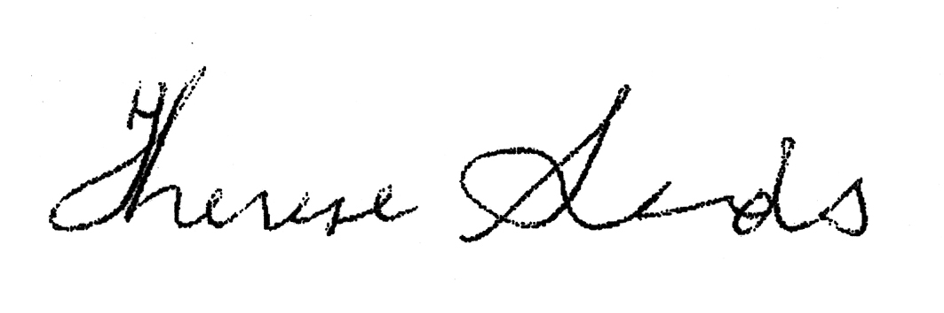

THERESE SANDS
Director

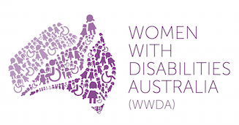 | 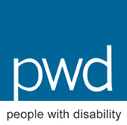

pwc, Disability expectations – Investing in a better life, a stronger Australia, November 2011, pwc, http://www.pwc.com/gx/en/industries/government-public-services/public-sector-research-centre/australia/investing-in-a-better-life-a-stronger-australia.html
‘Don’t fund the NDIS with cuts to social services and childcare’, Media Release, Disabled People’s Organisations Australia, 13 February 2017, http://dpoa.org.au/news/dont-fund-the-ndis-with-cuts-to-social-services-and-childcare/
See e.g., Disabled People’s Organisations Australia, ‘Priorities for the 2017/2018 Federal Budget’, Submission to the Department of Treasury, January 2017; Disabled People’s Organisations Australia, ‘Re: Inquiry into the Budget Savings (Omnibus) Bill 2006’, Submission to the Senate Standing Committees on Economics, 7 September 2016; People with Disability Australia, ‘Social Services Legislation Amendment (Budget Repair) Bill 2016’, Submission to Senate Community Affairs Legislation Committee, September 2016; People with Disability Australia, ‘Social Services and Other Legislation Amendment (2014 Budget Measures No.1) Bill 2014 and Social Services and Other Legislation Amendment (2014 Budget Measures No.2) Bill 2014’. Submission to Senate Community Affairs Legislation Committee, July 2014.
National Welfare Rights Network detail recent changes to portability for income support recipients in their submission to the Senate Community Affairs Committee inquiry into the Social Security and Other Legislation Amendment (2012 Budget and Other Measures) Bill 2012
Ibid
Eligibility information can be found on the Department of Social Services website here http://www.humanservices.gov.au/customer/enablers/centrelink/pensioner-education-supplement/eligibility
Council of Australian Governments, National Disability Strategy 2010-2020 Second Implementation Plan, Commonwealth of Australia, https://www.dss.gov.au/our-responsibilities/disability-and-carers/program-services/government-international/national-disability-strategy#2nd
National Welfare Rights Network Media Release 29.5.14 found here https://www.welfarerights.org.au/news/2014/5/29/media-release-29-may-2014-budget-cuts-hit-carers-people-with-disabilities-and-single
Australian Bureau of Statistics, Disability, Ageing and Carers, Australia: First Results, 2015, http://www.abs. gov.au/AUSSTATS/abs@.nsf/Lookup/4430.0.10.001Main+Features12015?OpenDocument
Department of Social Services, Progress Report to the Council of Australian Governments 2014, p. 55
Department of Social Security briefing attended by PWDA in June 2014
Senate Community Affairs Committee (2014) ‘Answers to Questions on Notice’, 2013-14 Additional Estimates Hearings, Question No. 655.
Ibid.
National Welfare Rights Network, ‘Budget 2016: More people with a disability move onto Newstart Allowance, but no action to ensure its adequacy’, Welfare Rights Review, Vol.2 No. 1, https://www.welfarerights.org.au/welfare-rights-review/welfare-rights-review-vol-2-no-1/budget-2016-more-people-with-disability-move
‘Unemployed and pensioners collateral damage in budget fight’, Media Release, 22 August 2016, Australian Council of Social Services, http://www.acoss.org.au/media_release/unemployed-and-pensioners-collateral-damage-in-budget-fight/

