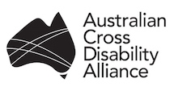 | Australian Cross Disability Alliance (ACDA) Delegates to Attend Conference of States Parties to the Convention on the Rights of Persons with Disabilities  14 to 16 June 2016, New York, USA

A delegation representing the Australian Cross Disability Alliance (ACDA) will attend the 9th Session of the Conference of States Parties (COSP) to the Convention on the Rights of Persons with Disabilities (CRPD). COSP runs from 14th to 16th June 2016 and will be held at the United Nations Headquarters in New York. Significantly, 2016 will mark ten years since the United Nations’ adoption of the CRPD.

The annual conference invites delegates from signatories to the UN CRPD and representatives from civil society organisations and Governments around the world to discuss implementation of the CRPD and related international development issues. The overall theme for the conference is “Implementing the 2030 development agenda for all persons with disabilities: Leaving no one behind”. Thematic discussions and side events will address the four subthemes:

- Eliminating poverty and inequality for all persons with disabilities
- Promoting the rights of persons with mental and intellectual disabilities
- Enhancing accessibility to information and technology and inclusive development
- Celebrating the 10th anniversary of the adoption of the CRPD

About the Australian Cross Disability Alliance (ACDA)

The Australian Cross Disability Alliance (ACDA) is an innovative alliance of four national Disabled Person’s Organisations (DPOs) in Australia. The four DPOs that founded, and comprise the ACDA are: Women With Disabilities Australia (WWDA); National Ethnic Disability Alliance (NEDA); First Peoples Disability Network Australia (FPDNA); and, People with Disability Australia (PWDA). The ACDA is funded by the Australian Government as the national representative structure of and for all people with disability and is the recognised coordinating point between Government/s and other stakeholders, for consultation, engagement with, and advice regarding people with disability in Australia.

Delegation Activities

The ACDA delegation will undertake significant work at COSP CRPD, including hosting and co-hosting side events; attending and participating in pre-arranged high-level meetings; speaking at a range of side events being hosted and co-hosted by Governments, international organisations and civil society; as well as networking and stakeholder engagement. Critically, young people with disability on the ACDA delegation will be involved in the UNFPA launch event of the ‘WE DECIDE’ Global Program on Youth with Disability, which the ACDA, in conjunction with young Australians with disability, helped to establish and develop. Women With Disabilities Australia (WWDA) has been invited by UNFPA to officially co-host the formal UNFPA Launch Event. The COSP events which the ACDA has formal involvement in at this stage, include:

- Side event: ‘Article 32: a multi-county discussion on its impact on bilateral development aid’ - Council of Canadians with Disabilities, Disability Rights Fund, ACDA (People with Disability Australia)
- Side event: ‘Global Launch of WE DECIDE Programme to support Young Persons with Disabilities for Equal Rights and a Life Free of Violence’ – UNFPA, ACDA (Women With Disabilities Australia)
- Side event: ‘The indefinite detention of people with disability in Australia’ - ACDA (First Peoples Disability Network Australia, People with Disability Australia)
- Workshop: ‘Workshop on the Measurement of Disability’ – Washington Group on Disability Statistics, UNICEF, International Disability Alliance

Australian Cross Disability Alliance (ACDA) Delegation

The ACDA will be represented at COSP CRPD by ten delegates. The delegation represents a diverse cross-section of people with disability and representation from the four founding ACDA organisations. Consistent with the thematic focus of COSP this year, the delegation includes strong representation of Aboriginal persons with disability; women with disability; young people with disability, people with specific lived experience and knowledge relating to accessibility of information and technology; and people with significant expertise in the 2030 development agenda. Critically, the ACDA delegation models people with disability as the key interlocutors in the implementation and monitoring of the CRPD. The ACDA thanks the Australian Human Rights Commission for providing financial assistance for ACDA delegates to attend COSP CRPD.

The ACDA delegation is listed below in alphabetical order:

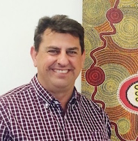 | Scott Avery  Scott is the Policy and Research Director at First Peoples Disability Network (Australia). He has an extensive career in public policy in Aboriginal and Torres Strait Islander affairs, health, disability, justice and education.
Cashelle Dunn
Cashelle is completing a degree in Human Rights at Monash University, and is working part time as Manager of the Women With Disabilities Australia (WWDA) Youth Network, which she sees as a critical mechanism to enable girls and young women with disability to participate fully in economic, social and political development, and to experience full and effective enjoyment of their human rights.

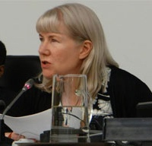 | Samantha French  Samantha has worked in the disability field for over twenty-five years in Government and non-Government sectors in disability policy, education and advocacy work at the national, regional and international levels. Sam is currently employed as Advocacy Manager for People with Disability Australia (PWDA).
Damian Griffis
Damian is a descendant of the Worimi people of the Biripi nation. Damian is the CEO of the First Peoples Disability Network (Australia) - the national DPO representing Aboriginal people with disabilities and their families.
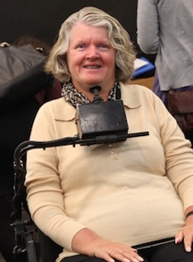 | Rosemary Kayess  Rosemary is a human rights lawyer, and Director of the Human Rights and Disability Project, of the Australian Human Rights Centre at the Faculty of Law, University of New South Wales in Sydney, where she teaches international human rights law. Rosemary has participated on and led delegations to many UN meetings and events, and provides advice on disability issues to UN agencies and special mechanisms.
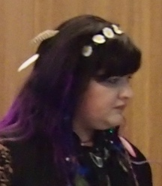 | Suzy Kemp  Suzy Kemp is a young Aboriginal woman with disability of the Wiradjuri people. Suzy is building her capacity and skills to promote and advance the human rights of young women with disability, particularly young Aboriginal women with disability. She is a member of Women With Disabilities Australia (WWDA).
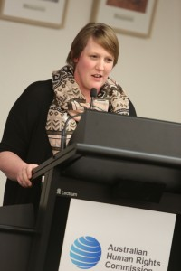 | Bonnie Millen  Bonnie is a young woman with disability who lives in Adelaide. Bonne is active within the DPO movement, and is a current Board member of Women With Disabilities Australia (WWDA) and People With Disability Australia (PWDA).
Brendan Pearce
Brendan is a 22-year-old disabled man who lives in rural and regional Australia. He is currently the Chair of the Australian Hearing Paediatric Program Advisory Committee, and has just completed a Bachelor of Media at Southern Cross University, where he majored in Journalism, and Policy & Governance. Brendan is a member of People with Disability Australia (PWDA).
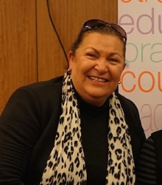 | June Reimer  June is a Dunghetti–Yuan woman but lived most of early years in the NSW Central West. Most recently, she has lived in Sutherland Shire – Dharawal country. June Reimer is currently the CEO of the Aboriginal Disability Network NSW (ADNNSW).
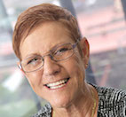 | Kay Sadler  Kay is a Worimi woman of the Biripi nation born on the Pacific Highway, ten kilometres south of Taree. Kay is currently the Vice Chair of the First Peoples Disability Network Australia (FPDNA).

Keep Up to Date with COSP CRPD Activities

During the COSP CRPD the ACDA delegation will regularly report back to the ACDA DPO member organisations, the disability sector, and other stakeholders while at COSP, including through update posts on social media including Facebook, Twitter, Instagram, and through the ACDA and its member organisations’ websites and newsletters.

Post-Event Report

A comprehensive post-event report will be produced and disseminated worldwide by the ACDA. Post-event follow up will include specific and dedicated work to identify mechanisms and processes for domestic and international implementation of any recommendations and outcomes stemming from the 9th Session of the COSP CRPD. The ACDA will also liaise with the Australian Government delegation to COSP to investigate the feasibility of hosting a joint post-event forum.

For further information:

United Nations COSP CRPD
https://www.un.org/development/desa/disabilities/conference-of-states-parties-to-the-convention-on-the-rights-of-persons-with-disabilities-2/9thsession.html

Australian Cross Disability Alliance
http://crossdisabilityalliance.org.au/

ACDA member organisations’ social media accounts and websites
http://crossdisabilityalliance.org.au/about/

http://www.twitter.com/DisAllianceAUS

