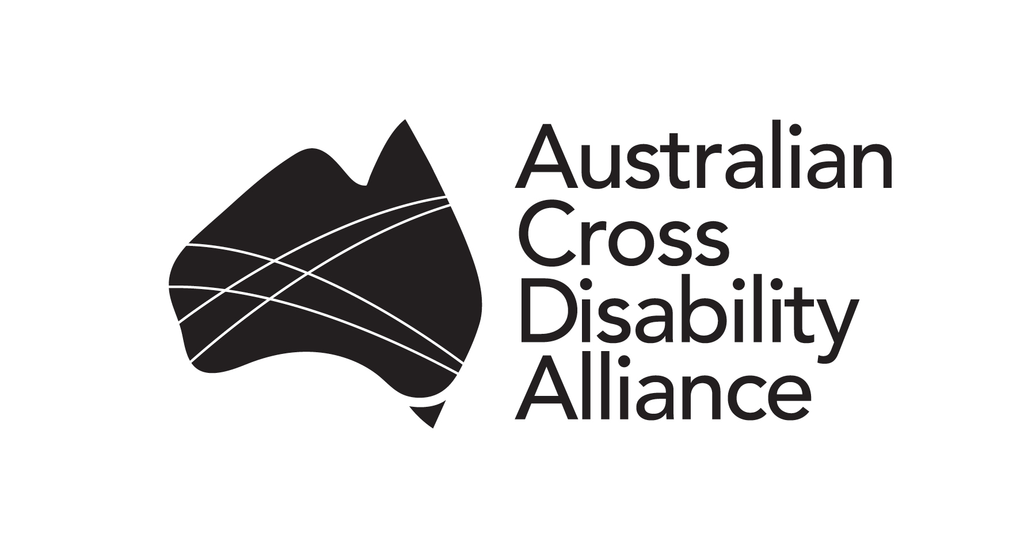

Submission

Department of Communications and the Arts
Communications Accessibility: 2016 and Beyond

May 2016

Contact:
Ngila Bevan
Human Rights Advisor
Manager, Advocacy Projects and Communications
People with Disability Australia (PWDA)
E: ngilab@pwd.org.au
Ph: 02 9370 3100

The Australian Cross Disability Alliance
The Australian Cross Disability Alliance (ACDA) is an alliance of national Disabled People’s Organisations (DPOs) in Australia. The key purpose of the ACDA is to promote, protect and advance the human rights and freedoms of people with disability in Australia by working collaboratively on areas of shared interests, purposes and strategic priorities and opportunities. The ACDA was founded by, and is made up of four national cross-disability DPOs that have been funded by the Australian Government to be the recognised coordinating point between Government/s and other stakeholders, for consultation and engagement with people with disability in Australia. In forming the ACDA, its four founding member organisations recognise and value the strength of working together in a spirit of mutual respect and trust, to proactively pursue human rights outcomes for all people with disability in Australia. The four ACDA members are:
Women With Disabilities Australia (WWDA) is the national cross-disability DPO for women and girls with all types of disabilities in Australia. It operates as a transnational human rights organisation and is run by women with disabilities, for women with disabilities. WWDA’s work is grounded in a human rights based framework which links gender and disability issues to a full range of civil, political, economic, social and cultural rights.
First Peoples Disability Network Australia (FPDNA) is the national cross-disability DPO representing Aboriginal and Torres Strait Islander people with disability and their families. FPDNA utilises a range of strategies in its representative role, including through the provision of high-level advice to governments, and educating the government and non-government sectors about how to meet the unmet needs of Aboriginal and Torres Strait Islander people with disability.
People with Disability Australia (PWDA) is the national cross disability rights and advocacy organisation run by and for people with disability. Working within a human rights framework, PWDA represents the interests of people with all kinds of disability. Its primary membership is made up of people with disability and organisations primarily constituted by people with disability. It also has a large associate membership of other individuals and organisations committed to the disability rights movement.
National Ethnic Disability Alliance (NEDA) is the national peak organisation representing the rights and interests of people from Culturally and Linguistically Diverse (CALD/NESB) people with disability, their families and carers throughout Australia. NEDA advocates at the federal level so that CALD/NESB people with disability can participate fully in all aspects of social, economic, political and cultural life.
The key objectives of the ACDA are to:
- work to advance the rights of all people with disability from all walks of Australian life, in relevant policy frameworks, strategies, partnership agreements and any other relevant initiatives;
- promote and engender a collaborative, co-operative and respectful relationship with all levels of Government in the efforts of the ACDA to advance the human rights of people with disability;
- build on and further develop networks, strategic alliances and partnerships at state/territory, national and international levels to advance human rights of people with disability;
- promote the ACDA at national and international levels as the coordinating point for engagement with the Australian DPO sector; and build respect for, appreciation of, and faith in the DPO sector in Australia.

Introduction
The Australian Cross Disability Alliance welcomes the opportunity to respond the Department of Communications and the Arts consultation ‘’Communications Accessibility: 2016 and Beyond’’, specifically regarding the future of the National Relay Service (NRS). People with disability have a right to equal access to communication. The extent to which people with disability have equal access to communication impacts upon the fulfillment of other rights such as equal access to goods and services for example.
People who are Deaf, hard of hearing or who have a hearing or speech impairment must have equal access to communication devices as people without disability. This is articulated in the UN Convention on the Rights of Persons with Disabilities (CRPD) Article 9 (accessibility), Article 21 (freedom of expression) Article 4 (general obligations) and Article 2 (definitions).
There are two consequences of this: firstly that communication goods and services should be universally designed so that they meet the needs of people with disability; secondly that when specialist communication goods or services are required these must be provided in a way which provides equal access to people with disability.
We have a number of concerns about proposals for the future of the NRS as outlined in the options paper which would be retrograde steps in achieving substantive equality for people who are Deaf, hard of hearing or who have a hearing or speech impairment.

Human Rights, Accessibility & Universal Design
Article 4(1)(f) of the CRPD imposes a general obligation on parties to undertake or promote research and development of universally designed goods, services, equipment and facilities, and to promote their availability and use. It also requires parties to promote universal design in the development of standards and guidelines. Article 2 defines ‘universal design’ to mean the design of products, environments, programmes and services to be usable by all people, to the greatest extent possible, without the need for adaptation or specialised design.
Universal design is based upon seven principles:
- Principle 1: Equitable Use
The design is useful and marketable to people with diverse abilities
- Principle 2: Flexibility in Use
The design accommodates a wide range of individual preferences and abilities
- Principle 3: Simple and intuitive
Use of the design is easy to understand, regardless of the user’s experience, knowledge, language skills, or current concentration level
- Principle 4: Perceptible information
The design communicates necessary information effectively to the user regardless of ambient conditions or the user’s sensory abilities
- Principle 5: Tolerance for error
The design minimises hazards and the adverse consequences of accidental or unintended actions
- Principle 6: Low physical effort
The design can be used efficiently and comfortably and with a minimum of fatigue
- Principle 7: size and space for approach and use
Appropriate size and space is provided for approach, reach, manipulation and use regardless of user’s body size, posture or mobility
The terms of Article 4 of the CRPD as they relate to universal design, are reinforced by Article 9. Article 9 imposes general obligations on parties to ensure that persons with disability are able to access all aspects of the physical and social environment on an equal basis with others. This includes a specific responsibility to promote access to communication technologies. To implement this obligation, parties are required to pursue a range of measures, including the following measures which have direct relevance to the telecommunication sector and the NRS:

- Develop and adopt minimum standards and guidelines for the accessibility of all public services and facilities, and monitor their implementation;
- Ensure that non-State actors that provide services and facilities for the public also take account of the accessibility requirements of persons with disability;
- Provide training for all stakeholders on accessibility issues facing persons with disability;
- Provide signage in Braille and easy to read and understand forms in all public buildings and facilities;
- Provide forms of live assistance and intermediaries to facilitate accessibility to public buildings and facilities;
- Provide any other form of assistance or support to persons with disability to ensure their access to information; and
- Promote access for persons with disability to new information and communication technologies and systems, including the Internet.

Article 4, in relation to universal design, and Article 9 need to be interpreted and applied together. Universal design is a principal means by which parties can meet their obligations under Article 9, particularly with respect to the development of guidelines and standards for accessibility. However, it is equally important to appreciate that Article 9 also requires a range of specific, positive measures to ensure accessibility and that these go beyond the scope of the principle of universal design.

The availability of accessible and affordable communication technologies must not be overestimated
Universal design has obvious relevance to communication devices and methods all types, but it is important to appreciate that it is a general principle, with applicability across many contexts. For example, Principles 1, 3 and 4 have particular relevance to the design of communication technology such as phones, mobile and smart phones, tablets and computers.

Communication devices ought to be produced in a way that makes them readily accessible to persons of diverse abilities; they ought to be easy to understand regardless of the person’s existing level of knowledge and skills, their language skills, and their level of concentration; and, they ought to communicate necessary information to the user regardless of the user’s sensory abilities. In other words, mainstream communication devices and mechanisms ought to be available in formats that can be readily used by a person with disability. We agree that smart phones, tablet and laptop technology has positively impacted on the accessibility of communication for many people who are Deaf, hard of hearing or who have a hearing or speech impairment.

However, the availability of this technology does not reduce the obligation of government to ensure that people with disability have equal access to communication technology. We advocate that the government should be doing more to educate people with disability about the availability of mainstream communication devices and how to use them; promote the development and use of accessible technologies by mainstream providers; and ensure that there is no additional cost for people with disability to access these technologies.

For example, the increasing use of mobile technology such as smart phones by people with disability must not be viewed as a cost saving measure by government. It cannot be assumed that all people with disability have access to the internet or smart phones, or that these are affordable options to facilitate communication. Barriers to education and employment, as well as the cost of disability itself, such as the purchase of aids and equipment, mean that for many people internet access and mobile phone subscriptions are unaffordable. For people who are Deaf, hard of hearing or who have a hearing or speech impairment, the call time component of mobile phone plans is largely irrelevant, the data plan may be of greater importance yet the customer with disability must pay for both.

Putting the onus onto the consumer with disability to create sufficient demand to force the market to provide accessible communication products at an equitable price would be an unacceptable cost shifting measure by government. Sustainability concerns would not justify a move towards compelling people with disability to use mainstream services which cost them more than the cost of a NRS call. Until the point where mainstream communication technologies are equally available, accessible and affordable for people with disability on an equal basis with others the government has an obligation to continue to provide services that fill the equity gap. When the telecommunications industry and generic services meet the needs of most persons, there will be substantially less need to develop and fund specialist or parallel systems such as the NRS to compensate for the inaccessibility of the mainstream system. There will also be substantially less need to make specific adjustments to enable individuals to utilise the mainstream system. However, we strongly disagree that this describes the situation we are currently in.

As a result, we would not agree with any changes to the Telecommunications Regulations which lead to a reliance on the Disability Discrimination Act 1992 to ensure equal access to telecommunications technology for people with disability. The industry must be proactively supported by government to ensure that all forms of telecommunications are accessible and affordable to people with disability; that there is no additional cost of access for people with disability; and that people with disability and the wider community are aware of and confident in using alternative modes of communication.

We would support the creation of an independent body to inform and monitor these actions to ensure that the telecommunication industry becomes increasingly disability responsive and inclusive. People with disability and their representative organisations should be involved in any such body, and widely consulted regarding any changes to the Telecommunications Regulations or the NRS.

The NRS must meet the communication needs of people with disability on an equal basis with others
Despite increasing availability of alternative technologies, the NRS remains an essential service for many thousands of people with disability, which is evidenced by the recent increase in usage. We do not expect that demand for this service will rapidly decline; in fact it may become increasingly relied upon by an aging population, and older people who are either less comfortable with new technologies or unable to afford them. Therefore, we are concerned at the inference within the options paper that funding is being capped at $20 million or that consideration of the economic sustainability of the service overrides the obligation to provide equity in access to communication for people who are Deaf, hard of hearing or who have a hearing or speech impairment. This would be discriminatory and a significant retrograde step in implementing the UN CRPD.
All of the services of the NRS should be expanded so that they are available 24 hours a day, 7 days a week, 365 days a year. Only then will it be meeting the needs of people with disability on an equal basis as others. People who are Deaf, hard of hearing or who have a hearing of speech impairment require access to speech based telephone communication at all times of the day or night as do the rest of the community. People with disability have the same requirements as people without disability to call loved ones in the middle of the night, to respond to emergencies, to communicate around patterns of shift work, and to contact services and make or change appointments.
It is not correct to assume that all communication with government agencies and providers of goods and services can be undertaken through text based communication. English is not the first language of many Deaf people and reliance on text would also force them to use a language they may not feel proficient to communicate in, or render text based services inaccessible. Facebook, viber, skype and twitter are all useful tools for interacting with friends and family, but they are not always appropriate or practical for other interactions. For example, informing a GP that you are running late for an appointment, changing a booking with a local hairdresser, or calling in sick to work may all require a timely personal communication. For these reasons it is also inappropriate to cap the use of the service, notwithstanding that this move would also be inequitable. People with disability have the right to communicate as much or as little as they want and when they want, and the introduction of ‘fair use’ policies would be significantly inappropriate.
It would also be inequitable for people with disability to have to register to be able to access the NRS – a service which is intended to create equity with the rest of the community as opposed to providing some form of advantage or privilege. It would create barriers to use as there are time and cost implications of acquiring proof of hearing or speech impairment. Moreover, we consider it very unlikely that a person who is not Deaf, hard of hearing or who does not have a hearing or speech impairment would be motivated to use the NRS fraudulently.
As a result we strongly disagree with any proposal to restrict or cap access to the National Relay Service. All NRS services should be available 24 hours a day, 7 days a week, 365 days a year (including video relay); the NRS must be adequately funded to the extent required to provide this service; and a national Next Generation 000 service should be implemented to allow SMS communication with the 000 operator.
We thank the Department for the opportunity to provide feedback to this consultation process.

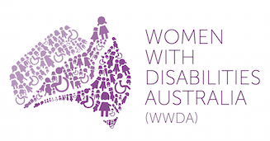 | 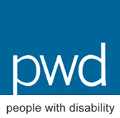

Adapted from Accommodating Human Rights, People with Disability 2010.

