Report on the Australian Youth with Disability National Forum:

‘Promoting Sexual and Reproductive Health and Rights’

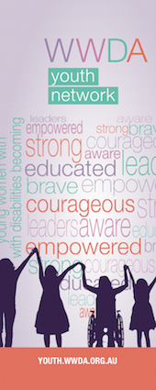 | 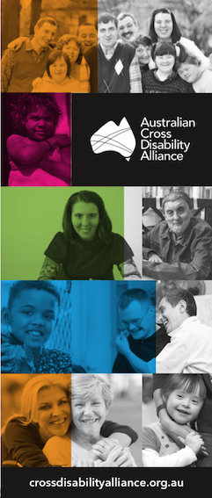 | 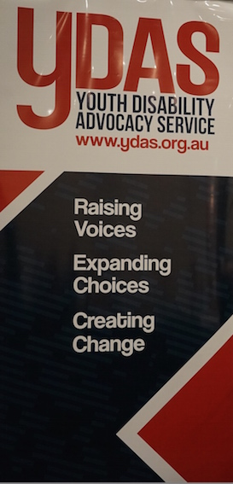

Friday 6th November 2015
Raddison on Flagstaff Hotel
Melbourne, Victoria

PUBLISHING INFORMATION

Report on the Australian Youth with Disability National Forum: ‘Promoting Sexual and Reproductive Health and Rights’

Prepared by Carolyn Frohmader for and on behalf of Women With Disabilities Australia (WWDA), People With Disability Australia (PWDA), the Australian Cross Disability Alliance (ACDA) and the United Nations Population Fund (UNFPA). © Copyright ACDA November 2015

The Australian Youth with Disability National Forum: ‘Promoting Sexual and Reproductive Health and Rights’ was organised and hosted by Women With Disabilities Australia (WWDA) and People With Disability Australia (PWDA) for an on behalf of the Australian Cross Disability Alliance (ACDA), Women With Disabilities Australia (WWDA) Youth Network, the Youth Disability Advocacy Service (YDAS), and the United Nations Population Fund (UNFPA).

The Australian Youth with Disability National Forum: ‘Promoting Sexual and Reproductive Health and Rights’ was funded in part, by contributions from the Australian Department of Social Services (DSS) National Disability Conference Initiative; the United Nations Population Fund (UNFPA), and Women With Disabilities Australia (WWDA). This Report of the proceedings of the Australian Youth with Disability National Forum has been written in part, to inform the development of the United Nations Population Fund (UNFPA) Global initiative ‘Youth and Disability Policies of Social Inclusion, Gender Equality, Non-Discrimination and Prevention of Sexual Violence’ (2015-2018).

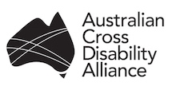  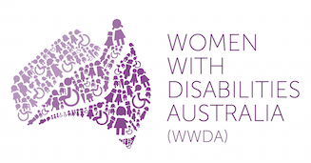  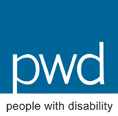 | 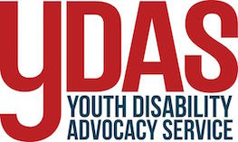  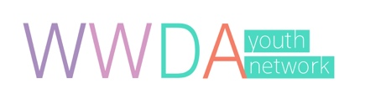  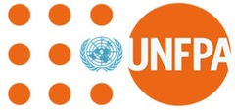  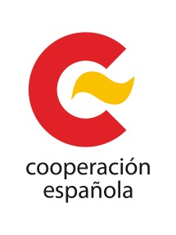

CONTACT

Australian Cross Disability Alliance (ACDA)
PO Box 407, LENAH VALLEY 7008 TASMANIA, AUSTRALIA
Ph: +61 405 789 142 [Tues-Thurs] and/or Ph: +61 438 535 123
Email: contact@crossdisabilityalliance.org.au
Web: http://crossdisabilityalliance.org.au/
Twitter: https://twitter.com/disallianceaus
Contact: Christopher Brophy/Carolyn Frohmader

CONTENTS

Introduction 4

Background to the UNFPA Global Project 5

About the Organisations 8

The Context for the UNFPA Global Project 10

The Youth with Disability National Forum: Planning & Organisation 13

The ‘Youth with Disability National Forum’ Proceedings 19

Introduction to the UNFPA Global Project’ 20
‘What are we here to do today and how will we do it?’ 21
An Introduction to Human Rights 25
Our sexual rights and reproductive health rights 30
Responses from Young People with Disability on the UNFPA Global Program Campaign 34

Conclusion 67

Appendices 68

Agenda for the Youth with Disability National Forum 68
The Participant Information Kit 69
Definitions Handout 81
Photo/Video Consent and Release Form 82
Participant Information Form 83

INTRODUCTION

In November 2015, the Australian Cross Disability Alliance (ACDA) in conjunction with the Women with Disabilities Australia Youth Network (WWDAYouth), and the Victorian Youth Disability Advocacy Service (YDAS), hosted a national forum of young people with disability on the theme of sexual and reproductive rights. The “Youth with Disability National Forum” was held as part of an exciting and innovative global project being established by the United Nations, to improve the human rights of young people with disability worldwide – particularly their sexual and reproductive rights and their right to freedom from violence.

The global project is being coordinated and implemented by the United Nations Population Fund (UNFPA) with support from Family Care International (FCI), and has been funded by the Spanish Agency for International Development Cooperation (AECID). It is currently in the establishment phase and Women With Disabilities Australia (WWDA), People with Disability Australia (PWDA) and the Australian Cross Disability Alliance (ACDA) has been working with the UNFPA and FCI to provide expert advice and assistance to set up and implement the Project, which is expected to run for four years.

Part of the planning and establishment phase of the global project includes developing the promotional campaign for the entire project. This includes for example, developing logos, slogans, branding and campaign messages that will be used throughout the four year project. In providing expertise and advice to UNFPA and FCI, the ACDA recommended that young people with disability be centrally involved in the design of all elements of the global promotional campaign for the global project.

UNFPA and FCI offered to support Women With Disabilities Australia (WWDA), People with Disability Australia (PWDA) and the ACDA to host a National Forum of young people with disability in Australia to contribute their ideas, suggestions, views and feedback on the draft global promotional campaign for the project, and also to consult and engage with them on the theme of sexual and reproductive rights – which forms a priority focus of the global project.

This document reports on the “Youth with Disability National Forum” held in Melbourne on 6 November 2015. It includes:

- The background to the UNFPA Global Project, including ACDA’s involvement and role;
- Information about the organisations hosting the Youth with Disability Forum, as well as information about UNFPA, FCI and AECID;
- The context for the Global Project;
- The detailed proceedings of the “Youth with Disability National Forum”;
- A number of supporting Appendices.

BACKGROUND TO THE UNFPA GLOBAL PROJECT

In early July 2015, Carolyn Frohmader, Executive Director of Women With Disabilities Australia (WWDA) and Therese Sands (Co-CEO of People with Disability Australia), were invited by the United Nations Population Fund (UNFPA) to travel to Uruguay to attend and participate in an international meeting of recognised experts on the theme of ‘Youth and Disability: Policies of Social Inclusion, Gender Equality, Non-Discrimination and Prevention of Sexual Violence’.

The International Expert Group meeting was conducted specifically to assist the UNFPA and its partners, by informing the development of a four year global initiative aimed at improving the human rights of youth with disability - particularly their sexual and reproductive rights and their right to freedom from violence. The global program is being coordinated and implemented by the United Nations Population Fund (UNFPA) with support from Family Care International (FCI), and is being funded by the Spanish Agency for International Development Cooperation (AECID).

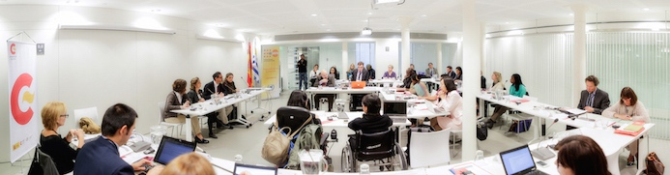
Participants at the International Expert Group meeting

The UNFPA global program includes the development of an international program to strengthen policies that are inclusive, non-discriminatory, based on gender equality and the prevention of sexual violence. The overall programme goal is the development and implementation of a human rights-based intervention model to address non-discrimination, gender equality and sexual violence prevention, including sexual and reproductive health, for youth with disability.

The global program prioritises five key areas for action:

- State-of-the-art and data, including best practices - including for eg: data analysis, identification of gaps in information and good practices in the political and legal frameworks to address the needs of young people with disability.

- Promotion of worldwide dialogue and advocacy - including for eg: setting up of institutional networks for dialogue and advocacy, for training, and for experts and organisations/networks of young people with disability; development of a technology-based observatory specialised on DSR and sexual and reproductive health and rights.

- Standards of intervention - including for eg: the development of quality human rights standards to prevent sexual violence against young people with disability, and to promote their sexual and reproductive health and rights.

- Strategies for skills development – including for eg: the development of knowledge platforms and communities of practice.

- Dissemination and Awareness - including for eg: the development of a global promotional campaign

The global program will ensure a collaborative approach and partnership with Governments, other UN Agencies, in particular the United Nation Partnership on Rights of Persons with Disability; the Committee on the Convention of the Rights of Persons with Disability; the UN Special Rapporteur on the Rights of Persons with Disabilities; global NGOs working with persons with disability; donors and grant-making foundations; academic institutions; and specialised consulting organisations.

The International Expert Group meeting on the ‘Youth and Disability Policies of Social Inclusion, Gender Equality, Non-Discrimination and Prevention of Sexual Violence’ was held in Montevideo, Uruguay on September 2nd, 3rd and 4th 2015. Over the three days, Carolyn and Therese facilitated a number of panels and working groups, and also gave presentations regarding the work of Women With Disabilities Australia (WWDA), the WWDA Youth Network, and People With Disability Australia (PWDA). Carolyn and Therese also gave a presentation on the establishment, model and role of the Australian Cross Disability Alliance (ACDA), including its work to advance the human rights of children and young people with disability.

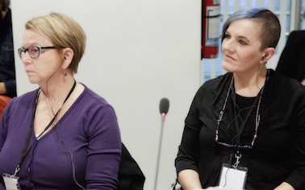  Therese (L) and Carolyn (R) at the International Expert Group meeting | 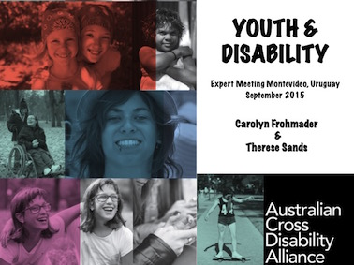  Front page of Powerpoint presentation delivered by Carolyn and Therese meeting

One of the sessions held during the Expert Group meeting in Uruguay, involved a presentation from Family Care International (FCI), which, amongst other things, is developing the over-arching “branding” and messaging for the four-year global program. FCI presented to the participants at the Expert Group meeting, their ideas regarding possible logos and messaging for the global program. Led by Carolyn Frohmader and Therese Sands, the participants at the Expert Group meeting strongly recommended that UNFPA and FCI engage directly with young people with disability to get their input into the campaign logos, branding, messaging and design.

In this context, after returning to Australia, WWDA was contacted by UNFPA and FCI to see if WWDA would be willing to conduct a ‘Focus Group’ in Australia with young people with disability, to elicit feedback on the global program “branding”, as well as seek information from young people with disability about their views on sexual and reproductive rights, and prevention of violence – particularly gender-based violence.

Given that WWDA is a founding member of the Australian Cross Disability Alliance (ACDA) and that the ACDA had been represented at the International Expert Group meeting, WWDA proposed that the ACDA host a “Youth with Disability National Forum” in conjunction with the WWDA Youth Network and the Victorian Youth Disability Advocacy Service (YDAS) - to contribute to the development of the UNFPA Global Program, particularly the global project campaign logos, branding, messaging and design.

The “Youth with Disability National Forum” was conducted on Friday 6th November in Melbourne and attended by 14 young people with disability from around Australia, aged between 15 and 25 years. WWDA assumed responsibility for organising the logistics for the Forum, which was held at the Raddison on Flagstaff Hotel in Melbourne, Victoria.

ABOUT THE ORGANISATIONS

The Australian Cross Disability Alliance (ACDA)
The Australian Cross Disability Alliance (ACDA) is an alliance of national disabled people’s organisations (DPOs) in Australia. DPO’s are organisations led by and for people with disability. The key purpose of the ACDA is to promote, protect and advance the human rights and freedoms of people with disability in Australia by working collaboratively on areas of shared interests, purposes and strategic priorities and opportunities. The ACDA was founded by, and is made up of four national cross-disability DPOs: Women with Disabilities Australia (WWDA); First Peoples Disability Network Australia (FPDNA); People With Disability Australia (PWDA), and the National Ethnic Disability Alliance (NEDA). The ACDA has been funded by the Australian Government to be the recognised coordinating point between Government/s and other stakeholders, for consultation and engagement with people with disability in Australia. In forming the ACDA, its four founding member organisations recognise and value the strength of working together in a spirit of mutual respect and trust, to proactively pursue human rights outcomes for all people with disability in Australia.

Women With Disabilities Australia (WWDA) and WWDA Youth Network
Women With Disabilities Australia (WWDA) is the peak organisation for women with all types of disabilities in Australia. It is an organisation made up of women with disabilities and associated organisations. WWDA represents more than 2 million disabled women and girls in Australia, and is run by and for women with disabilities. WWDA operates as a transnational human rights and systemic advocacy organisation. The WWDA Youth Network is an initiative of WWDA and was created by and for girls and young women with disability aged 13-30 years. It is organic, interactive and distributed across a range of platforms including Facebook, Twitter, Instagram and the flagship WWDA Youth Network website. The WWDA Youth Network model is scaffolded by a human rights framework. Its key functions include for example: providing peer education, learning and participation opportunities for girls and young women with disability around issues such as: sexual and reproductive health rights; gender identity, gender expression, sexuality; freedom from all forms of violence; decision-making processes; inclusive education; access to justice and meaningful employment.

The Youth Disability Advocacy Service
Youth Disability Advocacy Service (YDAS) is a state-wide advocacy service for young people with disabilities in Victoria, Australia. YDAS is the only advocacy service in Australia which exists specifically to work directly with young people with disabilities to achieve their human rights. YDAS offers free individual advocacy to young people aged 12-25 who have a disability. YDAS is also continually undertaking systemic advocacy and working on policy issues that are important to young people with disabilities such as housing, independent living, employment and education. YDAS works to ensure that the interests of young people with a disability are heard by government and other decision-makers. YDAS was established in 2006 and is funded by the State Government of Victoria. YDAS is a partner agency of the Youth Affairs Council of Victoria.

The United Nations Population Fund (UNFPA)
UNFPA is the lead United Nations agency for delivering a world where every pregnancy is wanted, every childbirth is safe and every young person's potential is fulfilled. The goal of UNFPA, as reflected in its mission statement, is to deliver a world a world where every pregnancy is wanted, every birth is safe, and every young person's potential is fulfilled. To accomplish this, UNFPA works to ensure that all people, especially women and young people, are able to access high quality sexual and reproductive health services, including family planning, so that they can make informed and voluntary choices about their sexual and reproductive lives.

The Spanish Agency for International Development Cooperation (AECID)
AECID is the official Spanish Agency for international development cooperation and for humanitarian assistance, responsible for the coordination of the whole Spanish humanitarian aid. AECID is the sum of all people, institutions, resources and skills that Spain offers to developing countries with the end goal of contributing to human development, the eradication of poverty and full access to rights. It is based on a broad political and social consensus on a national level in line with the following principles:
- The recognition of all human beings in their individual and collective capacity;
- The defence and promotion of Human Rights and fundamental freedoms;
- The need to foster global, interdependent, participatory, sustainable and gender-equitable human development throughout the world;
- The promotion of durable and sustainable economic growth;
- Respect for the resolutions adopted by international Organisations.

Family Care International (FCI)
Family Care International (FCI) was the first international organisation dedicated to maternal health, founded out of a determination to remedy this neglect. FCI has been working ever since -collaboratively, innovatively, and effectively - to make pregnancy and childbirth safer around the world. FCI pursues a world where no woman suffers preventable injury or death from pregnancy or childbirth-related causes and in which all people are able to enjoy their sexual and reproductive health and rights. In the halls of power, FCI - one of the world’s leading voices for maternal and reproductive health - fights for political commitment, stronger policies, and more funding for programs that save women’s lives. The work of FCI is designed to empower individuals and strengthen and support civil society.

THE CONTEXT FOR THE UNFPA GLOBAL PROJECT

Today’s adolescents and youth make up more than a quarter of the world’s population. They are shaping social and economic development, challenging social norms and values, and building the foundation of the world’s future. Whilst notable progress has been made, many young people – particularly young girls and young people with disability – are denied the investments and opportunities that they require to realise their full potential. For millions of young people around the world, puberty – the biological onset of adolescence – brings not only changes to their bodies but also more exposure to human rights abuses, particularly in the areas of sexual and reproductive health and rights, including freedom from all forms of violence.

According to the 2011 World Report on Disability (WRD), and the Organisation of Economic Cooperation and Development (OECD), between 15% - 20% of the world’s population experience some form of disability, with 80% of them living in developing countries. Estimates suggest that there are between 180 and 220 million young people with disability aged between 15-24 years worldwide. Disability is experienced unevenly across countries and the likelihood of having a disability rises dramatically with age. Women and girls with disability outnumber men and boys with disability.

Young people with disability are recognised as amongst the most marginalised and poorest of all the world’s youth. The United Nations Economic, Scientific and Cultural Organisation (UNESCO), estimates for example, that 98% of children with disability in developing countries do not attend school and 99% of girls with disability are illiterate.

A safe and successful passage from adolescence into adulthood is the right of every child, including those with disability. This right can only be fulfilled if families and societies make focused investments and provide opportunities to ensure that young people with disability progressively develop the knowledge, skills and resilience they need for a healthy, productive and fulfilling life. Further, national and global development, security and social justice can only be achieved if young people with disability are included as full and active participants. Investing in young people now is in everyone’s interest and is everyone’s responsibility: families, community leaders, nongovernmental organisations, governments, the private sector, the international community, and others alike.

Young people with disability are in a sensitive transition period of their lives from childhood to adulthood, during which multiple and intersecting forms of discrimination can heighten their exposure to violence, including sexual violence. The compound effects at a young age of violence and the denial of human rights due to discrimination on grounds of disability can significantly impact on a young person’s self-esteem, exercise and enjoyment of their human rights, thereby deepening their social exclusion and marginalisation.

During adolescence, discrimination and violation of human rights can impact negatively on the educational attainment, health outcomes, social and emotional development and physical and mental integrity of young people with disability. As a result, young people with disability are less likely than their non-disabled peers, to realise their full potential as active members of society with legal capacity and the right to make decisions on issues affecting them, and those of their families, communities, and nations.

In particular, young girls with disability are more likely than their non-disabled counterparts, to experience violations of their human rights particularly their right to sexual and reproductive health and freedoms. Gender-based assumptions and expectations place young girls with disability at a disadvantage with respect to substantive enjoyment of rights, such as freedom to act and to be recognised as having capacity, to participate fully in economic, social and political development, and to make decisions concerning their circumstances and conditions. These gendered differences are reflected in the life experiences of young girls with disability and young boys with disability.

It is widely recognised that women and girls with disability are more likely than their peers to be subjected to sexual and other forms of violence. Violence against women and girls with disability has devastating social, economic and inter-generational consequences and jeopardises their sexual and reproductive health and rights. In addition, violence perpetrated against women and girls – through harmful practices such as female genital mutilation (FGM), child marriage, early pregnancies, commercial sexual exploitation, forced sterilisation, forced contraception – are widely recognised as causes of disability for millions of young women and girls throughout the world. Women and adolescent girls with disability are exposed to higher levels of sexual violence and coercive practices. Studies in Europe, North America and Australia show that more than 50% of women with disability have experienced violence compared to a third of women without disability and are also less likely to seek legal protection.

A country’s economic, legislative, physical, and social environment may create, maintain or exacerbate barriers to the participation of young people with disability in economic, public, and social life. Barriers include for example, inaccessible public services (e.g. health, education, employment, vocational training) and inadequate funding for services: inaccessible buildings, transport, information, and communication (including technology), and significant attitudinal barriers due to prejudices, stigma and discrimination. These barriers are further compounded by a lack of data, information and analysis to support evidence-based, efficient, and effective policies to advance the human rights of young people with disability.

In many countries and settings, society incorrectly believes that young people with disability are asexual. Access to reproductive and sexual health information is often not available to young people with disability, or is disseminated through inappropriate means such as via inaccessible clinics and venues, inaccessible print or electronic media, or by service providers who cannot communicate with young people with disability. Few education programs cater to the reproductive and sexual health rights of young people with disability. Many health care professionals and providers have little or no understanding of the reproductive and sexual health rights of young people with disability and consequently feel unwilling or unable to address these issues.

The lack of social acknowledgment of young people with disability’s sexuality has many negative consequences for young people with disability. Regrettably, many young people with disability absorb, accept and internalise negative beliefs and stereotypes as fact and refrain from sexuality and intimacy altogether. Well-meaning parents/carers/guardians/support persons/friends may not acknowledge young people with disability as sexual beings and may actively discourage them from expressing any form of sexuality. Other young people with disability will have relationships, but without receiving their rightful access to appropriate education and may therefore be at risk, or engage in high risk activities. Some might go through several uncertain relationships, as the marriage of people with disability is frowned upon in many countries and in some cases is even legally prohibited. The right of people with disability to found and maintain a family is also actively discouraged, curtailed and denied by many societies, sometimes by law.

Article 23 of the Convention on the Rights of Persons with Disabilities (CRPD) recognises the right of persons with disability to form relationships, marry, start and maintain a family and adopt children. It also states that countries should provide persons with disability access to the same sexual and reproductive health care and family planning education available to individuals without disability.

The UNFPA Global Project to advance the sexual and reproductive health and rights of young people with disability is a long overdue and critical initiative to raise awareness of, and address many of these issues.

The Australian Cross Disability Alliance (ACDA), in conjunction with the WWDA Youth Network and the Youth Disability Advocacy Service (YDAS), commends UNFPA, AECID and FCI on this much needed global project. Our organisations are honoured and privileged to be a part of this innovative and crucially important global initiative to promote and advance the sexual and reproductive health and rights of all young people with disability around the world.

The ‘Youth with Disability National Forum’

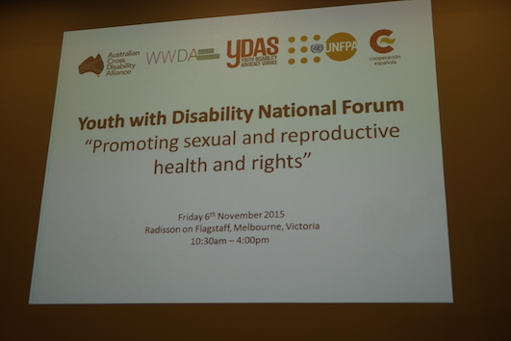

The Planning, Organisation, Participants, Facilitators and Support Persons

THE YOUTH WITH DISABILITY NATIONAL FORUM: PLANNING, ORGANISATION AND PARTICIPANTS

Organising the Forum
The “Youth with Disability National Forum” was held in Melbourne on Friday 6th November at the Raddison on Flagstaff Hotel. Due to the short time frame for organising and hosting the Forum, participants were identified through existing networks with a particular focus being on ensuring an inclusive and representative event.

Prior to the Forum, participants were provided with a ‘Participant Information Form’ to complete, detailing their access and any other requirements. A ‘Consent Form’ was also provided to Forum participants prior to the event so that they could provide their consent (or not) to have their photos, information and videos captured on the day. These Forms are provided in an Appendix to this document. A detailed ‘Participant Information Kit’ was developed and provided to all participants, support persons and workers, prior to the Forum. The Information Kit provided detailed information on all the logistics, including venue, travel, accommodation, meals, as well as a background to the Forum itself. A copy of the ‘Participant Information Kit’ is provided as an Appendix to this document.

A number of the participants and support persons travelled from interstate to attend and participate in the Forum. Given that the Forum was a day long event, and several participants were travelling long distances to attend, all those travelling were provided with 2 nights paid accommodation at and/or near to the Forum venue. All participants travelling to and staying in Melbourne, including support persons, were paid a daily Per Diem in advance to cover the costs of evening meals and incidentals. All participants, support persons and staff were provided with taxi vouchers in their Information Pack to enable transportation to and from their homes to airports and to and from the Forum venue.

On behalf of the ACDA, WWDA Youth Network, and YDAS, WWDA staff and volunteers organised the Forum venue and all requirements, including catering, conference materials, technical support, access requirements and so on. Prior to the Forum, WWDA and PWDA staff undertook a site visit and inspection of the venue to ensure all access and other requirements were in place and well organised prior to the Forum taking place. As part of the preparation for the Forum, ACDA, WWDA Youth Network and YDAS, met a number of times to plan and organise the Forum agenda, structure and content for the day. WWDA Youth Network manager, Cashelle Dunn, prepared all the presentation materials for the day, including handouts and a Powerpoint Presentation.

The Forum Participants
Fourteen young people with disability from around Australia attended and participated in the “Youth with Disability National Forum”. For many, it was the first time they had participated in such an event and the first time they had been invited to provide their views on issues of concern to young people with disability.

Ten young women with disability and four young men with disability were invited to attend the Forum. It was considered important by the Forum organisers, to ensure a greater representation of young women with disability, in recognition of the fact that young women with disability experience, and are at particular risk of, violations of their right to sexual and reproductive health and the right to freedom from all forms of violence, including gender-based violence. Additionally, the Forum organisers recognised that access to decision-making, political participation and representation are essential markers of gender equality. Yet women and girls with disability the world over, are often excluded from, and denied opportunities to participate in decision-making about issues that affect their lives and those of their families, community and nation.

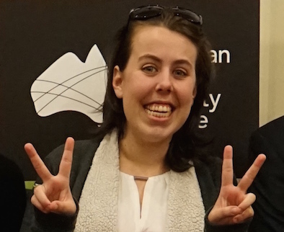  Charlotte | 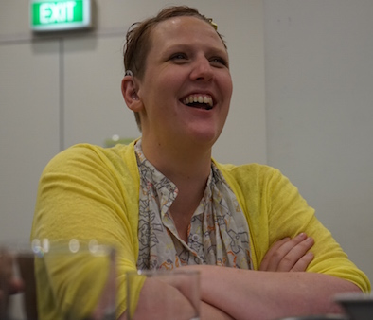  Bonnie | 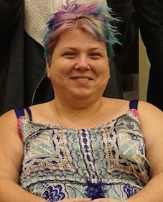  Amy | 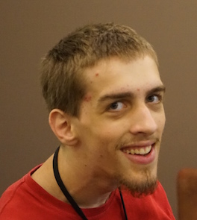  Jonathan
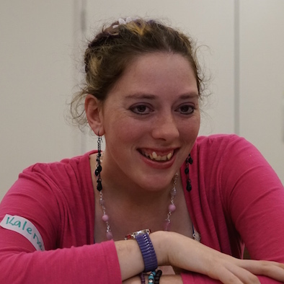  Kalena | 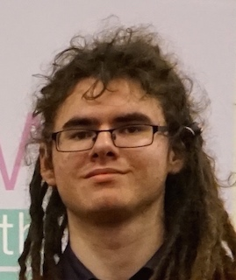  Ryan | 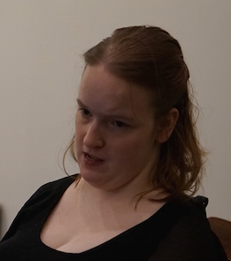  Ariana | Daye
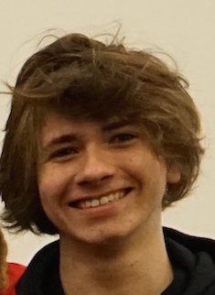  Jade | 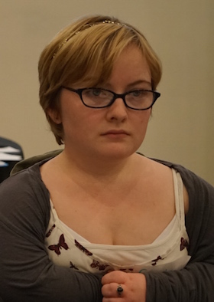  Georgia | 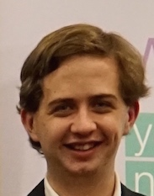  Brendan | 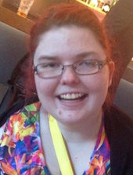  Kaitlin
 | 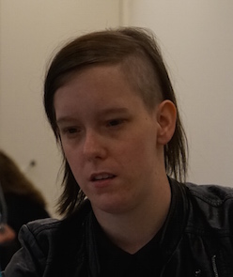  Amorette | 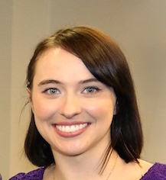  Cashelle

The Forum Facilitators
The “Youth with Disability National Forum” was co-facilitated by the Manager of the WWDA Youth Network, Cashelle Dunn and the Manager of YDAS, Dr George Taleporos.

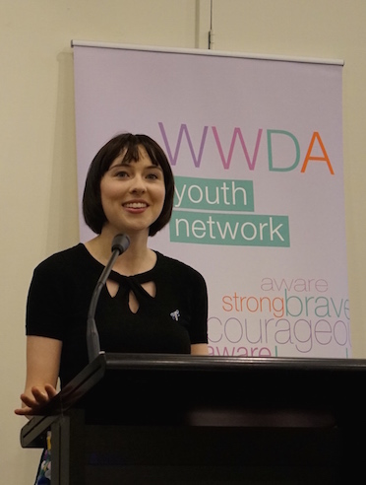  Cashelle | 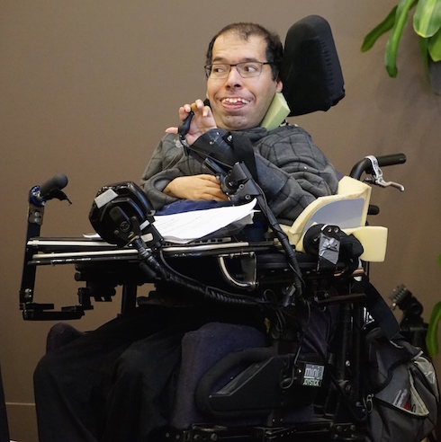  George

Cashelle Dunn
Cashelle is the founder and Manager of the WWDA Youth Network, established in 2014 and officially launched by the Minister for Women, the Hon Michaelia Cash, in July 2015. Having previously worked in a range of vocations, and studying in New York for two years, Cashelle recently completed a degree in Human Rights at Monash University in Melbourne. Cashelle experiences epilepsy and psychosocial disabilities and has been dealing with them since 13 years of age. Cashelle was elected Vice-President of Women with Disabilities Australia (WWDA) in 2014, becoming the youngest ever Vice-President of the organisation. Cashelle has represented WWDA and young women and girls with disability at various Un forums and events, including at the 53rd session of the Committee Against Torture in 2014; the seventh session of the Committee on the Rights of Persons with Disabilities (CRPD) Conference of States Parties (COSP) in 2014, and the United Nations International Day of the Girl Summit in 2015.

Dr George Taleporos
George is the Manager of YDAS and has been in the role since the organisation was established in 2006. George has a PhD in Psychology, and PhD research was around body image and sexuality issues and how they are affected by physical disability. Prior to managing YDAS, George worked in advocacy, training and community development. He has delivered disability awareness training to local government, as well as disability service providers. He has previously worked with various disability advocacy organisations and been closely involved in setting up new services, and advocating on systemic issues around community living and attendant support.

The Forum Group Facilitators and Support Staff
Along with the Forum co-facilitators Cashelle and George, three additional group facilitators/support staff (Mathew, Carolyn and Chris) also assisted with the Forum and provided support as required. The group facilitators acted as note-takers/scribes, and assisted with facilitating small group work.

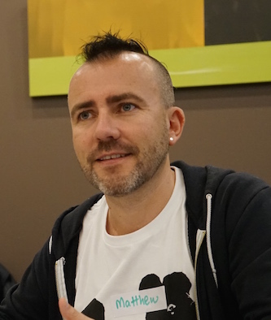  Matthew | 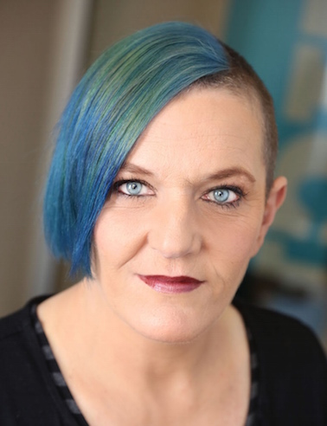  Carolyn | 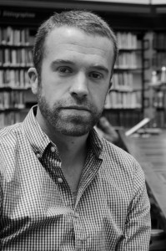  Chris

Matthew Bowden
Matthew Bowden is Co-Chief Executive Officer of People with Disability Australia (PWDA), a national grassroots, mutual support, representative and advocacy organisation of and for people with all types of disability. PWDA is a founding member of the Australian Cross Disability Alliance (ACDA). Matthew has worked for PWDA since 2003 in various manager and leadership positions. Matthew has worked with and for people with disability for 25 years in positions in the United Kingdom, the Solomon Islands and Australia. His main areas of expertise are in individual advocacy and the sexual and reproductive rights of people with disability. Matthew has worked with children, young people and adults with disability with sexual behaviours of concern including those charged with sex offences against children in the UK and Australia. This work has predominantly been with people with intellectual disability. He has conducted this in roles providing therapeutic intervention, education, program design, positive behaviour support and advocacy.

Carolyn Frohmader
Carolyn Frohmader is the Executive Director of Women With Disabilities Australia (WWDA) and has held this position for almost 20 years, working at the national and international levels to promote and protect the human rights of women and girls with disability. Under Carolyn’s leadership, WWDA has received a number of prestigious awards for its ground-breaking work including the National Human Rights Award and a number of national and state violence prevention awards. Carolyn has a Masters Degree from Flinders University and also has an extensive background in women’s health, public health policy, and community development. Carolyn has won a number of Awards for her work for and with women and girls with disability at the national and international levels, including the 2013 National Human Rights Award [Individual]. In 2015 Carolyn was named as a finalist in the National 100 Women of Influence Awards.

Christopher Brophy
Prior to July 2015, Chris had periodically worked with WWDA as a consultant. Chris is now employed by WWDA as director of strategic communications in a part-time role. The role was created in order to support WWDA to develop communications infrastructure and systems to meet the increasing demand and profile of WWDA at national and international levels. Chris also assists with WWDA’s role as a member of the Australian Cross Disability Alliance (ACDA) and contributes his knowledge, skills and experience to the policy, research and project work that WWDA undertakes. Chris also works part time in the LGBTI sector and has a Degree in Social Work.

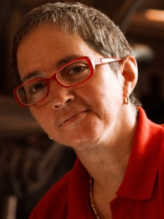

The organisers of the “Youth with Disability National Forum” engaged a photographer to capture the photos and videos from the Forum. All except one participant consented to have their photos and video footage taken during the event.

Margherita Coppolino - The Forum Photographer
Margherita Coppolino (pictured left) is a disability and diversity consultant, a Board member of Women With Disabilities Australia (WWDA) and a recognised and accomplished photographer. Margherita is also a powerful speaker and motivator. Margherita is a tertiary-qualified and industry accredited Trainer and Mediator. During her consultancy career, she also has honed & developed specialist skills in project management, mediation, facilitation, recruitment, case management and keynote speaking.

The Forum Participant Support Persons
A number of the participants at the “Youth with Disability National Forum” were wonderfully supported by their support persons to ensure all were able to contribute to and engage with the process. The ACDA acknowledges and thanks Renee, Peta, Deb, Alex and Ana for their support with the event.

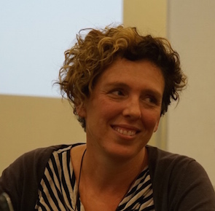  Renee | 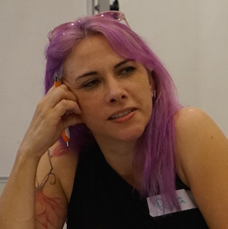  Peta | 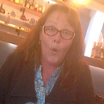  Deb
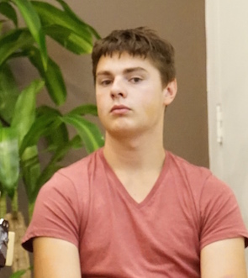  Alex | 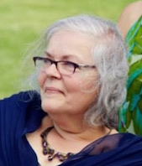  Ana

The ‘Youth with Disability National Forum’ Proceedings

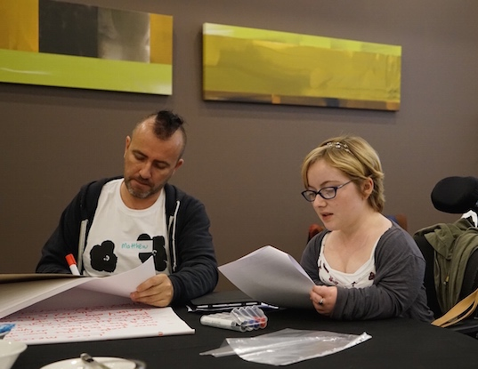

Session:

‘Introduction to the UNFPA Global Project’

‘What are we here to do today
and how will we do it?’

Acknowledgement of traditional owners
The Opening session of the Forum began with an Acknowledgment of the traditional owners of the land on which the ‘Youth with Disability National Forum’ was taking place. Aboriginal and Torres Strait Islander people have a unique position in the history and culture of Australia. They are the original owners of the land and it is recognised that this special position is recognised and incorporated in all official events such as festivals and community events, program launches and other major social and community events and meetings.

Cashelle Dunn presented the formal Acknowledgment of the traditional owners, on behalf of the hosting organisations, ACDA, WWDA Youth Network and YDAS:

“I would like to begin by acknowledging the traditional owners and custodians of the land on which we meet today, the Wurundjeri people of the Kulin Nation. I pay my respects to their Elders both past and present.”

Group introductions
Following the formal Acknowledgment of the traditional owners of the land, the participants, support persons and staff introduced themselves. Everyone attending the Forum was also provided with name tags to wear during the day.

Introduction to UNFPA Global Project
Cashelle gave participants a brief overview of the UNFPA Global Project, the background to the Project, the relationship between ACDA and the UNFPA, and also explained the purpose of the Forum in the context of the UNFPA Global Project.

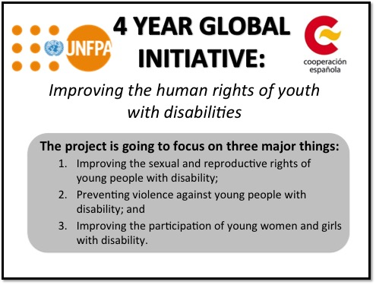

As part of the introductory information session about the UNFPA Global Project, Cashelle gave a brief presentation and explanation to the Forum participants on the concepts and understandings of ‘branding’, ‘messaging’, ‘slogans’, and ‘logos’. The definitions used were provided to the participants as a hand out. The presentation included a power-point presentation and discussion on the following components:
- What is Branding?
- What is ‘Messaging’?
- What is a ‘Logo’?
- What is a ‘Slogan’?

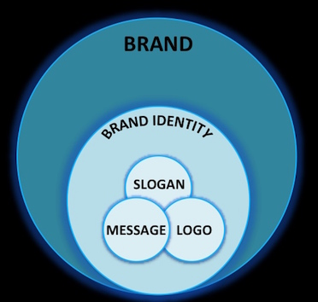

What is Branding?
‘Branding’ is designed to educate or create certain emotions. For a business, branding attracts customers and encourages repeat business. For a non-profit organisation, it attracts loyal supporters, donors and advocates to your cause. Branding is more than just your logo or name — a lot more. Branding is telling your story to your audience and showing why YOU matter. It’s about the experience and perception your audience has of your organisation.

‘Brand’ is the perception someone holds in their head about you, a product, a service, an organisation, a cause, or an idea. Brand building is the deliberate and skillful application of effort to create a desired perception in someone else’s mind. The presentation used the example of Apple as a very successful ‘brand’ that has a simple logo, simple message, simple advertisements, simple slogan, simple colours – but is extremely recognisable the world over.

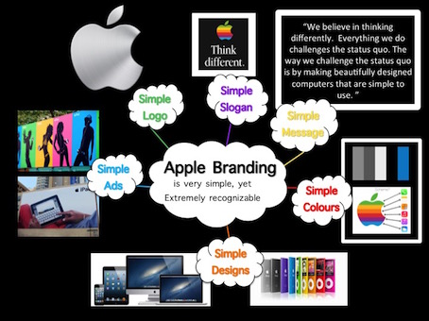

What is ‘Messaging’?
Every ‘brand’ needs a voice. Brand messaging provides the words that help their audience understand their value (why its useful) and values (what it believes in). The presentation used the example of Apple to convey how brand ‘messaging’ is utilised:

“We believe in thinking differently. Everything we do challenges the status quo. The way we challenge the status quo is by making beautifully designed computers that are simple to use.”

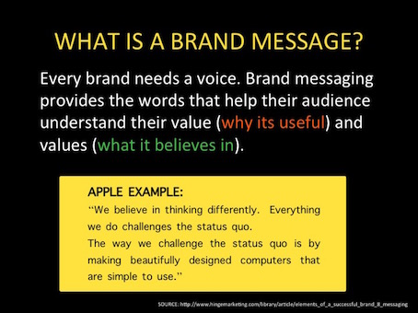

What is a ‘Logo’?
A logo is the graphic symbol that represents a person, company or organisation. A logo aids in promoting public recognition. The presentation gave examples of logos that are widely recognised including Apple and Walt Disney.
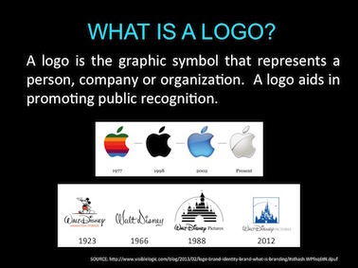

What is a ‘Slogan’?
A branding slogan is a small set of words or a short phrase that a business uses to make its company and products stick in its audience’s memories. An effective branding slogan not only sticks in the audience’s mind, but also invokes a mood and creates a bond with the audience. The presentation gave examples of slogans that are widely recognised both within the Australian context and internationally. Examples included:
- Apple – with the slogan ‘Think Different’
- Weet Bix – an iconic Australian cereal brand with the slogan ‘Aussie Kids are Weetbix Kids’
- Unicef - with the slogan ‘unite for children’
- Disney Parks - with the slogan ‘Where dreams come true’

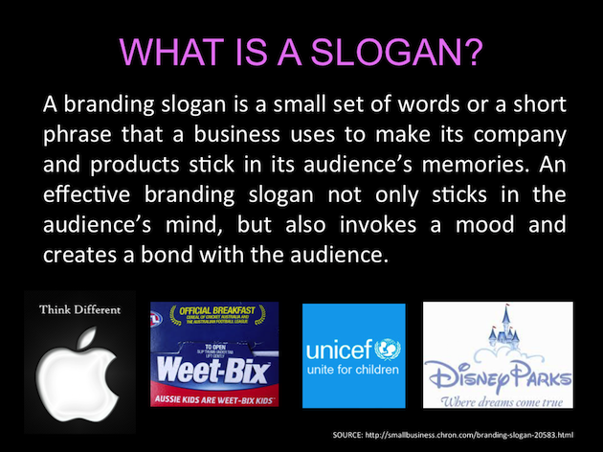

The presentation also provided examples of how a business, organisation or entity (such as ‘unicef’) can create specific ‘Project Slogans’ – such as in unicef projects addressing girls education; aids prevention; and water.

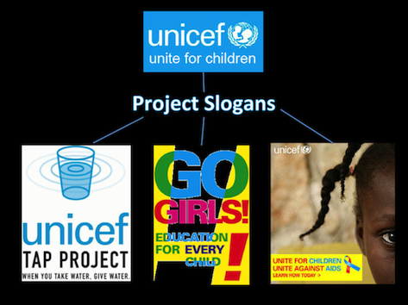

The presentation gave the example of how a well recognised ‘brand’ will create ‘new’ branding for specific programs, products, or projects. The unicef ‘Tap Project’ was used as an example to highlight:

The Brand: unicef

The Project: unicef Tap Project

New Logo: half full glass of water

New Slogan: ‘When you take water, give water’.

New Message: ‘The unicef Tap Project is a nationwide campaign that provides clean water and adequate sanitation to children around the world.’

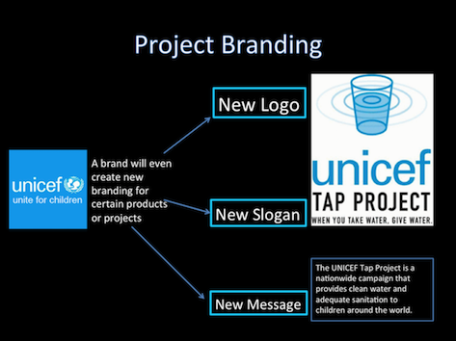

The ‘Youth with Disability National Forum’ Proceedings

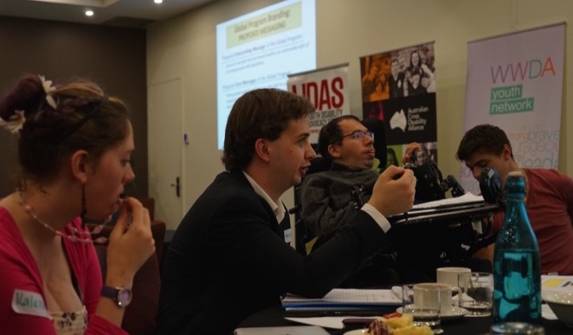

Session:

‘An Introduction to Human Rights’
‘Our sexual rights and reproductive health rights’

Agreeing on a Group Contract
The participants agreed it was important to establish and agree on a ‘Group Contract’ before the discussion sessions got underway. The participants established a set of ‘rules’ which a agreed would be followed and respected during the Forum.

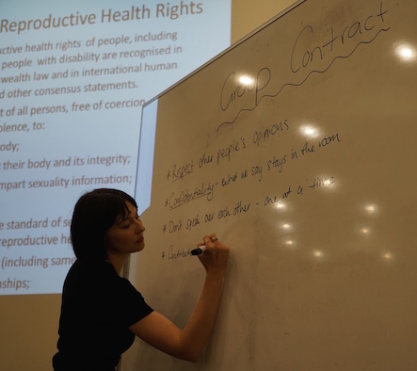

The set of rule statements developed by the participants for the ‘Group Contract’ were:

- Respecting other people's opinions and taking them on board

- Not agreeing with a statement is OK

- Confidentiality is important - information will be de-identified who said what unless you say it's OK to.

- Speak one at a time.

- Contribute to the best of your ability.

- It's OK not to contribute, it's Ok to contribute.

- Phones on silent or turn it off.

- Focus on the group as much possible.

- Keep safe, check in with yourself and seek support if you need it from one of the group facilitators.

Presentation: What are Human Rights?
In order to set the context for the later sessions, George Taleporos gave a brief presentation on ‘human rights’. Participants were shown a short captioned video entitled ‘The Story of Human Rights’ which gave an overview of the history of the human rights movement, and the evolution of the United Nations Universal Declaration of Human Rights, was signed in 1948 to provide a common understanding of what everyone’s rights are, and which forms the basis for a world built on freedom, justice and peace.

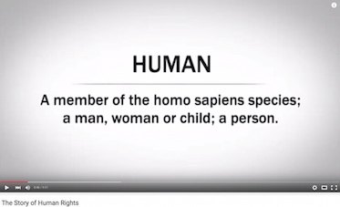 | 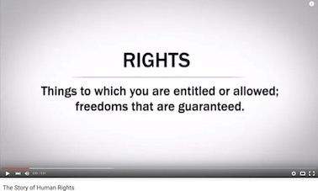

The video presentation, designed specifically for young people, provided a summary of the key articles of the United Nations Universal Declaration of Human Rights, giving an overview of the key human rights to which all persons are entitled:

1. We Are All Born Free & Equal. We are all born free. We all have our own thoughts and ideas. We should all be treated in the same way.

2. Don’t Discriminate. These rights belong to everybody, whatever our differences.

3. The Right to Life. We all have the right to life, and to live in freedom and safety.

4. No Slavery. Nobody has any right to make us a slave. We cannot make anyone our slave.

5. No Torture. Nobody has any right to hurt us or to torture us.

6. You Have Rights No Matter Where You Go. I am a person just like you!

7. We’re All Equal Before the Law. The law is the same for everyone. It must treat us all fairly.

8. Your Human Rights Are Protected by Law. We can all ask for the law to help us when we are not treated fairly.

9. No Unfair Detainment. Nobody has the right to put us in prison without good reason and keep us there, or to send us away from our country.

10. The Right to Trial. If we are put on trial this should be in public. The people who try us should not let anyone tell them what to do.

11. We’re Always Innocent Till Proven Guilty. Nobody should be blamed for doing something until it is proven. When people say we did a bad thing we have the right to show it is not true.

12. The Right to Privacy. Nobody should try to harm our good name. Nobody has the right to come into our home, open our letters, or bother us or our family without a good reason.

13. Freedom to Move. We all have the right to go where we want in our own country and to travel as we wish.

14. The Right to Seek a Safe Place to Live. If we are frightened of being badly treated in our own country, we all have the right to run away to another country to be safe.

15. Right to a Nationality. We all have the right to belong to a country.

16. Marriage and Family. Every grown-up has the right to marry and have a family if they want to. Men and women have the same rights when they are married, and when they are separated.

17. The Right to Your Own Things. Everyone has the right to own things or share them. Nobody should take our things from us without a good reason.

18. Freedom of Thought. We all have the right to believe in what we want to believe, to have a religion, or to change it if we want.

19. Freedom of Expression. We all have the right to make up our own minds, to think what we like, to say what we think, and to share our ideas with other people.

20. The Right to Public Assembly. We all have the right to meet our friends and to work together in peace to defend our rights. Nobody can make us join a group if we don’t want to.

21. The Right to Democracy. We all have the right to take part in the government of our country. Every grown-up should be allowed to choose their own leaders.

22. Social Security. We all have the right to affordable housing, medicine, education, and childcare, enough money to live on and medical help if we are ill or old.

23. Workers’ Rights. Every grown-up has the right to do a job, to a fair wage for their work, and to join a trade union.

24. The Right to Play. We all have the right to rest from work and to relax.

25. Food and Shelter for All. We all have the right to a good life. Mothers and children, people who are old, unemployed or disabled, and all people have the right to be cared for.

26. The Right to Education. Education is a right. Primary school should be free. We should learn about the United Nations and how to get on with others. Our parents can choose what we learn.

27. Copyright. Copyright is a special law that protects one’s own artistic creations and writings; others cannot make copies without permission. We all have the right to our own way of life and to enjoy the good things that art, science and learning bring.

28. A Fair and Free World. There must be proper order so we can all enjoy rights and freedoms in our own country and all over the world.

29. Responsibility. We have a duty to other people, and we should protect their rights and freedoms.

30. No One Can Take Away Your Human Rights.

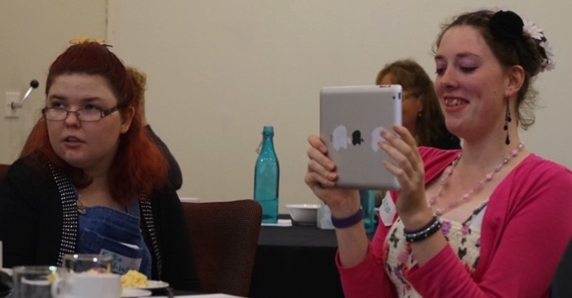

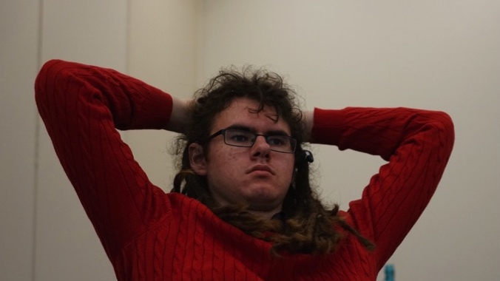

Presentation and Group Discussion: What are our sexual rights and reproductive health rights?
Expanding further on the presentation on human rights, George Taleporos gave a brief overview on the concept of ‘sexual rights’ and ‘reproductive’ rights, as core human rights belonging to all people:

Sexual and reproductive health rights of people, including children and young people with disability are recognised in State laws, Commonwealth law and in international human rights documents and other consensus statements.

They include the right of all persons, free of coercion, discrimination and violence, to:
- know about their body;
- have others respect their body and its integrity;
- seek , receive and impart sexuality information;
- sexuality education;
- the highest attainable standard of sexual health, including access to sexual and reproductive health care services;
- choose their partners (including same sex partners);
- make or break relationships;
- decide to be sexually active or not;
- consent to sexual relations;
- access sexual and reproductive health care services;
- consent to marry or live together in a de-facto relationship;
- decide whether or not, and when, to have children;
- be free of the individual sexual attitudes of caregivers
- pursue a satisfying, safe and pleasurable sexual life.

Sexual health is a state of physical, emotional, mental and social well-being in relation to sexuality; it is not merely the absence of disease. Sexual health requires a positive and respectful approach to sexuality and sexual relationships, as well as the possibility of having pleasurable and safe sexual experiences, free of coercion, discrimination and violence. For sexual health to be attained and maintained, the sexual rights of all persons must be respected, protected and fulfilled.

The group participants engaged in a discussion on the presentations around human rights, and specifically ‘sexual rights’ and ‘reproductive’ rights. The group facilitators took notes of the discussion and feedback comments and were also available to provide support if required.

The participants provided the following feedback and comments about their views on what sexual and reproductive rights meant to them as young people with disability:

“The places where people live impact on their ability to exercise sexual and reproductive rights like if you're in institutional care rather than in your own home in the community.”

“Access to reproductive health should not change whether you are single or in a relationship.”

“The right to be able to keep your children when you have them and not to be assumed that you're unfit to be a parent.”

“The right of some people with disability to access surrogates when unable or to choose whether to have a child (that choice is also based on disability reasons to access to surrogate).”

“Another sexual and reproductive right, same sex couples don't have the same rights as straight couples, - legal rights in parenting is one area where things are not equal.”

“Having both parents recognised as legal guardians in same sex parents.”

“For people who can't easily communicate we need to ensure that staff and health care providers it is known - communication supports to be in place for people around expressing sexual and reproductive health needs/ will and preference. These supports need to be put in place.”

“Information needs to be put in accessible language and formats to suit the needs of all people with disability.”

“People have the right to supports to things such as assistance putting a condom on if they're unable to do it themselves.”

“People who require it need to have decision making supports around S&RHRs and this needs some independent monitoring to make sure that in disability services this is being implemented and supported.”

“People do not need to have sex, don't want to have it, asexuality needs to be supported and understood as a human right. This is a valid sexual orientation.”

“Sexuality is very important. You need trust. You need a proper understanding of it and for it not to be forced upon you.”

“Body image is important – being comfortable with yourself. Being who you are and proud in what you are. Shouldn’t have to hide.”

“Sexual and reproductive rights mean:
- Feeling safe
- Having the right to see a doctor
- Having access to contraception
- Having access to sexual health services
- Having access to in-vitro fertilisation (IVF) both as a single person and as a couple
- Having the right to make a conscious decision to have and raise children.”

“I’ve never had anything explained to me about my sexual and/or reproductive rights.”

“Disability is often excluded from sexual education both at school and at home.”

“I eventually found out some information through disability organisations, retreats and by reading books.”

“I received basic sex education at school.”

“Doctors and health services have explained some sex education to me.”

“I found out information about sexual and reproductive rights by seeking out services as an adolescent.”

“I found out about contraception through word-of-mouth.”

“I find out information by using Google.”

“I would go to the police or people in authority to find out information about my rights.”

“I would ask my friends for information about my sexual and reproductive rights.

“I would go to the local youth service to get information.”

“Young people with disability have less opportunities than young people without a disability to access information about sexual and reproductive rights and are less able to make their own decisions about sexual and reproductive rights.”

“My choices about my sexual and reproductive rights are often taken away or decisions are forced on me by others.”

“Young people with disability are more discriminated against – there’s just the assumption out there that “apparently we don’t do sex.”

“There is not much accessible information about sexual and reproductive rights for young people with disabilities and this is a real barrier.”

“There’s the assumption in society that girls and guys with disability won’t need or use sexual and reproductive health rights information.”

“People with disabilities experience a lot of abuse and violence, including forced sex. One of the biggest problems is that there’s no-where to get support. Technically, you might be able to report violence to the police, but realistically, how much support would they give you? Probably not much.”

“Most people with disabilities, and that includes children and young people with disabilities, are not believed if they report violence. Even if they are believed, they wont get the same treatment or response as someone who doesn’t have a disability.”

“The Government should make sure that all sexual and reproductive rights education at all levels of schools, includes information for and about people with disability.”

“The subject of sex, sexual and reproductive health and rights of young people with disabilities is still a ‘taboo’ subject that is hidden. We need to shed more light on the subject and get rid of the stigma.”

“There should be a requirement that all services have to make information about sexual and reproductive rights (including prevention of violence) available in accessible formats.”

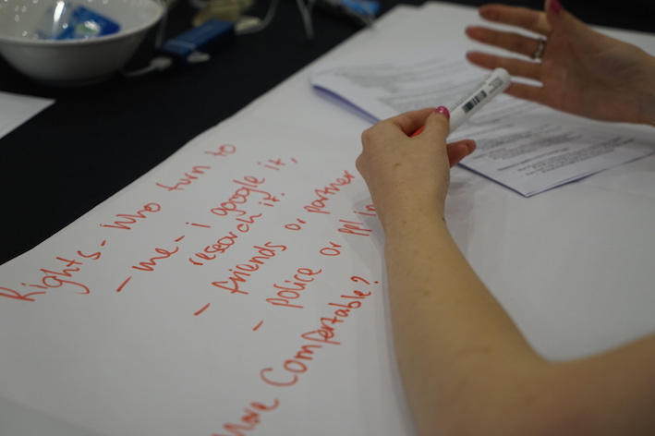

The ‘Youth with Disability National Forum’

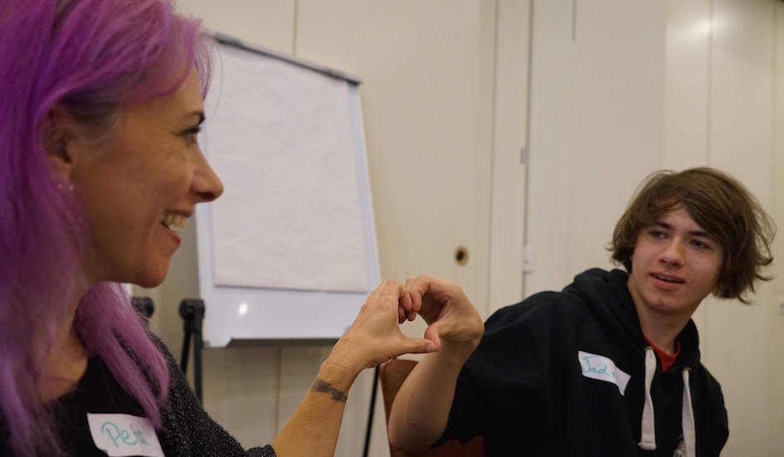

The Responses of Young People with Disability to the UNFPA Global Program draft campaign logos, branding, messaging and design

SMALL GROUP WORK: PROVIDING FEEDBACK AND IDEAS ON THE UNFPA GLOBAL PROGRAM MESSAGING AND BRANDING

In this session of the ‘Youth with Disability National Forum’, participants focused on contributing their feedback, comments, suggestions, views, opinions ad ideas on the draft ‘branding’ for the UNFPA Global Program that had been developed by Family Care International (FCI) for consultation with young people with disability. For the purposes of this session, the Forum participants formed into three smaller sized groups and a spokesperson was elected by the group members to report back to the larger group at the end of the session. A group facilitator supported each of the three groups, taking notes and providing support where and if required. This section of the Report provides detailed information on the feedback from the Forum participants on the proposed/draft messaging, slogans and logos, as well as alternatives for consideration by UNFPA and FCI.

GLOBAL PROGRAM BRANDING: PROPOSED MESSAGING

Proposed OVER-ARCHING MESSAGE of the Global Program:

‘Access to reproductive and sexual health is an inalienable right of all young people with disabilities.’

Proposed CORE MESSAGES of the Global Program:

‘Young people with disabilities have the right to a full emotional, sexual and reproductive life, as well as information and services that are acceptable, accessible, appropriate and affordable.’

‘A life free from sexual violence. Young persons with disabilities have the right to be free from sexual violence and be empowered to demand and receive protection and justice.’

Proposed CROSS-CUTTING MESSAGES of the Global Program:

‘Equality in rights to every person concerns all of us: Diversity is a reality. Every person, independently of their circumstances, is entitled to the highest enjoyment of their human rights.’

‘Maintain attention to concurring factors: We must keep in mind that multiple factors of discrimination (disability, poverty, gender, age, etc.), multiply inequalities.’

GROUP 1: Feedback on the Proposed OVER-ARCHING MESSAGE of the Global Program

‘Access to reproductive and sexual health is an inalienable right of all young people with disabilities.’

“There’s a bit too much jargon, the message needs to be simplified.”

“Inalienable” is an complex word, the language needs to be more accessible.”

“The word universal should be added to the statement.”

“Instead of saying ‘inalienable’ say that these are rights that can’t be given away i.e. access to reproductive and sexual health can’t be given or taken away from all young people with disabilities.”

“The word vital or inherent could be used instead of inalienable.”

“The overarching message should say sexual and/or reproductive health, not sexual and reproductive health – the two are not always linked and it shouldn’t be assumed that for a person that they are linked.”

“An explanatory note could sit under the overarching message.”

“The overarching message needs to be contextualised, broken down and explained – what is sexual and reproductive health?”

“Reproductive health shouldn’t focus on the capacity to have a child. Sexual health for women isn’t about the right to have a child or be defined by reproductive capacity.”

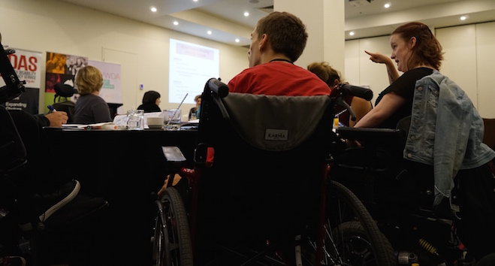

GROUP 2: Feedback on the Proposed OVER-ARCHING MESSAGE of the Global Program

‘Access to reproductive and sexual health is an inalienable right of all young people with disabilities.’

“Change ‘inalienable’ to a simpler term. It is not easy to understand. Young people may not know what it means.”

“It should be a simple message with simple, easy to understand words.”

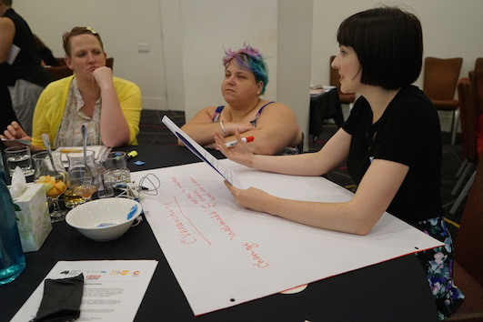

GROUP 3: Feedback on the Proposed OVER-ARCHING MESSAGE of the Global Program

‘Access to reproductive and sexual health is an inalienable right of all young people with disabilities.’

“The words need to be simplified.”

“It should have a picture with it for people who have difficulty reading.”

“All the messages should have pictures to go with them.”

“It needs plainer words.”

“The word ‘inalienable’ is not understandable. Its too long and it needs to be simplified.”

“There should be a more meaningful word than ‘inalienable’.”

“The words “access to…” at the start don’t need to be there. It could just be a strong simple statement like: “Sexual and reproductive rights belong to all young people.”

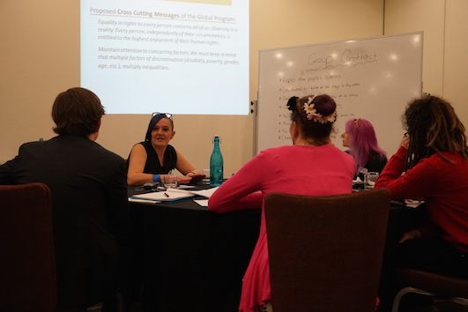

GROUP 1: Feedback on the Proposed CORE MESSAGES of the Global Program

‘Young people with disabilities have the right to a full emotional, sexual and reproductive life, as well as information and services that are acceptable, accessible, appropriate and affordable.’

‘A life free from sexual violence. Young persons with disabilities have the right to be free from sexual violence and be empowered to demand and receive protection and justice.’

“Message needs to be made more accessible, some people might not know what affordable means. All of the ‘a’ words needs to be explained (affordable, accessible etc).”

“Sexual and reproductive health rights need to be defined and explained.”

“The Core Message might be overloading people – it could help to break it up.”

“Sex isn’t only about reproducing.”

“Sexual health/ and or reproductive rights should be the term used not only ‘and’.”

“Should express that everyone is afforded the right to keep their child not only have a child – many women with disability have their children taken from them.”

“Not only sexual violence affects emotional wellbeing – other forms of violence by themselves and intersecting with sexual violence impact.”

“‘Sexualised’ violence could be the term used, being made to feel ashamed for wanting to be sexual could constitute sexual violence – this shaming is common for young people with disability.”

“Sexual violence and emotional abuse need defining and breaking down.”

“The acknowledgement that sexual violence isn’t always done by workers or partners it can be done by family members and people in the community too.”

“People with disability are so often seen as asexual and/or infantilised.”

“I am having a kid. I don’t care what anyone says or thinks. I will have a child whether I have a partner or not. I may want to use a sperm bank to have a child.”

“Students with disability need access to education around sexual and/or reproductive health rights.”

“This should be in the curriculum of schools as it often isn’t. Education about rights around freedom from violence also needs to be included.”

“Don’t need normative definitions of sexual and/or reproductive health rights.”

“Infertility shouldn’t be framed as a deficit.”

“The person’s right to disclose/not disclose information needs to be respected. This should not be done by the person’s family or their partners. It is the person’s choice to make a disclosure.”

“Asexuality can be related to having a disability but this doesn’t disentitle us from having romantic relationships.”

“There needs to be public awareness about the rights of people with disability to participate in sexual and reproductive health.”

“I’ve been given no information about sexual and/or reproductive health rights – nothing in school and nothing useful that I could put into context, I needed to figure it all out by myself.”

“Tumblr was my source of information, it’s a decentralised information source, this is very useful and allows two way engagement.”

“In Sydney the Cerebral Palsy Alliance ran a program I went to called “Unite to Intimacy and Beyond”. It was a very small group and we all respected each other’s views, beliefs and privacy.”

“Contrary messages go to younger people than older people with disability – this is wrong. This translates to how people with disability get information and how we access services and supports.”

“I went to a mainstream school and a special school. I found out more information about sexual and/or reproductive health rights in the mainstream school. In the special school it was all about what you shouldn’t do, all of the messages were negative, it was all, no, no no, ‘don’t have sex’, don’t have kids’ etc.”

“My legal capacity and ability to provide consent was not respected or honoured by my school, I was an 18 year old student so able by law to consent, but they would not accept a consent form for a program that I had signed myself they said that they didn’t care that I was 18 and that the form could only be signed by my parents despite be being an adult.”

“There needs to be a more constructive dialogue between disability organisation s and mainstream education providers.”

GROUP 2: Feedback on the Proposed CORE MESSAGES of the Global Program

‘Young people with disabilities have the right to a full emotional, sexual and reproductive life, as well as information and services that are acceptable, accessible, appropriate and affordable.’

‘A life free from sexual violence. Young persons with disabilities have the right to be free from sexual violence and be empowered to demand and receive protection and justice.’

“The first statement is too long.”

“Cut out the word ‘full’ in the first statement as its not needed.”

“Cut down the four ‘A’s [acceptable, accessible, appropriate and affordable] in the first message – too complicated.”

“[The core message] blurs two topics into one – sexual health and sexual violence.”

“Good to include information on services to support young people to understand their rights.”

“[The program] should be for everyone. Reframe so it’s obvious it’s not just for young people with disability but all young people.”

“The second statement is good – simple: “life free from sexual violence”.

“Repetition in the second statement makes it too wordy. Make it more simple.”

“Second statement should just say ‘be empowered’.”

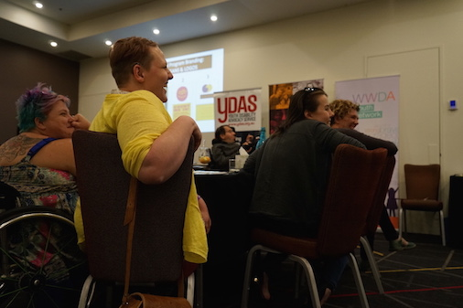

GROUP 3: Feedback on the Proposed CORE MESSAGES of the Global Program

‘Young people with disabilities have the right to a full emotional, sexual and reproductive life, as well as information and services that are acceptable, accessible, appropriate and affordable.’

‘A life free from sexual violence. Young persons with disabilities have the right to be free from sexual violence and be empowered to demand and receive protection and justice.’

“There should be pictures with each statement so that young people with disability who have low literacy skills or who can’t read, can still be included and can understand what the core messages are about.”

“Reproductive rights and sexual rights are not always the same thing – they should be separate points.”

“The term “sexual violence” is not clear and is an incomplete term. Perhaps it would be better to use the term ‘sexualised violence’.”

“People with disability, including young people with disability, experience many forms of violence. The first statement should reflect this and could say: “Young persons with disabilities have the right to be free from all forms of violence.”

“The second statement should be simplified. It’s repetitive, using the phrase ‘sexual violence’ twice. Not necessary. Make it more simple and direct.”

“The first statement is way too wordy. Need to have a simple, direct statement that young people with disability can identify with.”

“Don’t think the word ‘protection’ should be used in the second statement. Young people with disability need rights and agency, not ‘protection’.”

“These two statements are too wordy and are not youth friendly. They should be re-written so that they use simple language that young people can identify with. They should be short and to the point.”

“There are so many types and forms of violence experienced by young people with disability. Why is there only a focus of ‘sexual violence’?”

“The statements should just use the word ‘violence’ rather than ‘sexual violence’.”

“There first statement could be simplified to make a direct and clear affirmative statement like ‘Young people with disabilities have the right to a full emotional, sexual and reproductive life’. This right is not just about access to information and services. It’s more than that. The second part of the statement which says: ‘as well as information and services that are acceptable, accessible, appropriate and affordable’, should be left out.”

“The first statement says ‘Young people with disabilities’ and the second one says ‘Young persons with disabilities’. There should be consistency with terms.”

The two statements should be simplified. The first one could simply state that ‘Young people with disabilities have the right to a full sexual and reproductive life. The second one could simply state that: ‘Young people with disabilities have the right to be free from all forms of violence’.”

GROUP 1: Feedback on the Proposed CROSS-CUTTING MESSAGES of the Global Program

‘Equality in rights to every person concerns all of us: Diversity is a reality. Every person, independently of their circumstances, is entitled to the highest enjoyment of their human rights.’

‘Maintain attention to concurring factors: We must keep in mind that multiple factors of discrimination (disability, poverty, gender, age, etc.), multiply inequalities.’

“There needs to be a more rounded definition of what are the specific characteristics that would leave to these factors of discrimination.”

“Intersections being addressed in a key message are important. People with disability deserve to be given the same opportunities as everyone else despite difference.”

“In some cases there should be the right of self-identification – some of the intersectional issues may not be apparent to the naked eye e.g. disability type, poverty etc. – intersectionality can be hidden.”

“Don’t use the term diversity – this accepts that there is a norm. We are not deviations from the standard. Representation or representative would be preferred language over diversity.”

“A lot of people fall into the trap that one form of discrimination/ experience are analogous to others but this isn’t the case.”

“When inequalities multiply things interrelate in ways that people don’t understand unless they’ve been there.”

“Difference should not be pathologised (about women or race) a real medical issue can be ignored when this happens. Difference should not be problematized and seen as wrong, it happens more to us as women.”

“The main factors are self-determination and living independently. There is a problem with the view of mental illness, the definition is based on the norms of society. These norms can change and evolve over time.”

“The passive voice is used in messages. Who is giving us these rights?”

“Some of the language is difficult to read and understand and this is a problem. If we’re talking about the highest enjoyment of human rights – our ability to do things are impacted by our disability. Our human rights are taken away from us every day. We don’t get given our human rights.”

GROUP 2: Feedback on the Proposed CROSS-CUTTING MESSAGES of the Global Program

‘Equality in rights to every person concerns all of us: Diversity is a reality. Every person, independently of their circumstances, is entitled to the highest enjoyment of their human rights.’

‘Maintain attention to concurring factors: We must keep in mind that multiple factors of discrimination (disability, poverty, gender, age, etc.), multiply inequalities.’

Feedback on the Cross Cutting Message 1

“The word ‘enjoyment’ is not good. It doesn’t fit. Needs a word that sounds more professional.”

“The statement is not clear or easy to understand. Simplify it.”

“The statement ‘diversity is a reality’ is unclear. Needs to be simpler.”

“Don’t know what the cross cutting messages mean.

“The term ‘Diversity’ is a confusing word. Could use ‘respectful of others’.”

“Could use “everyone has the right to be different”.

Feedback on the Cross Cutting Message 2

“The statement does not make sense.”

“It has to be broken down [simplified] and explained.

“The word ‘concurring’ should be removed. It’s a complex term.”

“It’s just words. No connection. No solution.”

“Simplify the statement.”

“The term ‘Keep in mind’ is not a strong statement.”

“The statement should not include the brackets (parentheses).”

“Change the word ‘multiply’.”

“These sentences are not simple. They sound wordy and business like.”

“The term ‘Right to enjoy rights’ doesn’t make sense.”

“Use ‘these factors contribute to inequalities’ instead.”

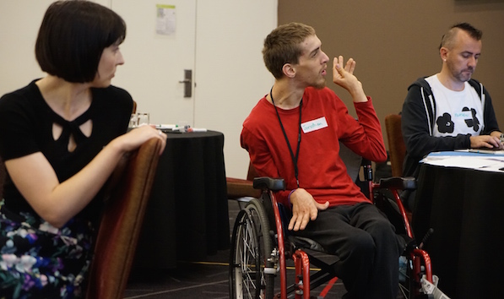

GROUP 3: Feedback on the Proposed CROSS-CUTTING MESSAGES of the Global Program

‘Equality in rights to every person concerns all of us: Diversity is a reality. Every person, independently of their circumstances, is entitled to the highest enjoyment of their human rights.’

‘Maintain attention to concurring factors: We must keep in mind that multiple factors of discrimination (disability, poverty, gender, age, etc.), multiply inequalities.’

Feedback on the Cross Cutting Message 1

“It’s too complicated.”

“There should be a much more simple way of wording this statement.”

“It’s too wordy and unnecessarily complicated.”

“It should have pictures with it so that people who cant read or for those who have intellectual disability or cognitive impairment can also understand the messaging.”

“It needs to be written in a way that easily captures the desired message. For example: Could it simply state that: “Every person is equally entitled to enjoy their human rights”.

Feedback on the Cross Cutting Message 2

“This statement is too wordy and is trying to do too much in one statement.”

“This statement, as with all the others should have pictures alongside them to convey the message in a picture format.”

“It is problematic to cite just ‘some’ factors of discrimination (in the brackets). It would be easier to leave them out all together, and have a small explanatory note somewhere that expands on what these factors are.”

“The statement should be made more simple, maybe something like: ‘Some people experience many forms of discrimination which makes it even harder for them to enjoy their human rights’.”

‘It may be necessary to have some sort of glossary or simple way of defining some of the terms.”

“The use of the words ‘Keep in mind’ are vague and it’s not even clear who this is directed at. It’s also a pretty passive set of words.”

GLOBAL PROGRAM BRANDING: PROPOSED SLOGANS

Proposed SLOGANS of the Global Program:

OPTION A

Name: “We decide”

Slogan: “Same rights, same choices”

Subtitle: Young people with disabilities: for a fulfilling emotional, sexual and reproductive life

OPTION B

Name: “Count Me In”

Slogan: “Young persons with disabilities: equality now!”

Subtitle: An initiative for equal opportunities and a life free of sexual violence.

GROUP 1: Feedback on the Proposed SLOGANS of the Global Program

Name: “We decide”
Slogan: “Same rights, same choices”
Subtitle: Young people with disabilities: for a fulfilling emotional, sexual and reproductive life

Name: “Count Me In”
Slogan: “Young persons with disabilities: equality now!”
Subtitle: An initiative for equal opportunities and a life free of sexual violence.

“Don’t like the ‘count me in’ slogan.”

“The slogans tip-toe around the central issue. The central issue is that people regardless of ability have the right to pursue whatever level of sexual issues they want.”

“These slogans don’t mean anything.”

“‘I decide’ - You can only decide if you have choices. The notion of independence is a myth for everyone, no one regardless of disability/ability is truly independent of others.”

“These slogans tame the topic down.”

“‘Give us a chance to explore our sexualities’ would be a better slogan.”

“Each culture has its own context within which they would view these slogans. Maybe they could vary how these slogans are promoted depending on the geographic locations/cultures.”

“The name- slogan – subtitle are unrelated (option B), it’s really mixed up, the messaging is inconsistent.”

“As a young person none of the options speak to me.”

“They look like they’ve been written by people who really don’t have much to worry about in relation to sexual and/or reproductive health rights – Option A is written from a position of privilege – Option B is pitying towards us .”

“Global rights to everyone all over the world wherever. You need supports for your rights to be achieved.”

“We shouldn’t have to fight our families, or bureaucracies to get the right medical care.”

“Try having a speech impairment in the medical system in Australia. It is abhorrent. Australia is brought down to a 3rd world level when you look at how little is done around providing technologies and training around communication disability.”

“You can claim asylum in Cuba based on your health status.”

“I like the name ‘ We decide’ but don’t like ‘same rights, same choices’ as this doesn’t make sense.”

“Equality isn’t about making everyone the same. It’s about saying look at how different we are. Look at what we can achieve if we afford everyone the same human rights.”

“We don’t need equal treatment, we need equitable treatment.”

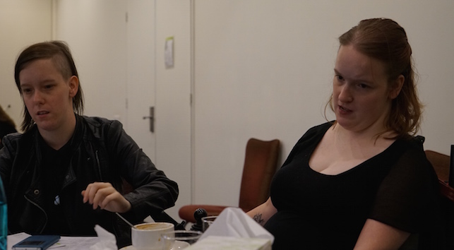

GROUP 2: Feedback on the Proposed SLOGANS of the Global Program

Name: “We decide”
Slogan: “Same rights, same choices”
Subtitle: Young people with disabilities: for a fulfilling emotional, sexual and reproductive life

Name: “Count Me In”
Slogan: “Young persons with disabilities: equality now!”
Subtitle: An initiative for equal opportunities and a life free of sexual violence.

Feedback on Proposed Slogan Option A

“Subtitle from Option B could be moved to Option A.”

“Subtitle doesn’t fit. ‘Reproductive’ has different meanings to young people and people over age 25.”

“Feels lost.”

“I like ‘same rights, same choices’.”

“I’m not sure about the name.”

“Like name and slogan. Dislike subtitle.”

“The word ‘fulfilling’ seems strange.”

“The subtitle makes no sense.”

“Is “we” talking about everyone or just young people with disability?”

“Suggested alternative for the sub-title: ‘An initiative for young people with disability for equal opportunity and a life free from sexual violence’.”

Feedback on Proposed Slogan Option B

“The phrase “Count me in” has been used too much.”

“It could mean different things to different people.”

“It’s not good, not bad, just overused.”

“The slogan seems too ‘in your face’.”

“The words “young people with disability” should be in the subtitle instead of slogan.”

“Subtitle – I like it but the word ‘discrimination’ could be added at the end.”

“Change the word ‘violence’ to ‘discrimination’.”

“Slogan options: maybe ‘we want’ or ‘I decide’.”

GROUP 3: Feedback on the Proposed SLOGANS of the Global Program

Name: “We decide”
Slogan: “Same rights, same choices”
Subtitle: Young people with disabilities: for a fulfilling emotional, sexual and reproductive life

Name: “Count Me In”
Slogan: “Young persons with disabilities: equality now!”
Subtitle: An initiative for equal opportunities and a life free of sexual violence.

Feedback on Proposed Slogan Option A

“We Decide” is simple. It portrays the message of young people with disability ruling our own lives.”

“The name “We Decide” is good in a way because it has universal meaning which would be good for the global nature of the program.”

“The slogan could be ‘Nothing About Us Without Us’ which is pretty well known world-wide.”

“The sub-title is not very clear.”

“The sub-title could be simplified. A possible alternative could be ‘An initiative to improve the human rights of young people with disabilities.’

“The sub-title in Option B is better than the sub-title in Option A.”

Feedback on Proposed Slogan Option B

“The name “Count Me In” is old jargon and has been used a lot.”

“It’s a passive name and not strong enough.”

“Don’t like any of Option B.”

“The only possible bit of Option B I like is some of the sub-title but even that is too limiting.”

“I don’t think the sub-title for Option B works at all. I also don’t think it should be just restricted to ‘sexual violence’.”

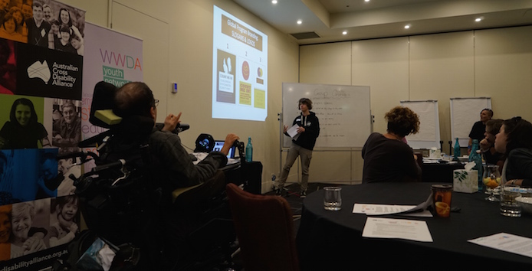

GLOBAL PROGRAM BRANDING: PROPOSED LOGOS OF THE GLOBAL PROGRAM

Proposed LOGO 1 of the Global Program:

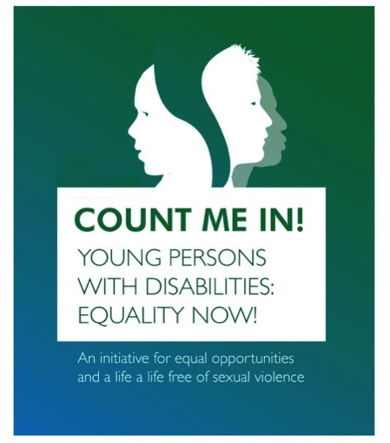

Proposed LOGO 2 of the Global Program:

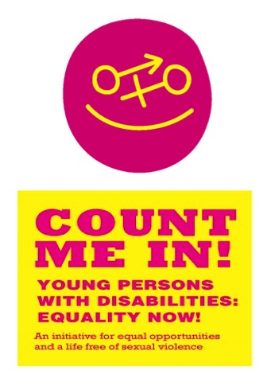

Proposed LOGO 3 of the Global Program:

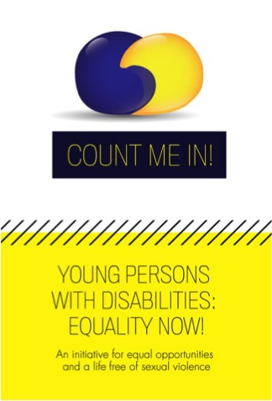

General Feedback and Comments on Proposed LOGOS

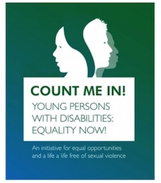 | 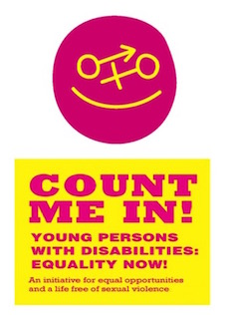 | 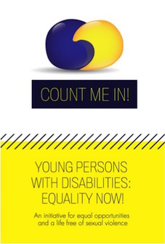

“These three proposed logos are all terrible! They are not youth friendly at all.”

“The logos are old fashioned, boring and just not engaging at all.”

“They are all shit.”

“The colours are very 70s/80s – very old fashioned.”

“The logos should represent sex, intimacy, affection, the three logos presented don’t do this at all.”

“The logos should not use too many words, lots of us can’t read. With the three proposed logos, you’d have to be able to read to know what it is about.”

“The logo should speak to young people but also older generations so they know what this program is about and a logo that would stand the test of time.”

“Using the international symbol of disability somewhere in the logo would be good because it is recognised globally.”

“An alternative logo could be the disability symbol but instead of the wheel you have a circle with both the arrow and the cross (gender symbols) pointing in different directions.”

“Stay away from gender symbols, don’t force this onto people. Gender Queer won’t fit into the cross and arrow (female and male) symbols.”

“It’s about people - not just about boys or girls.”

“Show people hugging in the logo.”

“Something symbolising able-bodied people and people with disability that shows that we’re different in the way that we think and feel – similar but different symbols.”

“It may depend how the logo is to be used within the strategy. In developing countries they may have to rely on a static image. In advanced economies there may be more use of digital media to make the logo more interactive.”

GROUP 1: Specific Feedback and Comments on Proposed LOGOS

LOGO 1 | LOGO 2 | LOGO 3

Proposed LOGO 1

“This logo looks like an offensive representation of Dissociative Identity Disorder.”

“This logo is shit.”

“I don’t like it at all, we don’t have multiple heads!”

“The colours are terrible.”

Proposed LOGO 2

“This logo just looks horrible.”

“This logo looks patronising ie: ‘girls and boys all the same and al happy’ – it’s demeaning.”

“Stay away from using gender symbols.”

“Gender Queer won’t fit into the cross and arrow (female and male) symbols.”

“This logo is very gender binary and this is not useful at all.”

Proposed LOGO 3

“This logo is meaningless, it looks like play-doh.”

“This logo looks like two blobs having sex.”

GROUP 2: Specific Feedback and Comments on Proposed LOGOS

LOGO 1 | LOGO 2 | LOGO 3

Proposed LOGO 1

“The colour and the image is awful.”

“It looks plain, bland and boring.”

“The colours used are dull and certainly not engaging or attention grabbing.”

“I don’t like the way the faces are ‘facing’ away from each other. It’s an opposite idea to the slogan proposed for it “Count Me In”.”

“What’s written and what’s portrayed [by the logo] are two different things.”

“The only thing I like about this logo is the font used.”

“This logo is just plain ugly.”

Proposed LOGO 2

“What is the image meant to be?

“Looks more like its aimed at little children, not young people.”

“At least the colours are bright and catching.”

“The font stands out.”

“The image is quite confusing.”

“The gender symbols are conservative and not inclusive.”

Proposed LOGO 3

“What does that picture mean?”

“Bolded font would look better.”

“I have no idea what the image is aiming [to depict].”

“The font is too small.”

“The title won’t be seen.”

“The text in the yellow section just disappears.”

“Use different colours.”

“The colour scheme is awful.”

GROUP 3: Specific Feedback and Comments on Proposed LOGOS

LOGO 1 | LOGO 2 | LOGO 3

Proposed LOGO 1

“This logo looks more like a suicide prevention logo.”

“It looks like it suggesting that people with disability only have half a brain.”

“The bit in between the two heads looks like a tornado.”

“The colour scheme is dreadful. So boring and depressing.”

“The heads in the image have soulless eyes.”

“It looks like they are wearing masks.”

“It’s a crap logo for young people.”

“It’s artificial and doesn’t speak to young people at all.”

“I can’t imagine any young person identifying with this logo.”

Proposed LOGO 2

“This image is just terrible.”

“It’s not even a proper circle – it looks tacky and hand drawn.”

“It looks a bit like a game of naughts and crosses.”

“Its an awful colour scheme. Too sickly.”

“This logo is totally inconsistent with the message about diversity.”

“The gender symbols are just so wrong and are very conservative – they assume male/female only and do not portray the message of diversity and inclusiveness.”

“This logo and the colour scheme might appeal to young toddlers – but I can’t imagine young adolescents and youth identifying with it at all.”

Proposed LOGO 3

“That image is terrible.”

“The picture looks like two jelly beans.”

“The picture also looks like two quotation marks (‘ and ’) pushed together, which could imply that young people with disability can’t have a say.”

“What’s the image meant to be representing? It’s bizarre.”

“I don’t like the ‘stitching effect’ between the top half and bottom half of the image. To me it implies that people with disability are ‘broken’ and need to be ‘fixed’.”

“The colour scheme is pretty awful.”

“The only bit that I think could be useful is the box bit in the middle with ‘Count Me In’ text inside it – except I hate the ‘Count Me In’ phrase.

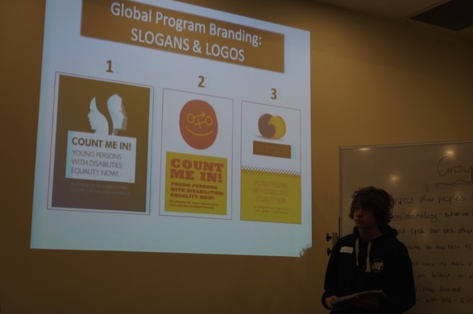

POSSIBLE ALTERNATIVES FOR THE LOGO OF THE GLOBAL PROGRAM

The groups turned to designing logos that they felt would be an improvement on the logos presented to the forum:

GROUP 1: Suggested Ideas for the LOGO

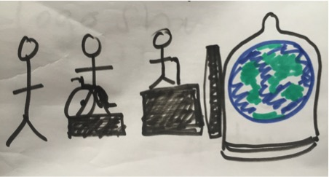
Group 1: Logo 1

In this logo the idea is that three people with different impairments and of different heights (one seated in a wheelchair), another of short stature using a stick, another without visible impairment become equal as they look over a wall to a view of the world sheathed in a condom.

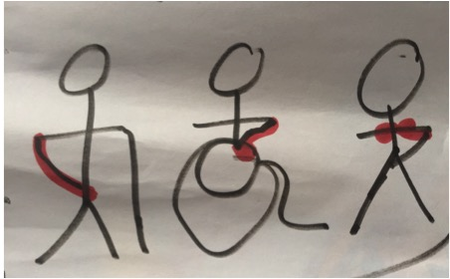
Group 1: Logo 2

In this logo three people with disability one using a cane, one using a wheelchair, another without a visible impairment – one of them has their hand on their groin/genitals, the other has their hand on their breast, the other has their hand over their uterus.

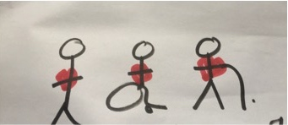
Group 1: Logo 3

In this logo the three people with disability (one whose impairment is not visible, another using a wheelchair and another a cane) have actual hearts drawn over their chests.

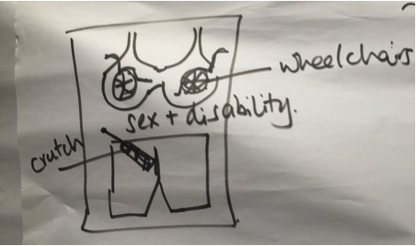
Group 1: Logo 4

In this logo two wheelchairs facing one another form breasts within a bra. Below this image are the words ‘sex and disability’ and then there is an image of a pair of boxer shorts and out of the fly of the boxer shorts a crutch sticks up in the air representing an erect penis.

GROUP 2: Suggested Ideas for the LOGO

The logo should use bright colours and bold lettering. Real life images of young people must be used – not drawn graphics. Images of actual real people would make it more appealing and interesting. It has to be real so that young people can engage with the Global Program.

Suggestion: Young people looking up at camera (birds-eye view) holding signs: “I decide” in different languages. Maybe a sign with their disability? Stand in a shape – maybe a globe or world. See sketches below.

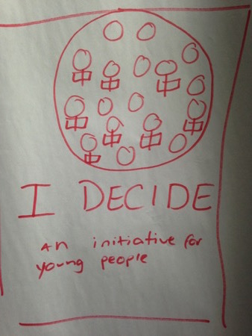  Group 2: Logo 1 | 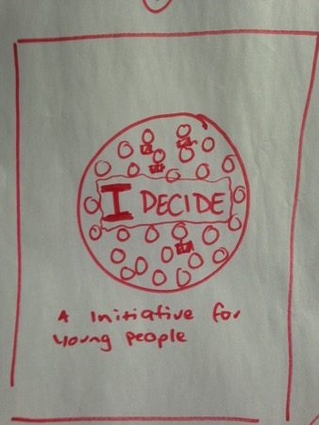  Group 2: Logo 2

LOGO 1 (above left) depicts the ‘world’ with real images of young people (including with visible and non-visible disabilities). Each person is holding a sign that says ‘I Decide’ in different languages. The images of the young people should be from different parts of the world. There is limited text which sits underneath/below the image.

LOGO 2 (above right) depicts a similar concept but with the name of the campaign (ie: I Decide) sitting ‘inside’ the world with the images of real young people (including with visible and non-visible disabilities) surrounding the name of the campaign.

GROUP 3: Suggested Ideas for the LOGO

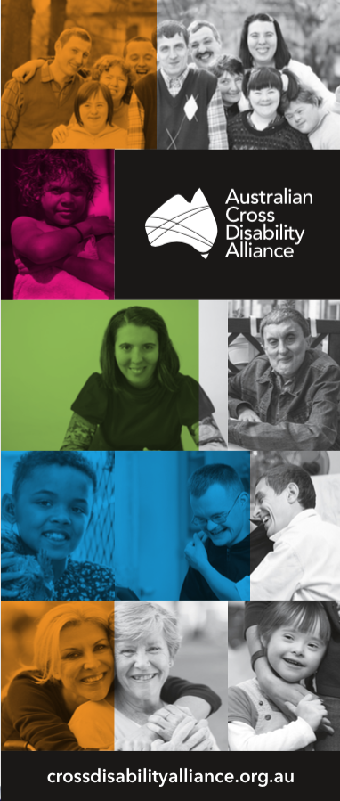

The campaign logo should depict images of real people, not animated logos, drawn graphic, or caricatures of people with disability.

The concept used by the Australian Cross Disability Alliance (ACDA) (shown left), is a good one and it could be used as an example for the Global campaign logo.

Have real images in a collage type format of young people with disability (including those with visible and non-visible disabilities).

Use images of young people from around the world so that the global nature of the Program is reflected.

Have the UNFPA logo somewhere on the logo so that people have a context for the Global Program.

Using the ACDA banner (left) as an example, the name of the campaign (‘We Decide’ or ‘I Decide’) could be transposed across/on top of the images.

There should be minimal text.

Perhaps at the bottom of the logo (similar to the bottom of the ACDA banner) it could simply state: ‘Improving the human rights of young people with disability’. And the UNFPA logo could sit alongside it or underneath it.

It should be bright, colourful and captivating. Using images of real young people in a collage type format, will enable young people with disability to identify and engage with the Global Program.

CONCLUSION

The Australian ‘Youth with Disability National Forum’ was a resounding success. As highlighted earlier in this report, for many of the young people attending, it was the first time they had ever been asked for their views on issues of concern and interest to young people with disability.

An unanticipated outcome of the ‘Youth with Disability National Forum’ was the eagerness and willingness of the participants to continue to be engaged in representation and consultation opportunities in relation to advancing and promoting the human rights of young people with disability in Australia, and indeed, around the world.

The Australian Cross Disability Alliance (ACDA) will continue to work with and support, the young people with disability in Australia, including those who participated in the ‘Youth with Disability National Forum’. There is a strong desire from young people with disability in Australia (including those attending the Forum), to establish and develop a more formalised and permanent mechanism to ensure young people with disability have their own voice and have opportunities to engage in, inform, and contribute to, the development of public policy on issues that affect, concern and interest them.

The ACDA is therefore, continuing to collaborate with young people with disability, including through our partner organisations the WWDA Youth Network and the Youth Disability Advocacy Service (YDAS), to support young people with disability to establish and build their own disabled people’s organisation (DPO).

The Australian Cross Disability Alliance (ACDA), in conjunction with the WWDA Youth Network and the Youth Disability Advocacy Service (YDAS), thanks the United Nations Population Fund (UNFPA), Family Care International (FCI) and the Spanish Agency for International Development Cooperation (AECID) for the opportunity to host the Australian ‘Youth with Disability National Forum’. We trust that the information provided by young people with disability attending the Forum, will inform the establishment and implementation of the UNFPA Global Program: ‘Youth and Disability: Policies of Social Inclusion, Gender Equality, Non-Discrimination and Prevention of Sexual Violence’ – a critical initiative to advance and promote the human rights of young people with disability throughout the world.

APPENDIX 1: Agenda for the Youth with Disability National Forum

10.30am: Arrive and morning tea

11.00: Acknowledgement of traditional owners

11:05: Group introductions

11:15: Introduction to UNFPA and the Global Project
• What are we here to do today and how will we do it?
- What is ‘branding’?
- What is ‘messaging’?
- What are slogans?
- What are logos?
11:30: Group contract and being safe

11:45: Presentation
- What are human rights?
- What are our sexual rights and reproductive health rights?
12:00pm: Break into 4 small groups
• Overarching message
• Core messages

1pm: Lunch break

1.45: Feedback from 4 Groups on the overarching and core messages

2.00 Back into 4 small groups
- Cross cutting messages
- Slogans
- Logos
3.00pm: Afternoon tea

3:30pm: Feedback from 4 Groups on cross cutting messages, slogans and logos

3:50pm: Summary of the day

4pm: Finish

APPENDIX 2: PARTICIPANT INFORMATION KIT

Youth with Disability National Forum

“Promoting sexual and reproductive
health and rights”

Participant Information Kit

Friday 6th November 2015
Raddison on Flagstaff, Melbourne, Victoria
10:30am – 4:00pm

1. Background

The Australian Cross Disability Alliance (ACDA) (www.crossdisabilityalliance.org.au) is made up of four national Disabled Peoples Organisations (DPOs), which are organisations run by and for people with disability. The four organisations are:

Women With Disabilities Australia (WWDA) - www.wwda.org.au
People With Disability Australia (PWDA) - www.pwd.org.au
First Peoples Disability Network (FPDN) - www.fpdn.org.au
National Ethnic Disability Alliance (NEDA) - www.neda.org.au

ACDA works to improve the human rights of all people with disability in Australia. It’s key purpose is to promote, protect and advance the human rights and freedoms of people with disability in Australia by working together on areas of shared interests, purposes and opportunities.

ACDA works both within Australia and also internationally. It does a lot of work with the United Nations to help improve the rights of people with disability all over the world.

Earlier this year, ACDA was invited to help the United Nations set up a worldwide project to improve the rights of young people with disability all around the world. The project is going to focus on three major things: 1) improving the sexual and reproductive rights of young people with disability; 2) preventing violence against young people with disability and 3) improving the participation of young women and girls with disability.

The United Nations Population Fund (UNFPA), which is a section of the United Nations, is managing this exciting new global project and ACDA will be working with them over the next four years on the Project. The Spanish Government is giving the UNFPA the money to set up and run this global Project.

This worldwide project is very important because young people (aged between 10-24 years) make up a quarter of the world’s population. They are the foundation of the world’s future but many young people, especially young people with disability and young women and girls, don’t get the opportunities that they need to realise their full potential. For millions of young people around the world, puberty – the biological onset of adolescence – brings not only changes to their bodies but also more exposure to human rights abuses, particularly in the areas of sexuality, relationships, violence and child bearing.

A safe and successful passage from childhood to adulthood is the right of every child, including those with disability. This right can only be fulfilled if young people with disability are given opportunities to develop the knowledge, skills and resilience needed for a healthy, productive and fulfilling life.

2. The Youth with Disability National Forum

The Australian Cross Disability Alliance (ACDA) is hosting the “Youth with Disability National Forum” on 6th November in Melbourne. ACDA is running this Forum together with the Women With Disabilities Australia (WWDA) Youth Network (http://youth.wwda.org.au) and the Youth Disability Advocacy Service Victoria (http://www.ydas.org.au).

We are holding the Forum because we want to make sure that young people with disability themselves are included in helping to set up the Global Project to improve the rights of young people with disability all around the world. We want to make sure that young people with disability can help lead the way by telling us their views about 1) improving the sexual and reproductive rights of young people with disability; 2) preventing violence against young people with disability and 3) improving the participation of young women and girls with disability.

The information that comes from the Forum will be given to the United Nations Population Fund (UNFPA) so that the advice from young people with disability themselves can be used to help set up and run the Global Project.

At the Forum we will also be taking photos and videos which will be given to the UNFPA to use to promote the Global Project all over the world. Groups of young people with disability in other parts of the world are also holding Forums like ours and they will also be providing their Forum information, photos and videos to the UNFPA.

All participants attending the National Forum on November 6th in Melbourne have been given a Consent Form to sign so that ACDA and UNFPA has permission to use the Forum information, images and videos for the Global Project and our work to improve the rights of young people with disability in Australia and throughout the world.

After the “Youth with Disability National Forum” on 6th November, ACDA will write up a report and also put together the photos and videos from the day. All participants will be given access to the Report and the photos and videos so that everyone has their own copy.

3. Forum Participants and Support Persons

The 12 young people attending and participating in the “Youth with Disability National Forum” in Melbourne on 6th November are:

Ms Bonnie Millen – South Australia
Ms Amy Deguara – Queensland
Ms Charlotte McSpedden - Queensland
Ms Kalena Spurling - Tasmania
Mr Brendan Pearce – New South Wales
Ms Daye Gang – Victoria
Mr Ryan Pollitt – Western Australia
Ms Georgia Whitaker – Victoria
Mr Jade Pollitt – Western Australia
Ms Ariane Garner-Williams - VIC
Ms Amorette Garner-Williams - VIC
Mr Jonathon Shar – New South Wales

The following support persons are also attending:

Ms Deb Montgomery
Ms Renee Mills
Mrs Ana Shar
Ms Peta Green

4. Forum Co-Facilitators and Contacts

Cashelle Dunn
Forum Co-Facilitator and Forum Organiser
Manager, Women With Disabilities Australia (WWDA) Youth Network
Email: cashelle@wwda.org.au
Phone: 0477 074 289

Matthew Bowden
Forum Co-Facilitator
Australian Cross Disability Alliance (ACDA)
Co-CEO, People with Disability Australia
Email: MatthewB@pwd.org.au
Phone: 0405 491 359

George Taleporos
Forum Co-Facilitator
Manager, Youth Disability Advocacy Service (YDAS) – VIC
Email: gtaleporos@yacvic.org.au
Phone: 0412 814 851

Carolyn Frohmader
Forum Organiser
Executive Director, Women With Disabilities Australia (WWDA)
Email: carolyn@wwda.org.au
Phone: 0438 535 123

Christopher Brophy
Forum Organiser
Strategic Communications Director, Women With Disabilities Australia (WWDA)
Email: chris@wwda.org.au
Phone: 0405 789 142

Margherita Coppolino
Photographer
Board Member, Women With Disabilities Australia (WWDA)
Email: mail@margheritacoppolino.com.au
Phone: 0412 854 639

5. Forum Venue

The “Youth with Disability National Forum” is being held at:

The Raddison On Flagstaff Gardens
380 William Street, Melbourne VIC 3000
Phone: 03 9322 8000
Email: resmelb@radisson.com
Web: www.radisson.com/melbourneau

A street map showing the location of the Hotel is provided below.

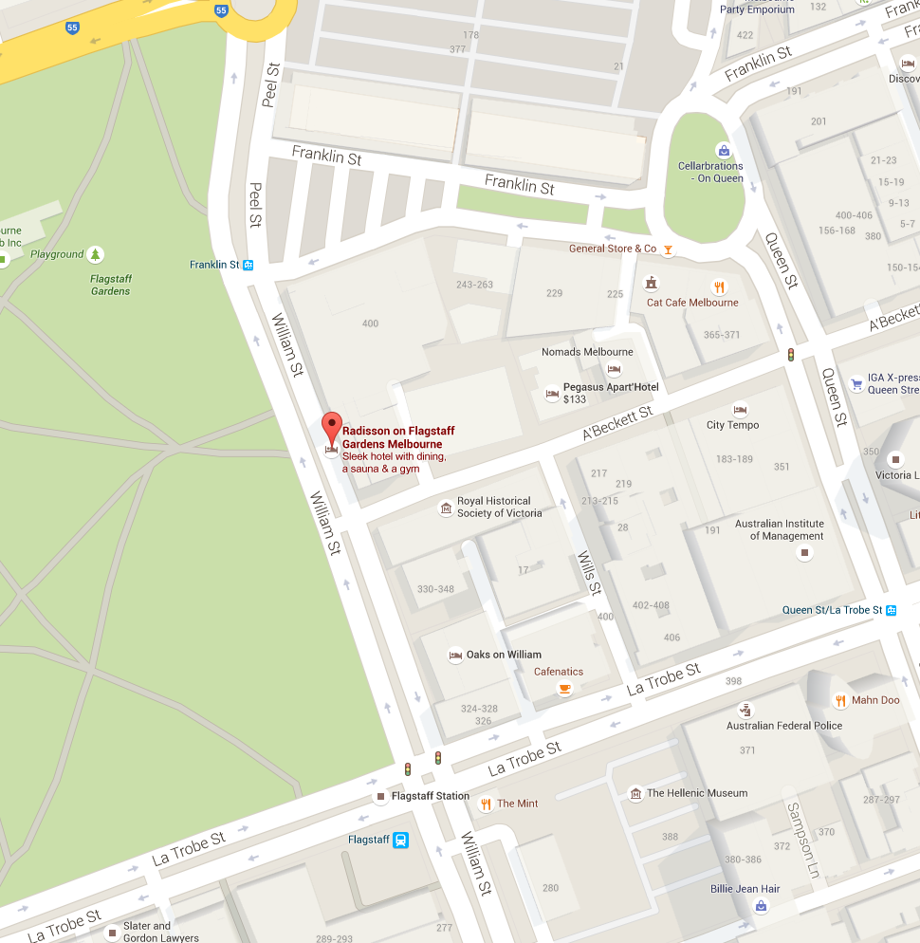

The Forum will take place from 10.30am – 4pm on Friday 6th November. An Agenda for the Forum is provided in this Information Kit.

The “Youth with Disability National Forum” will be held in the Flagstaff 1 Meeting Room.

A copy of the Floor Plan is provided below.

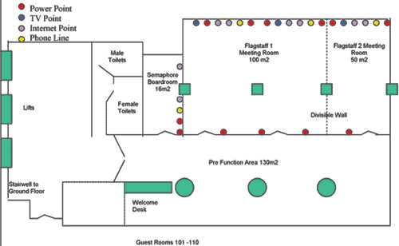

6. Travel Information

6.1. Flight Information

Those participants (and support person where applicable) who are flying to Melbourne for the National Forum, will find a copy of their itinerary/booking confirmation sheet included with this information package. This sheet includes your booking number and it would be advisable to carry this sheet with you during your flights. All participants will be required to produce photo-identification upon check-in for each flight. All flights have been booked by Women With Disabilities Australia (WWDA) using WWDA’s Travel agent, Susan Matthew, of Andrew Jones Travel. Susan’s contact number for your information is (03) 6221 3412.

6.2. Taxis

It is the responsibility of each participant (and support person where applicable) to arrange their own taxi travel to and from the National Forum. CabCharge e-tickets have been issued for each participant (and support person where applicable) to cover this cost.

The following CabCharge e-tickets have been issued to each participant, please find these enclosed in a sealed envelope at the back of this document. If any participant requires additional CabCharge e-tickets during the forum, please contact one of the Forum Co-Facilitators and contact persons.

Name | Cab Charge Numbers
Bonnie Millen | 550, 549
Ariane Garner-Williams | 528, 527, 479, 480
Amorette Garner Williams | 528, 527, 479, 480
Brendan Pearce | 548, 547, 546, 545
Daye Gang | 544, 543
Amy Deguara | To be provided at the Forum
Charlotte McSpedden | 538, 537, 536, 535
Jade Pollitt | 534, 533
Ryan Pollitt | 534, 533
Kalena Spurling | 532, 531, 530, 529
Georgia Whitaker | 526, 525
Jonathon Shar | 458, 457, 456, 455

CabCharge e-tickets can be used to pay for:

- Taxi to get from your home to your local airport;
- Taxi to get from Melbourne Airport to your hotel;
- Taxi to get from your hotel to Melbourne Airport;
- Taxi to get from your local airport to your home.

Each participant is required to return their CabCharge receipts, including ticket stub, along with any unused CabCharge e-tickets to Women With Disabilities Australia (WWDA) in the stamped addressed envelope, enclosed with the cabcharge e-tickets in this information package.

NB. CabCharge e-tickets should be treated as cash and should be kept in a secure place at all times.

7. Accommodation

Those participants (and support person where applicable) who are flying to Melbourne for the National Forum, accommodation will be at the Raddison On Flagstaff Gardens Hotel (the Forum venue) and the Pegasus Apart’Hotel (which is located very close to the Raddison Hotel).

Pegasus Apart’Hotel
206 A'Beckett St,
Melbourne VIC 3000
Ph: (03) 9284 2400
Email: reservations@pegasussuites.com.au
Web: http://www.pegasussuites.com.au/about-pegasus-hotel/

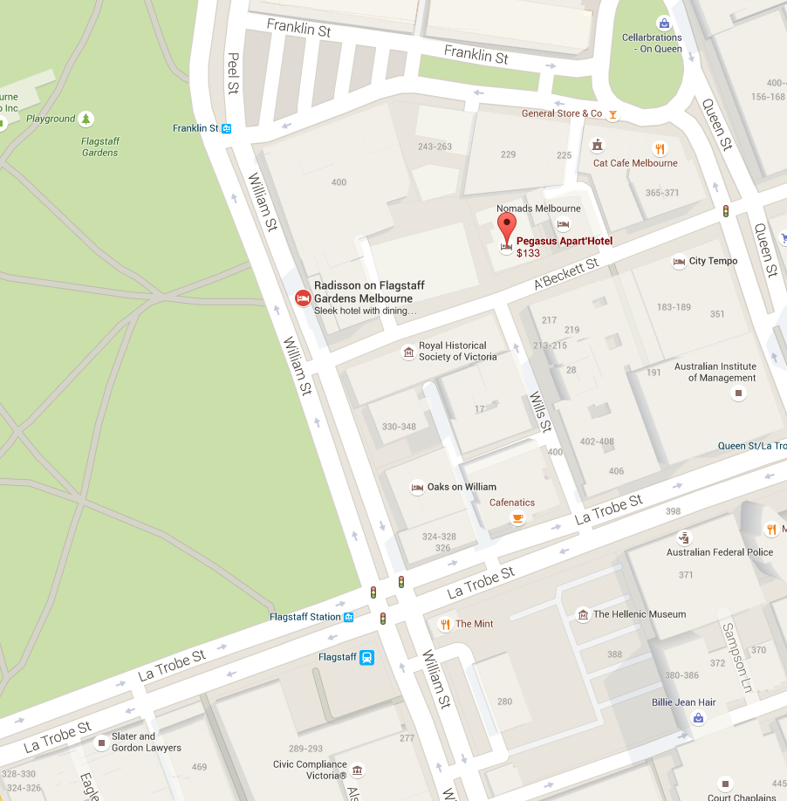

All accommodation has been booked and confirmed and will be pre-paid prior to the Forum.

For your information, accommodation arrangements for participants, support persons and co-facilitators is as follows:

Name | Hotel | Dates
Bonnie Millen | Raddison On Flagstaff Gardens | 5th and 6th Nov
Brendan Pearce | Raddison On Flagstaff Gardens | 5th and 6th Nov
Amy Deguara | Raddison On Flagstaff Gardens | 5th and 6th Nov
Charlotte McSpedden | Raddison On Flagstaff Gardens | 5th and 6th Nov
Renee Mills | Raddison On Flagstaff Gardens | 5th and 6th Nov
Kalena Spurling | Raddison On Flagstaff Gardens | 5th and 6th Nov
Deb Montgomery | Raddison On Flagstaff Gardens | 5th and 6th Nov
Jonathon Shar | Raddison On Flagstaff Gardens | 6th Nov
Mrs Shar | Raddison On Flagstaff Gardens | 6th Nov
Jade Pollitt & Ryan Pollitt | Pegasus Apart’Hotel | 5th and 6th Nov
Peta Green | Pegasus Apart’Hotel | 5th and 6th Nov
Christopher Brophy | Pegasus Apart’Hotel | 5th and 6th Nov
Carolyn Frohmader | Raddison On Flagstaff Gardens | 6th Nov

7.1. Accommodation Related Payment Information

All participants (and support person where applicable) will be individually responsible for any costs that they incur including minibar, telephone calls, additional internet access, dry cleaning, in-house videos, room service etc. Women With Disabilities Australia (WWDA) is pre-paying the accommodation charge, continental breakfast and meals as required. Any other expenses will be the responsibility of each participant and must be paid in full on checkout from the hotel.

7.2. Meals
Continental breakfast is included in the accommodation cost for all participants (and support person where applicable) staying in the Raddison On Flagstaff Gardens and Pegasus Apart’Hotel. Morning tea, lunch and afternoon tea will be provided for all attendees, including support persons, at the National Forum on 6th November. For those participants (and support person where applicable) who are staying for 2 nights, a per diem amount will be deposited to the bank account you and/or your support person has already provided to the Forum organisers. The per diem amount will cover the cost of 2 evening meals, and 2 days of incidental expenses. These amounts are calculated by the Australian Taxation Office (ATO) are:

$49.65 per person for the evening meal (X2 nights)
$18.75 per person (X2 days) for incidentals.

The full per diem amount for those staying two nights in Melbourne is therefore: $136.80 per person.

Agenda for the Youth with Disability National Forum

AGENDA

10.30am: Arrive and morning tea

11.00: Acknowledgement of traditional owners

11:05: Group introductions

11:15: Introduction to UNFPA and the Global Project
• What are we here to do today and how will we do it?
- What is ‘branding’?
- What is ‘messaging’?
- What are slogans?
- What are logos?
11:30: Group contract and being safe

11:45: Presentation
- What are human rights?
- What are our sexual rights and reproductive health rights?
12:00pm: Break into 4 small groups
• Overarching message
• Core messages

1pm: Lunch break

1.45: Feedback from 4 Groups on the overarching and core messages

2.00 Back into 4 small groups
- Cross cutting messages
- Slogans
- Logos
3.00pm: Afternoon tea

3:30pm: Feedback from 4 Groups on cross cutting messages, slogans and logos

3:50pm: Summary of the day

4pm: Finish

APPENDIX 3: Definitions Handout

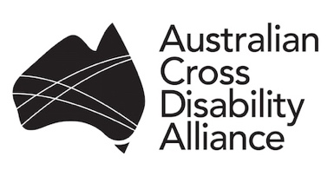 | 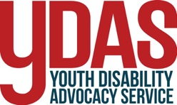 | 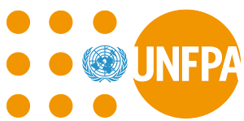

DEFINITIONS

What is "branding"?
Branding is designed to educate or create certain emotions. For a business, branding attracts customers and encourages repeat business. For a non-profit organisation, it attracts loyal supporters, donors and advocates to your cause.
Branding is more than just your logo or name — a lot more. Branding is telling your story to your audience and showing why YOU matter. It’s about the experience and perception your audience has of your organization.

What is a "brand"?
Brand is the perception someone holds in their head about you, a product, a service, an organization, a cause, or an idea. Brand building is the deliberate and skillful application of effort to create a desired perception in someone else’s mind.

What is "brand messaging"?
Every brand needs a voice. Brand messaging provides the words that help their audience understand their value (why its useful) and values (what it believes in).

What is a "logo"?
A logo is the graphic symbol that represents a person, company or organization. A logo aids in promoting public recognition.

What is a "slogan"?
A branding slogan is a small set of words or a short phrase that a business uses to make its company and products stick in its audience’s memories. An effective branding slogan not only sticks in the audience’s mind, but also invokes a mood and creates a bond with the audience.

APPENDIX 4: Photo/Video Consent and Release Form
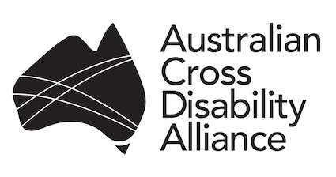 | 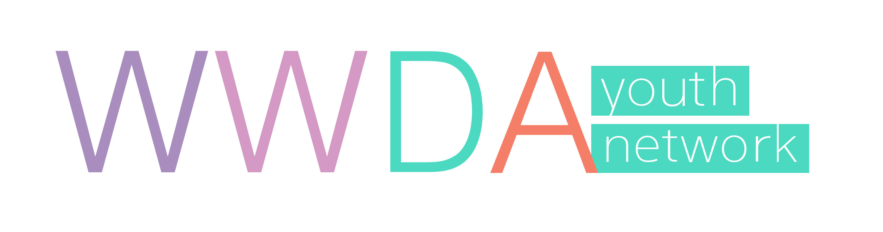  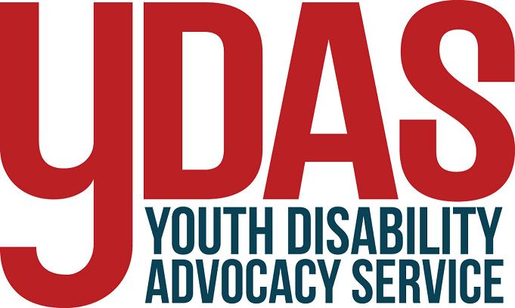

Photo/Video Consent and Release Form

The “Youth with Disability National Forum” is being held to help the United Nations Population Fund (UNFPA) develop and implement a Global Project to improve the human rights of young people with disability all around the world. The Global Project is called: “Youth and Disability Policies of Social Inclusion, Gender Equality, Non-Discrimination and Prevention of Sexual Violence”.

At the “Youth with Disability National Forum” we will be taking photographs and video footage of the proceedings of the Forum. The information that comes from the “Youth with Disability National Forum” will be recorded and given to the United Nations Population Fund (UNFPA) so that the advice from young people with disability themselves can be used to help promote, set up, and run the Global Project.

We would like your permission to use your photograph and video footage to promote the “Youth with Disability National Forum” and the Global Project “Youth and Disability Policies of Social Inclusion, Gender Equality, Non-Discrimination and Prevention of Sexual Violence”. Your photo and/or video footage may be used in our newsletters, publications on our websites and our social media sites (Facebook and Twitter). Your photo and/or video footage may also be used by the United Nations Population Fund and its affiliates, to promote the UNFPA Global Project “Youth and Disability Policies of Social Inclusion, Gender Equality, Non-Discrimination and Prevention of Sexual Violence”. This may include using your photo and/or video footage in publications, advertising or other media activities (including the Internet) related to the UNFPA Global Project.

If you agree to us taking and using your photographs and/or video footage please sign here.

I agree to having my photo and/or video footage taken and reproduced for the purposes of the “Youth with Disability National Forum” and the Global Project “Youth and Disability Policies of Social Inclusion, Gender Equality, Non-Discrimination and Prevention of Sexual Violence”.

Signature: _________________________________________________________________

Name: _________________________________________________________________

Date: _________________________________________________________________

If you disagree to us taking and using your photographs and/or video please sign here.

I disagree to having my photo and/or video footage taken and reproduced for the purposes of the “Youth with Disability National Forum” and the Global Project “Youth and Disability Policies of Social Inclusion, Gender Equality, Non-Discrimination and Prevention of Sexual Violence”.

Signature: _________________________________________________________________________

Name: ________________________________________________________________________________

Date: _________________________________________________________________________

APPENDIX 5: Participant Information Form

PARTICIPANT INFORMATION FORM
Name
Date of Birth
Full Home Address
Contact Number
Email Address
Frequent Flyer Number (if applicable)
Emergency Contact Name
Emergency Contact Number
Brief description of any accessibility requirements? (E.g. wheelchair access, interpreters, hearing loop, etc)
Are you travelling with a wheelchair, mobility aid, or assistance dog?
Do you have a food intolerance or allergy? (please specify)
Will you require overnight accommodation in Melbourne?
*All WA and NT participants please note if you will require two nights
Will you require an accessible room?
Are you travelling with a support person?
If yes, will your support person require a separate room?
SUPPORT PERSON INFORMATION
Name
Contact Number
Email Address
Emergency Contact Details
Frequent Flyer Number (if applicable)

http://www.undp.org/content/undp/en/home/librarypage/poverty-reduction/inclusive_development/disability-rights--he-un-partnership-to-promote-the-rights-of-pe.html
http://www.ohchr.org/EN/HRBodies/CRPD/Pages/CRPDIndex.aspx
http://www.ohchr.org/EN/Issues/Disability/SRDisabilities/Pages/SRDisabilitiesIndex.aspx
Ibid.
“Any act of gender-based violence that results in, or is likely to result in, physical, sexual or psychological harm or suffering to women, including threats of such acts, coercion or arbitrary deprivations of liberty, whether occurring in public or in private life.” Gender-based violence has become an umbrella term for any harm that is perpetrated against a person’s will, and that results from power inequalities that are based on gender roles. It is widely recognized that regardless of country or culture, gender-based violence has a greater negative impact on women and girls. See: UN Declaration on the Elimination of Violence against Women 1993; See: http://www.hhri.org/thematic/gender_based_violence.html
http://crossdisabilityalliance.org.au/
http://wwda.org.au/
http://fpdn.org.au
http://pwd.org.au
http://neda.org.au/
http://youth.wwda.org.au/
http://www.unfpa.org/ See also: http://www.unfpa.org/frequently-asked-questions
http://www.cooperacionespanola.es/en/about-us
http://www.familycareintl.org/en/home
UNFPA (2013) UNFPA Strategy on Adolescents and Youth: Towards realizing the full potential of adolescents and youth.
World Health Organisation, World Bank, “World Report on Disability” (2011).
Cited in: UNFPA (2015) Draft Conceptual Framework: ‘Youth and disability: Social policies of inclusion, gender equality, non-discrimination and prevention of sexual violence.’ Unpublished.
United Nations, Division for Social Policy and Development, Fact sheet on Youth with Disabilities, available at: http://social.un.org/youthyear/docs/Fact%20sheet%20youth%20with%20disabilities.pdf
Mora, L. (2015) Presentation: ‘Youth & Disability: Violence and SRH’. Montevideo, Uruguay, 2-4 September 2015.
UNESCO was created in 1945 in order to respond to the firm belief of nations, forged by two world wars in less than a generation, that political and economic agreements are not enough to build a lasting peace. Peace must be established on the basis of humanity’s moral and intellectual solidarity. See: http://en.unesco.org/about-us/introducing-unesco
United Nations, Division for Social Policy and Development, Fact sheet on Youth with Disabilities, available at: http://social.un.org/youthyear/docs/Fact%20sheet%20youth%20with%20disabilities.pdf
UNFPA (2013) UNFPA Strategy on Adolescents and Youth: Towards realizing the full potential of adolescents and youth.
See for eg: Women With Disabilities Australia (2013) ‘WWDA Submission to the CRPD Committee: Day of General Discussion on the Right to Education for Persons with Disabilities’. WWDA, Tasmania. Available online at: http://wwda.org.au/wp-content/uploads/2013/12/CRPD_13Sess.pdf
See for example: Dowse, L., Soldatic, K., Didi, A., Frohmader, C. & van Toorn, G. (2013) Stop the Violence: Addressing Violence Against Women and Girls with Disabilities in Australia, Background Paper, Women With Disabilities Australia, Hobart. Available at: http://wwda.org.au/wp-content/uploads/2013/12/STV_Background_Paper_FINAL.pdf See also: Frohmader, C., Dowse, L., and Didi, A. (2015) ‘Preventing Violence against Women and Girls with Disabilities: Integrating A Human Rights Perspective’. Available at: http://wwda.org.au/wp-content/uploads/2013/12/Think_Piece_Revised_Edition.pdf
See for eg: Women With Disabilities Australia (2015) WWDA Submission to the UN Committee on the Rights of the Child (CRC): Development of the General Comment on the Rights of Adolescents; 1st April 2015.
Mora, L. (2015) Presentation: ‘Youth & Disability: Violence and SRH’. Montevideo, Uruguay, 2-4 September 2015.
Cited in: UNFPA (2015) Draft Conceptual Framework: ‘Youth and disability: Social policies of inclusion, gender equality, non-discrimination and prevention of sexual violence.’ Unpublished.
United Nations, Division for Social Policy and Development, Fact sheet on Youth with Disabilities, available at: http://social.un.org/youthyear/docs/Fact%20sheet%20youth%20with%20disabilities.pdf
Ibid.
http://www.un.org/disabilities/convention/conventionfull.shtml
All but one participant consented to having their photo and videos taken during the Forum.
See: http://wwda.org.au/wwda-youth-network-launch-a-resounding-success/
See for example: http://www.workingwithatsi.info/content/practice_tips2.htm
http://www.thenonprofitvillage.org/branding-vs-marketing-and-what-nonprofits-need-to-know/
http://www.forbes.com/sites/jerrymclaughlin/2011/12/14/a-simple-blueprint-for-a-successful-brand/
Hinge Marketing, 2015, www.hingemarketing.com/library/article/elements_of_a_successful_brand_8_messaging
Visible Logic, 2013, http://www.visiblelogic.com/blog/2013/02/logo-brand-identity-brand-what-is-branding/#sthash.WPfnq6tN.dpuf
Kay Baxter, http://smallbusiness.chron.com/branding-slogan-20583.html
The Story of Human Rights, video available at: https://www.youtube.com/watch?v=oh3BbLk5UIQ See also: http://www.youthforhumanrights.org/what-are-human-rights.html
Sources: Sex & the Law 2006 Family Planning NSW; Anne Craft 1987; World Health Organisation – Gender and Human Rights
World Health Organisation – Gender and Human Rights
Alizah Epstein, http://www.thenonprofitvillage.org/branding-vs-marketing-and-what-nonprofits-need-to-know/
Jerry McLaughlin, 2011, http://www.forbes.com/sites/jerrymclaughlin/2011/12/14/a-simple-blueprint-for-a-successful-brand/
Hinge Marketing, 2015, www.hingemarketing.com/library/article/elements_of_a_successful_brand_8_messaging
Visible Logic, 2013, http://www.visiblelogic.com/blog/2013/02/logo-brand-identity-brand-what-is-branding/#sthash.WPfnq6tN.dpuf
Kay Baxter, http://smallbusiness.chron.com/branding-slogan-20583.html

