Australian Cross Disability Alliance

 |  | 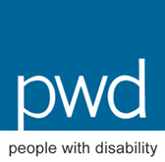 | 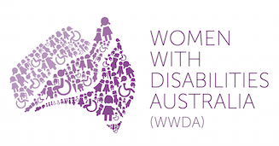

c/-Women With Disabilities Australia (WWDA)
PO Box 407, Lenah Valley, Tasmania 7008
Ph: 0438535123
E: chris@wwda.org.au
2 July 2015

Honourable Marcia Neave AO
Chair
Royal Commission into Family Violence
PO Box 535
Flinders Lane VIC 8009
Via Email: enquiries@rcfv.com.au

Dear Commissioner Neave,

The Australian Cross Disability Alliance (ACDA) is writing to contribute specific relevant materials to inform the Victorian Royal Commission into Family Violence, specifically in the context of family violence and people with disability. Although we understand the official date for written Submissions to the Royal Commission has closed, we request that our contribution be formally accepted and considered by the Royal Commission as part of is work to make recommendations to reduce and ultimately eliminate, family violence.

The ACDA is an alliance of national disabled people’s organisations (DPO’s) in Australia. The key purpose of the ACDA is to promote, protect and advance the human rights and freedoms of people with disability in Australia by working collaboratively on areas of shared interests, purposes and strategic priorities and opportunities. The ACDA represents the interests of all people with disability, from all backgrounds and circumstances, and is the recognised coordinating point between Government/s and other stakeholders, for consultation and engagement with people with disability in Australia. The ACDA works within and from, a human rights framework and approach, recognising and respecting that the international human rights normative framework, including the international human rights treaties and instruments to which Australia is a party, provide the human rights framework to advance the rights of people with disability.

It is widely acknowledged that people with disability, particularly women with disability, experience, and are at far higher risk of violence than the rest of the population. Violence against women with disability, for example, is more varied in nature and more severe than for women in general. Compared to other women, women with disability experience higher levels of all forms of violence more often and more intensely. They acquire more severe injuries as a result of the violence. Their experiences of violence last longer, often because they can’t get appropriate help. Women with disability are also subjected to violence by a greater number of perpetrators, including intimate partners, family members, formal or paid carers, informal or unpaid carers, staff in institutions, other residents in institutions and disability support workers. Women with disability are 40% more likely to be the victims of domestic violence than women without disability and more than 70% of women with disability have been victims of violent sexual encounters at some time in their lives. Twenty per cent of women with disability report a history of unwanted sex compared to 8.2% of women without disability. The rates of sexual victimisation of women with disability range from four to 10 times higher than for other women. Ninety per cent of Australian women with an intellectual disability have been subjected to sexual abuse, with more than two-thirds (68%) having been sexually abused before they turned 18 years of age.

These figures are alarming – yet, despite governments acknowledging the epidemic of violence against people with disability – including family violence - efforts to address violence against people with disability, particularly women with disability, have been slow and are rarely supported by investment and action. Research shows that it is partly because people with disability’s experiences of violence may not fit either historic, or contemporary definitions and understandings; that violence perpetrated against them often goes unidentified, unreported, un-investigated, inadequately investigated, or results in poor outcomes for the person concerned.

Violence perpetrated against people with disability, particularly women and girls with disability, therefore currently falls through a number of legislative, policy and service delivery ‘gaps’ as a result of the failure to understand the intersectional nature of the violence that they experience, the vast circumstances and spaces in which such violence occurs, and the multiple and intersecting forms of discrimination which make them more likely to experience, and be at risk of, violence.

Inclusive, consistent, and comprehensive definitions and conceptual understandings of ‘family violence’ and/or ‘domestic violence’ - which include the full variety of violent acts experienced by people with disability, in the full range of domestic settings and relationships experienced by people with disability –- are urgent and critical to ensure the safety of people with disability, and to reduce and ultimately eliminate, family violence.

Accompanying this letter are a number of relevant, timely and current reports on the issue of violence against people with disability, which the ACDA asks be formally accepted by the Royal Commission into Family Violence. These reports provide significant information, detail and direction for the Royal Commission including the legislative, policy, social, cultural and behavioural changes required to eliminate violence against people with disability, particularly women and girls with disability. These accompanying reports are:

Frohmader, C. and Cadwallader, J. (2014) Joint Submission from National Cross-Disability Disabled People’s Organisations (DPO’s) to the Senate Standing Committee on Finance and Public Administration ‘Inquiry into Domestic Violence in Australia’.

Frohmader, C., Dowse, L., & Didi, A. (2015) ‘Preventing Violence against Women and Girls with Disabilities: Integrating A Human Rights Perspective’. Women With Disabilities Australia (WWDA), ISBN: 978-0-9585268-4-5

Dowse, L., Soldatic, K., Didi, A., Frohmader, C. and van Toorn, G. (2013) Stop the Violence: Addressing Violence Against Women and Girls with Disabilities in Australia. Background Paper. Hobart: Women with Disabilities Australia.

Women With Disabilities Australia (WWDA), University of New South Wales (UNSW), and People with Disabilities Australia (PWDA) (2013) Report of the Proceedings and Outcomes of the National Symposium on Violence against Women and Girls with Disabilities. Hobart: Women with Disabilities Australia.

Council of Europe Convention on Preventing and Combating Violence Against Women and Domestic Violence (The Istanbul Convention)

DPP v Kumar [20 November 2013] VCC.

United Nations General Assembly: Special Rapporteur on Violence Against Women, its Causes and Consequences [Ms Rashida Manjoo]: Report on Violence Against Women With Disabilities (August 2012)

Attard, M., & Price-Kelly, S. (2010) Accommodating Violence: The experience of domestic violence of people with disability living in licensed boarding houses, People with Disability Australia, NSW.

French, P., Dardel, J., & Price-Kelly, S. (2009) Rights denied: Towards a national policy agenda about abuse, neglect and exploitation of persons with cognitive impairment, People with Disability Australia, Sydney.

Multicultural Disability Advocacy Association of NSW (MDAA) (2010) ‘Violence Through Our Eyes: Improving Access to Services for Women from non-English Speaking Backgrounds with Disability and Carers Experiencing Violence Project Report’.

The ACDA thanks the Victorian Royal Commission into Family Violence for the opportunity to contribute to its work.

Yours sincerely

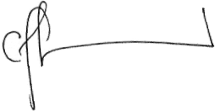  Carolyn Frohmader  Executive Director  Women With Disabilities Australia (WWDA) | 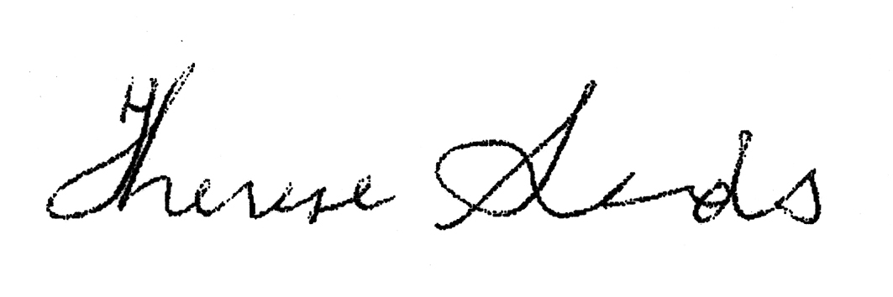  Co-Chief Executive Officer  People with Disability Australia (PWDA) | Dwayne Cranfield  Chief Executive Officer  National Ethnic Disability Alliance (NEDA) | 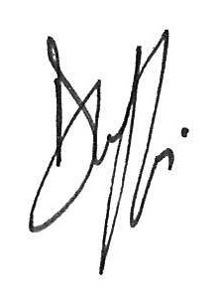  Damian Griffis  Chief Executive Officer  First People’s Disability Network Australia (FPDN)

‘Disabled people’s organisations’ (DPOs) are organisations that are made up of people with disability and governed and led by people with disability.
In: Frohmader, C. and Cadwallader, J. (2014) Joint Submission from National Cross-Disability Disabled People’s Organisations (DPO’s) to the Senate Standing Committee on Finance and Public Administration ‘Inquiry into Domestic Violence in Australia’.
Ibid.

